POSITIVE PARTNERSHIPS · PROFESSIONAL LEARNING
Facilitator Guide
School Leadership
SESSION  1 | SESSION  2 | SESSION  3 | SESSION  4 | SESSION  5 | SESSION  6

One page for every slide. Each page shows the slide, what it is for, what to do and say, the activity and how long to spend.
Workshop day 8:30 - 4:00 · Timings are indicative · PHASE 5 DRAFT

How to use this guide
The guide follows the six slide decks exactly. Every visible slide has its own page, in deck order, so you can keep the guide open beside the presenter view and turn one page per slide.
Each session opens with a planning page: the intent, what participants will leave with, what to prepare, and a run sheet with clock times.
EVERY SLIDE PAGE HAS
Header strip | The session colour, the session name and the slide number in the deck.
Slide and facts | A picture of the slide, the suggested minutes, the running clock, the grouping, and the Participant Guide page if there is one.
Purpose | One line on why the slide is there.
What to do | Numbered steps, in order.
Key messages | What participants should take from the slide.
You might say | Wording you can use or adapt, where the team has written it.
Activity card | Format, grouping, time, the prompt, steps, how to bring the room back and how to close.
Keep in mind | Cautions and what to avoid.
Background and thread | Context for you, and how the slide links to other sessions.

SESSION COLOURS
Each session keeps the colour used in the Participant Guide, so the page a participant has open matches the colour on your page.

The day at a glance
Time | Session |  | Slides | Page
8:30 - 9:45 | 1 | The Lens | 17 slides | p. 5
9:45 - 10:45 | 2 | Understanding Autistic Experience  Sensory and Thinking | 23 slides | p. 23
10:45 - 11:00 |  | Morning tea
11:00 - 12:30 | 3 | Autistic Experience at School  Communication, Connection and Identity | 26 slides | p. 47
12:30 - 1:00 |  | Lunch
1:00 - 2:15 | 4 | Learning Design  Designing an autism friendly school | 24 slides | p. 74
2:15 - 3:15 | 5 | Working in Partnership  Partnership as strategy | 19 slides | p. 100
3:15 - 4:00 | 6 | Flourishing & Full Circle  One change, one purposeful conversation | 11 slides | p. 120

The thread through the day
Participants hold two or three real, different students in mind from Session 1 onwards. Several Participant Guide pages carry forward:
- Session 1: Think about your students and My starting point (returned to in Session 6).
- Session 3: the school-day map, the school-level audit and the Carry into design card (brought to Session 4).
- Session 4: Our school change and the private My students check.
- Session 5: Bridge to the next family conversation (brought to Session 6).
- Session 6: Start · Continue · Reconsider and Plan the next conversation.

Ways of working
- Keep the students participants have in mind anonymous. Initials or roles only, in the room and on paper.
- Discuss systems, routines and environments, not identifiable students, families or colleagues.
- Every activity has an option to pass. Participants may move, write, listen or step out as they need.
- Look at the environment, task and routine before asking a student to change.
- Include strengths, interests and joy alongside barriers and support needs.
- Treat observations as questions to explore with the student and family, not conclusions about what a student feels.
- Participants write in their Participant Guide. Page numbers are on every slide page of this guide.

Before the day
☐ Local Traditional Custodians name confirmed and Acknowledgement of Country prepared in your own words.
☐ Student voice video tested with sound, captions on and transcript available.
☐ Participant Guides (Session summary p. 3; activities pp. 4 - 5), pens and plain paper.
☐ Venue details for housekeeping: exits, facilities, quiet space, breaks and feedback arrangements.
☐ Whiteboard or chart paper to capture recurring words and questions.
☐ Tables set for small-group discussion.
☐ Overwhelm and sensory joy video clips cued and tested with sound
☐ Autistic thinking video clip cued (once sourced)
☐ Participant Guide open at p. 6 - 9
☐ Pens, and Participant Guide p. 7 for the sensory activity
☐ Small groups set up for the sensory activity
☐ Participant Guide for every participant (pages 11 to 16)
☐ Purple, blue and orange Post-it notes on each table, and wall space to group them by colour
☐ Communication experiences video and masking video cued, with captions and a transcript
☐ Pens in at least two colours for the day map
☐ Optional: participants have their school's bell times or weekly timetable to hand
☐ Carry into design card: one per participant, if using the printed card as well as p. 16
☐ Closing image for slide 26 in place
☐ Signs for three corners of the room: Culture and learning; Routines; Teams and resourcing.
☐ A3 School change sheet (PL Leadership - Session 4 - School change sheet): one per trio, sections 1 - 4 used across the session, with "My students" cards on page 2.
☐ "My students" card: one per person, for the private check and the commitment.
☐ Printed option cards on each table (Professional learning and coaching, Predictability as policy, Inclusion team and review cycles, Documentation that helps staff).

SESSION  1 | 8:30 - 9:45 · 75 MINUTES · 17 SLIDES  The Lens

SESSION INTENT
Welcome participants, centre student voice and establish a neurodiversity-affirming, strengths-based approach. Participants bring two or three different students to mind and begin examining the assumptions that shape school experience, using an environment-first lens.
PARTICIPANTS LEAVE WITH
- Hold two or three different students in mind as a reference point for the day.
- Use consistent language for neurodiversity, neurodivergence and autism.
- Describe a neurodiversity-affirming, environment-first lens and the idea of dynamic disability.
- Identify assumptions in one familiar school routine and how curiosity could change the next response.

RUN SHEET
Clock | Segment | Slides | Minutes
8:30 - 8:36 | Opening and acknowledgements | 1-4 | 6
8:36 - 8:45 | Welcome, introductions and housekeeping | 5-6 | 9
8:45 - 9:05 | Students in mind and student voice | 7-9 | 20
9:05 - 9:18 | The lens: language, affirming stance, social model | 10-12 | 13
9:18 - 9:33 | Look again at school | 13-14 | 15
9:33 - 9:40 | DSE and dynamic disability | 15-16 | 7
9:40 - 9:45 | Today's workshop and transition | 17 | 5

PREPARE
☐ Local Traditional Custodians name confirmed and Acknowledgement of Country prepared in your own words.
☐ Student voice video tested with sound, captions on and transcript available.
☐ Participant Guides (Session summary p. 3; activities pp. 4 - 5), pens and plain paper.
☐ Venue details for housekeeping: exits, facilities, quiet space, breaks and feedback arrangements.
☐ Whiteboard or chart paper to capture recurring words and questions.
☐ Tables set for small-group discussion.

SESSION 1 | The Lens | SLIDE 1 of 17

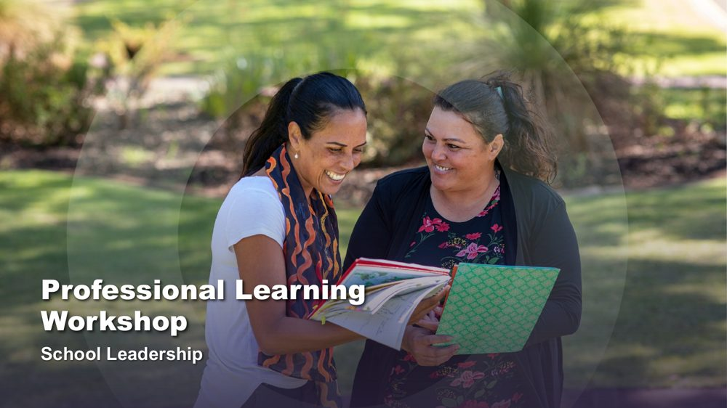 | Professional Learning Workshop - School Leadership  SUGGESTED TIME  2 min  CLOCK  8:30 - 8:32

Introduce the shared starting point for the day: how educators understand students and school.
WHAT TO DO  - Have the title slide on screen as participants arrive and settle.  - Welcome participants and introduce the delivery team.  - Name this as professional learning about understanding Autistic experience and improving access, belonging and partnership.  - Frame the day around curiosity and support, not fixing students or making them appear less Autistic.  - Keep this opening brief so the student reflection and student voice retain enough time. | KEY MESSAGES  - The day begins with the lens educators bring to students and school.  - Curiosity will connect the six sessions.

SESSION 1 | The Lens | SLIDE 2 of 17

 | Acknowledgement of Country  SUGGESTED TIME  2 min  CLOCK  8:32 - 8:34

Acknowledge the Traditional Custodians of the land on which the workshop is taking place.
WHAT TO DO
- Deliver the Acknowledgement of Country in your own words, following organisational protocol.
- Name the Traditional Custodians of the land where the workshop is being held, where this has been confirmed.
- Allow a brief pause before moving on.

KEEP IN MIND
- Do not read a generic script you have not prepared; take time before the day to learn the local Country and custodians.
- Keep the Acknowledgement respectful and unhurried, even if the session is running late.

SESSION 1 | The Lens | SLIDE 3 of 17

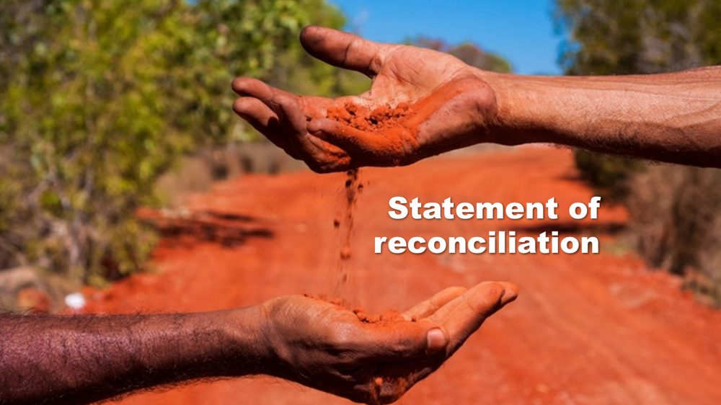 | Statement of reconciliation  SUGGESTED TIME  1 min  CLOCK  8:34 - 8:35

Share the organisation's commitment to reconciliation.
WHAT TO DO
- Share the organisation's statement of reconciliation as provided, following organisational protocol.
- Move on without adding commentary or discussion.

SESSION 1 | The Lens | SLIDE 4 of 17

 | First Nations advisory  SUGGESTED TIME  1 min  CLOCK  8:35 - 8:36

Advise First Nations participants that the workshop may contain images and voices of people who are no longer with us.
WHAT TO DO
- Read the advisory aloud or leave it on screen long enough for everyone to read it.
- Move on without further comment.

SESSION 1 | The Lens | SLIDE 5 of 17

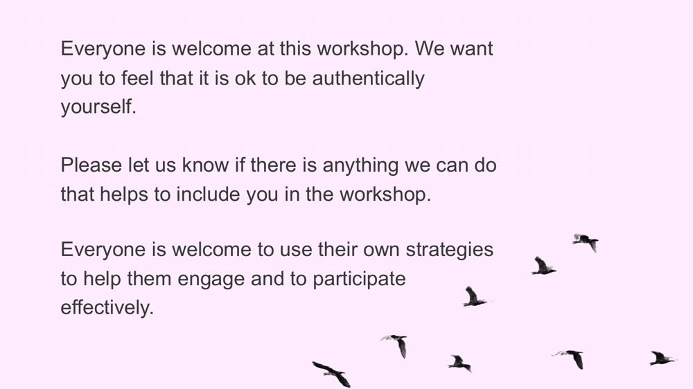 | Everyone is welcome  SUGGESTED TIME  6 min  CLOCK  8:36 - 8:42  GROUPING  Whole room

Welcome participants, establish an accessible way of working together and invite brief introductions.
WHAT TO DO  - Read or paraphrase the welcome: everyone is welcome to be authentically themselves and to use their own strategies to engage.  - Tell participants they may move, regulate, write, speak, listen or pass as needed.  - Invite participants to let the team know, at any time, if there is anything that would help include them.  - Invite brief introductions using first name, professional role and one hope for the day.  - Do not ask participants to identify a student, school or diagnosis. | KEY MESSAGES  - Different ways of participating are welcome.  - Participants bring useful knowledge and questions from their own settings.

ACTIVITY | Brief introductions with an option to pass whole room · 4 minutes
Your first name, your role and one thing you hope to understand better today.
- Model a concise introduction.
- Keep the round moving so no participant is pressured to give personal detail.
- Group the hopes into broad themes without naming individual students or schools.
Close: Let participants know where their themes sit across the six sessions.

KEEP IN MIND
- In a large room, use table introductions rather than a full-room round so the timing holds.

SESSION 1 | The Lens | SLIDE 6 of 17

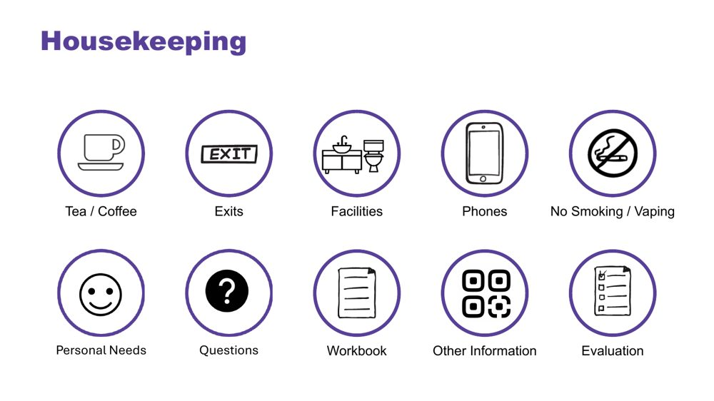 | Housekeeping  SUGGESTED TIME  3 min  CLOCK  8:42 - 8:45

Cover facilities, personal needs, questions and local arrangements.
WHAT TO DO
- Cover exits, facilities, breaks, phones, questions, participant materials, local arrangements and feedback plans.
- Point out any quiet or low-sensory space available at the venue.
- Explain how and when questions can be asked, including in writing.
- Cover venue-specific information here.

SESSION 1 | The Lens | SLIDE 7 of 17

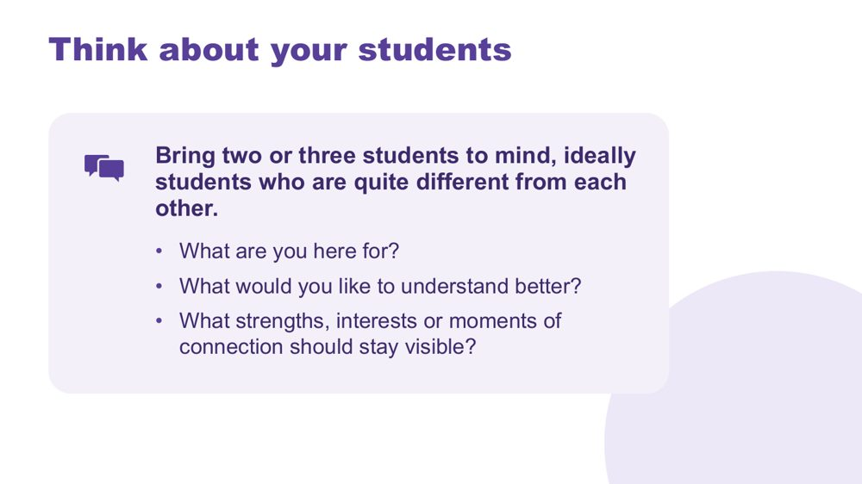 | Think about your students  SUGGESTED TIME  7 min  CLOCK  8:45 - 8:52  GROUPING  On your own  PARTICIPANT GUIDE  Page 4 - Think about your students

Give every participant a student-centred point of reference for the day.
WHAT TO DO  - Invite participants to bring two or three students to mind, ideally students who are quite different from each other.  - Suggest they might differ in age, communication or what school feels like for them.  - Ask participants to note initials or roles only, with no names or identifying details.  - Use the questions on screen to support private reflection.  - Give quiet thinking time before inviting any optional sharing.  - If participants share, redirect descriptions away from labels and towards what they want to understand.  - Ask participants to return to the same students during later mapping and design activities. | KEY MESSAGES  - See each student as a whole person, with strengths and interests as well as needs.  - Holding several different students builds a broad, mixed picture of Autistic experience.  - Questions can remain open while participants gather a fuller picture.

ACTIVITY | Private reflection on your own · 5 minutes
What are you here for? What would you like to understand better? What strengths, interests or moments of connection should stay visible?
- Ask participants to write without using students' names or school.
- Invite them to include strengths, interests or moments of connection as well as questions.
- Keep sharing optional.
Close: Ask participants to keep the reflection available for the rest of the day.

Thread The students brought to mind here return in the school-day mapping (Session 3), classroom design (Session 4) and final reflection (Session 6).

SESSION 1 | The Lens | SLIDE 8 of 17

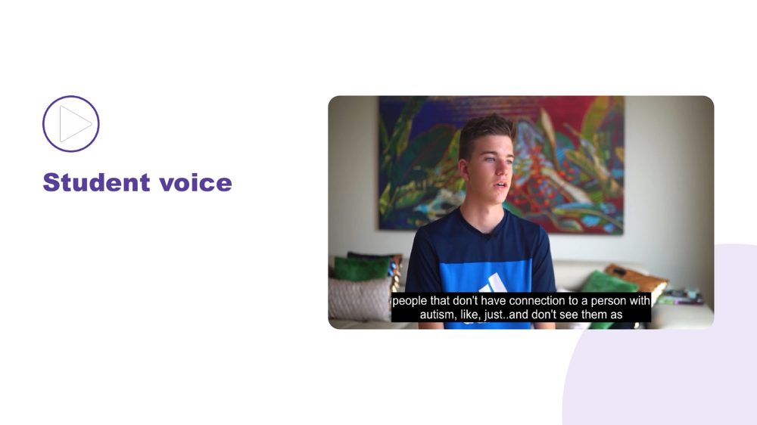 | Student voice  SUGGESTED TIME  6 min  CLOCK  8:52 - 8:58

Make space for Autistic young people to be heard in their own words.
WHAT TO DO  - Introduce the video as an opportunity to listen rather than diagnose, compare or extract a single lesson.  - Ensure captions are on and a transcript is available.  - Play the video without interrupting. | KEY MESSAGES  - Student voice is part of the workshop evidence.  - Each speaker's account is their own.

SESSION 1 | The Lens | SLIDE 9 of 17

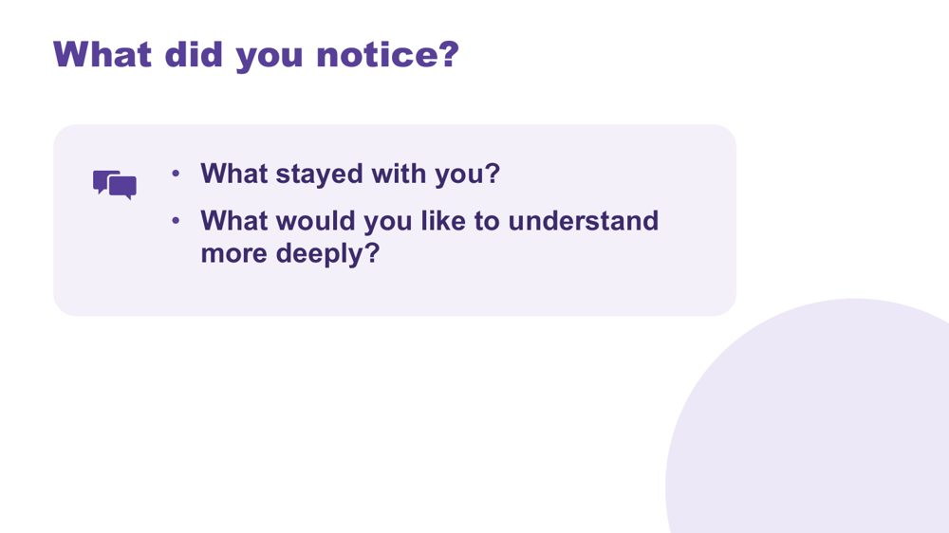 | What did you notice?  SUGGESTED TIME  7 min  CLOCK  8:58 - 9:05  GROUPING  On your own  PARTICIPANT GUIDE  Page 4 - What did you notice?

Support reflection on the student voice material.
WHAT TO DO
- Invite brief private reflection on the questions before discussion.
- Invite observations grounded in what speakers said rather than interpretations of appearance or behaviour.
- Avoid asking participants to compare a speaker with a student they teach.
- Record a few recurring words or questions without forcing consensus.
- Record questions that need follow-up through the appropriate program or local channel.

ACTIVITY | Think, write and optional share on your own · 6 minutes
What did you notice? What stayed with you? What would you like to understand more deeply?
- Give a minute or two of quiet writing time.
- Invite a few optional contributions from the room.
- Capture recurring words or questions where everyone can see them.
Close: Link participants' questions to the sensory, thinking, communication and school-day content that follows.

SESSION 1 | The Lens | SLIDE 10 of 17

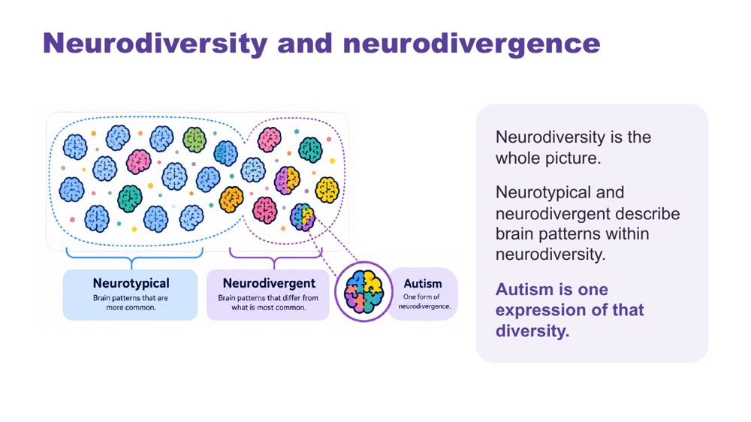 | Neurodiversity and neurodivergence  SUGGESTED TIME  4 min  CLOCK  9:05 - 9:09

Introduce the language for neurodiversity and neurodivergence.
WHAT TO DO  - Explain neurodiversity and neurodivergence using the workshop definitions on the slide.  - Keep the explanation brief and connected to the student-centred curiosity established earlier.  - Respect the language individuals use for themselves. | KEY MESSAGES  - Neurodiversity includes everyone.  - Neurotypical and neurodivergent describe brain patterns within neurodiversity; autism is one expression of that diversity.  - Use one consistent language frame across the workshop.  - Terminology should support dignity and curiosity rather than categorising students by worth.

SESSION 1 | The Lens | SLIDE 11 of 17

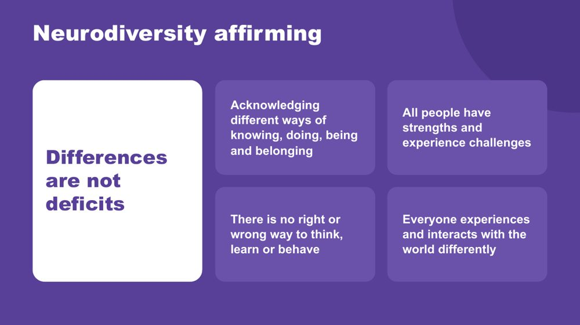 | Neurodiversity affirming  SUGGESTED TIME  5 min  CLOCK  9:09 - 9:14

Establish the practical, strengths-based stance participants will use throughout the day.
WHAT TO DO  - Walk through the principles on the slide.  - Connect the principles to the students participants brought to mind earlier.  - Ask what becomes visible when strengths, interests, joy and ways of connecting are included.  - Clarify that a strengths-based approach does not erase difficulty, access needs or fluctuating capacity.  - Model language that describes the environment and support needed without blaming the student. | KEY MESSAGES  - Begin with the person.  - Include strengths and joy alongside barriers and support needs.  - Stay curious about access and support.

SESSION 1 | The Lens | SLIDE 12 of 17

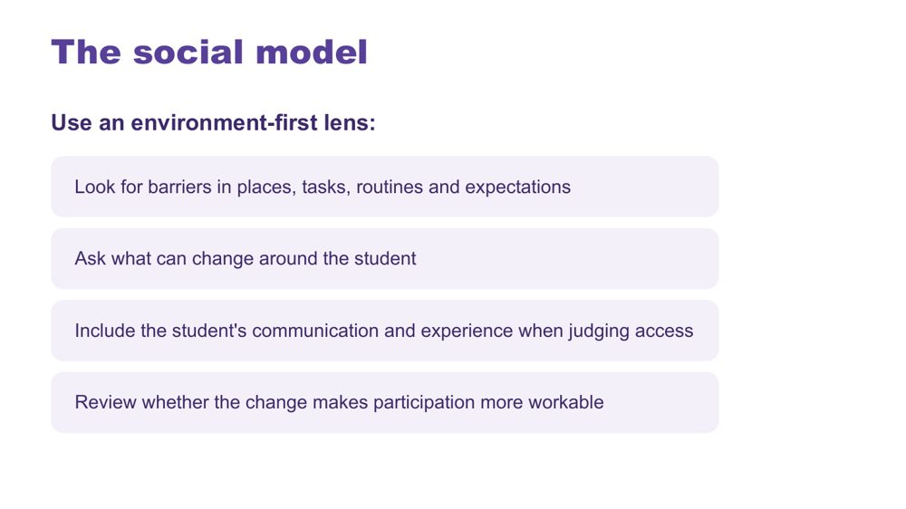 | The social model  SUGGESTED TIME  4 min  CLOCK  9:14 - 9:18

Connect the workshop lens with an environment-first view of barriers.
WHAT TO DO  - Explain the social model through barriers in places, tasks, routines and expectations.  - Walk through the environment-first steps on the slide.  - Direct discussion towards what can change around the student.  - Emphasise including the student's communication and experience when judging access. | KEY MESSAGES  - Look for barriers before asking the student to change.  - Environment and support are part of the experience being examined.

KEEP IN MIND
- Avoid implying that all difficulty disappears when an environment changes.

SESSION 1 | The Lens | SLIDE 13 of 17

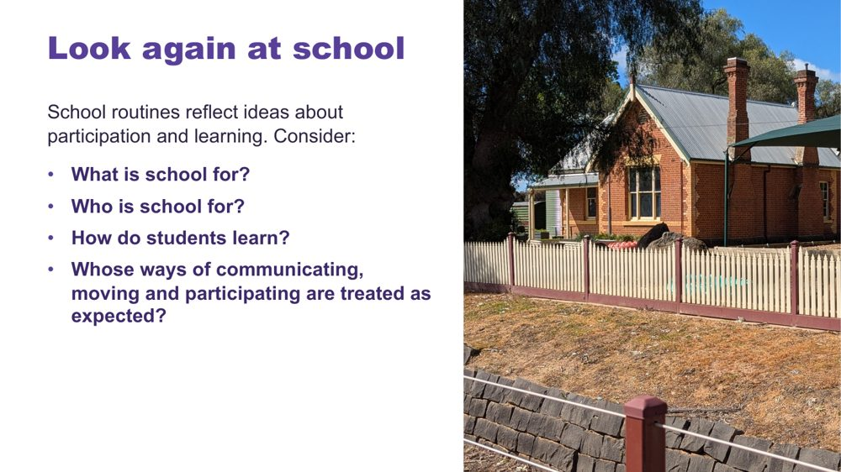 | Look again at school  SUGGESTED TIME  5 min  CLOCK  9:18 - 9:23  PARTICIPANT GUIDE  Page 5 - Look again at school

Help participants notice assumptions about the purpose, audience and methods of school.
WHAT TO DO  - Use the school questions to open reflective thinking; there is no single correct answer.  - Give a short moment of private thinking on the four questions.  - Invite participants to notice assumptions built into everyday routines, expectations and decisions. | KEY MESSAGES  - Assumptions shape what schools notice, reward and change.

KEEP IN MIND
- Keep the tone reflective rather than blaming individual educators.

SESSION 1 | The Lens | SLIDE 14 of 17

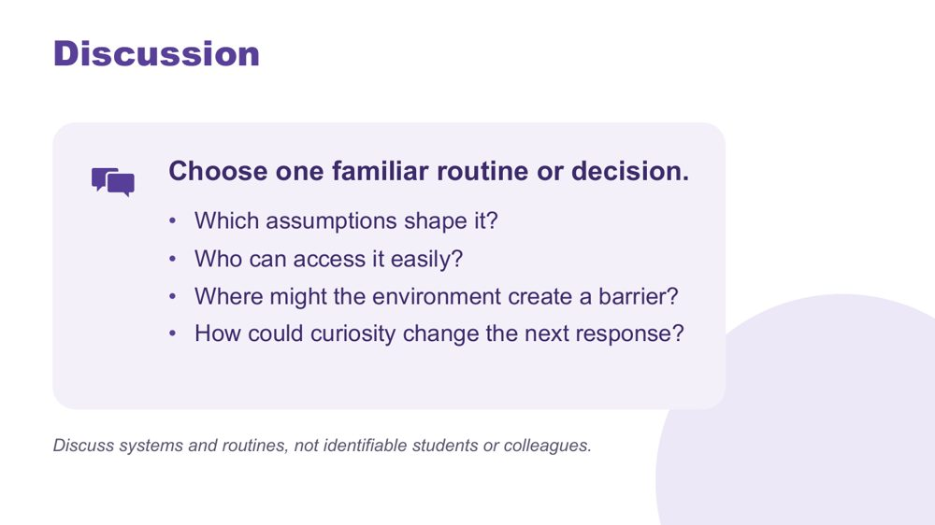 | Discussion  SUGGESTED TIME  10 min  CLOCK  9:23 - 9:33  GROUPING  Small groups  PARTICIPANT GUIDE  Page 5 - Look again at school (discussion)

Apply the questions to one familiar routine or decision and consider how curiosity could change the next response.
WHAT TO DO  - Move participants into small groups.  - Give each group one of the school questions to begin with, then the discussion prompts on screen.  - Ask groups to choose one familiar routine or decision to examine.  - Remind groups to discuss systems and routines, not identifiable students or colleagues.  - When examples become student-focused, ask what the environment, task or expectation contributed.  - Invite one concise observation from each group. | KEY MESSAGES  - Being curious gives us time to change the environment or task before placing more demands on a student.

ACTIVITY | Small-group discussion small groups · 10 minutes
Choose one familiar routine or decision. Which assumptions shape it? Who can access it easily? Where might the environment create a barrier? How could curiosity change the next response?
- Give each group one question to begin with.
- Ask groups to discuss systems and routines rather than naming individual students or colleagues.
- Invite one concise observation from each group.
Bring the room back
- Invite one example where curiosity could change the next response.
Close: Point out that the discussion has moved from assumptions about students to questions about access, environment and learning design.

KEEP IN MIND
- Keep the tone reflective rather than blaming individual educators.

SESSION 1 | The Lens | SLIDE 15 of 17

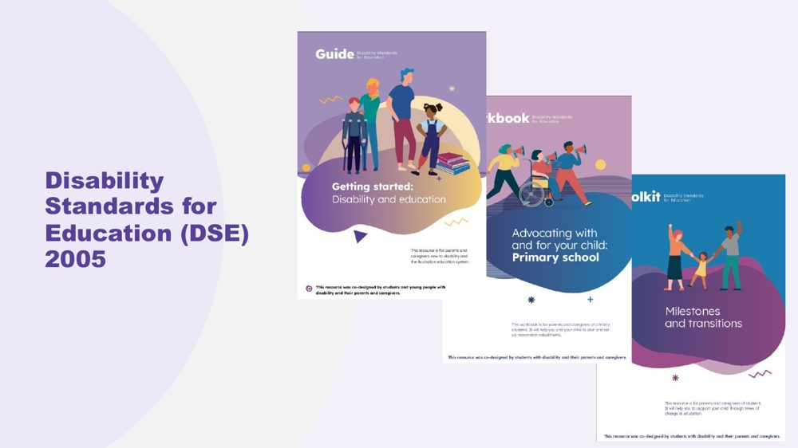 | Disability Standards for Education (DSE) 2005  SUGGESTED TIME  3 min  CLOCK  9:33 - 9:36

Point participants to the Disability Standards for Education 2005 and the Department of Education resources that support them.
WHAT TO DO
- Introduce the Disability Standards for Education 2005 briefly as part of the context for access and adjustments.
- Point participants to the three Department of Education resources listed below.
- Note that the workbook is written for parents and carers, so educators know what families may be reading.
- Refer detailed or school-specific questions to the appropriate program or local channel.

KEEP IN MIND
- Do not give legal advice or add legal claims beyond the published resources.

RESOURCES
- Getting started - Department of Education, Australian Government - https://www.education.gov.au/disability-standards-education-2005/resources/getting-started
- Advocating with and for your child: A workbook for parents and carers - Department of Education, Australian Government - https://www.education.gov.au/disability-standards-education-2005/resources/advocating-and-your-child-workbook-parents-and-carers
- Milestones and transitions - Department of Education, Australian Government - https://www.education.gov.au/disability-standards-education-2005/resources/milestones-and-transitions

SESSION 1 | The Lens | SLIDE 16 of 17

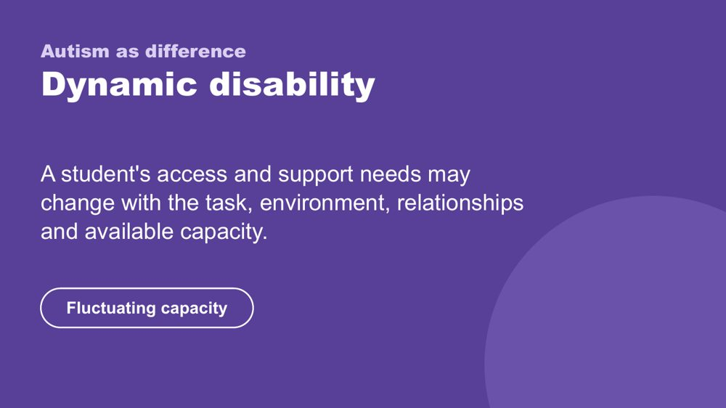 | Autism as difference - dynamic disability  SUGGESTED TIME  4 min  CLOCK  9:36 - 9:40

Introduce the framing of autism as difference and dynamic disability.
WHAT TO DO  - Explain how access and support needs can vary with the task, environment, relationships and available capacity.  - Name fluctuating capacity: what a student can do one day or in one setting may not be available in another.  - Connect the concept back to the need for curiosity across settings and days. | KEY MESSAGES  - Support should respond to the student and context rather than a fixed assumption.  - Strengths and substantial support needs can both belong in the picture.

KEEP IN MIND
- Avoid presenting one pattern of ability, need or capacity as universal.
- Do not add clinical, diagnostic or legal claims.

SESSION 1 | The Lens | SLIDE 17 of 17

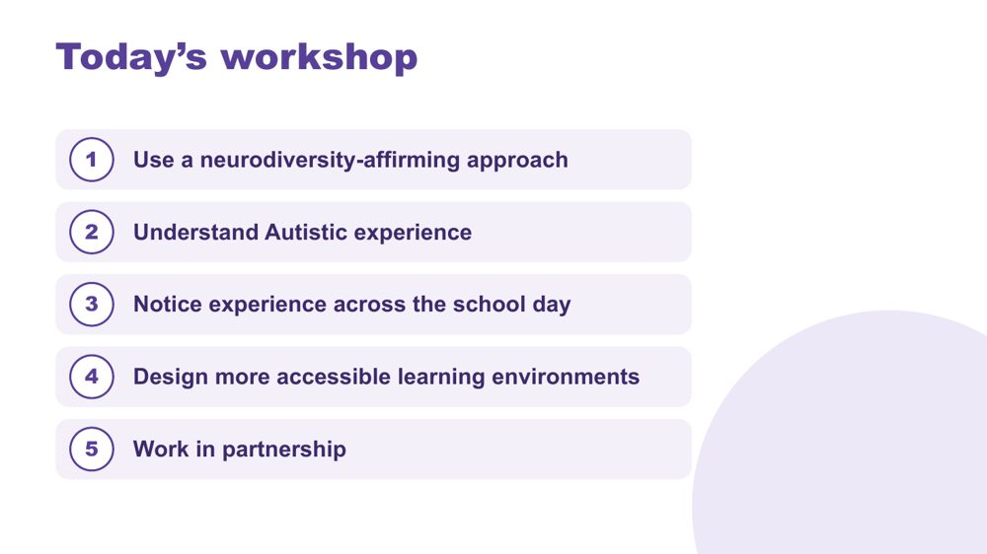 | Today's workshop  SUGGESTED TIME  5 min  CLOCK  9:40 - 9:45  PARTICIPANT GUIDE  Page 5 - My starting point

Orient participants to the learning progression across the full day.
WHAT TO DO  - Walk through the five aims on the slide without turning it into a detailed agenda.  - Explain that Sessions 1 and 2 build a shared understanding and that the school-level application becomes explicit from Session 3.  - Point out morning tea at 10:45 - 11:00 and lunch at 12:30 - 1:00.  - Remind participants that timings are indicative.  - Invite participants to complete My starting point in the Participant Guide; it returns in Session 6.  - Preview that Session 2 explores sensory processing, Autistic thinking and internal signals. | KEY MESSAGES  - The day moves from lens and understanding to school-day experience, classroom design and partnership.  - Belonging, capacity and joy remain visible across the whole sequence.

Thread My starting point is revisited in Session 6 (Flourishing & Full Circle).

SESSION  2 | 9:45 - 10:45 · 60 MINUTES · 23 SLIDES  Understanding Autistic Experience  Sensory and Thinking

SESSION INTENT
Build a picture of the students participants have in mind through three lenses: sensory processing, Autistic thinking and internal signals. The session is strengths-based, includes first-person Autistic voices, and keeps attention on environments, task demands and support rather than treating any single pattern as universal.
PARTICIPANTS LEAVE WITH
- describe the eight senses and four sensory response patterns, including sensory joy and stimming
- look at the sensory and task demands of a classroom routine before the student's response
- name detail-first processing, deep focus (monotropism) and executive functioning as lenses for inquiry, and connect them to the students they have in mind
- consider early signs of overwhelm and who else needs to know them

RUN SHEET
Clock | Segment | Slides | Minutes
9:45 - 9:47 | Opening frame | 1 | 2
9:47 - 10:05 | Sensory processing, voices and profiles | 2-9 | 18
10:05 - 10:13 | Sensory activity | 10 | 8
10:13 - 10:26 | Autistic thinking | 11-17 | 13
10:26 - 10:35 | Thinking discussion | 18 | 9
10:35 - 10:44 | Internal signals and reading the signs | 19-22 | 9
10:44 - 10:45 | Close and tea | 23 | 1

PREPARE
☐ Overwhelm and sensory joy video clips cued and tested with sound
☐ Autistic thinking video clip cued (once sourced)
☐ Participant Guide open at p. 6 - 9
☐ Pens, and Participant Guide p. 7 for the sensory activity
☐ Small groups set up for the sensory activity

SESSION 2 | Understanding Autistic Experience | SLIDE 1 of 23

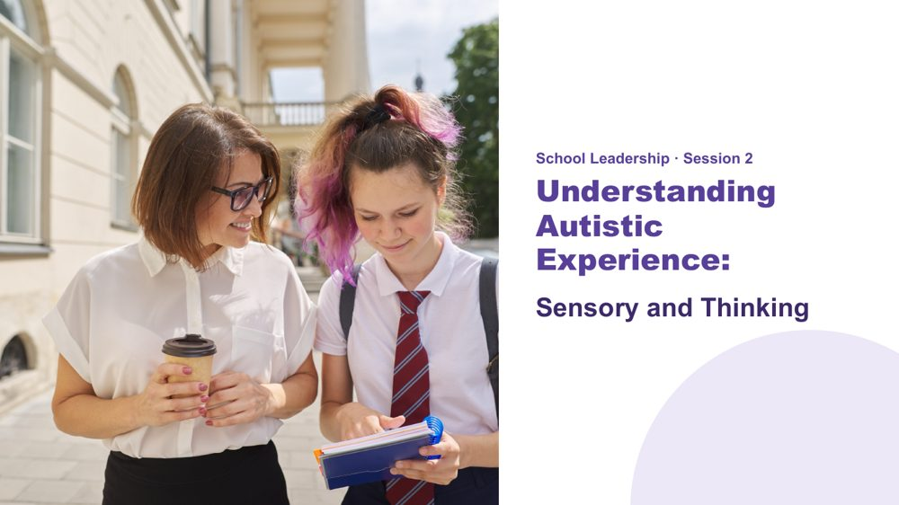 | Understanding Autistic Experience: Sensory and Thinking  SUGGESTED TIME  2 min  CLOCK  9:45 - 9:47  PARTICIPANT GUIDE  Page 6 - Session 2 summary

Orient the room to Session 2 and reconnect participants with the students they brought to mind in Session 1.
WHAT TO DO  - Orient the room before starting.  - Name the opening activity from Session 1: bringing two or three students to mind.  - Ask participants to keep those students in mind for the whole session.  - Name the three parts of the session: sensory processing, Autistic thinking and internal signals.  - Explain that the session offers areas to be curious about. It is not a checklist for deciding what a student experiences. | KEY MESSAGES  - This session is strengths-based.  - The three lenses are not deficit labels - they are tools for understanding.  - The goal is recognition and shared understanding of the Autistic experience.  - Common areas for inquiry do not replace knowing the individual student.  - Ask what the environment and task demand as well as what the student may need.

YOU MIGHT SAY
In this session we are going to build a picture of the students you have in mind. Not a list of what is hard, and not a catalogue of traits. A picture.
Each idea we look at is a piece. As we move through Session 2 and Session 3, the picture will be clearer.
Keep those students in mind as we go. This session is about them.

KEEP IN MIND
- Keep examples grounded in access and support.

Thread This is the opening frame. The "coming into focus" image logic starts here - fragments that build into a whole. Return to this at the close of Session 3.

SESSION 2 | Understanding Autistic Experience | SLIDE 2 of 23

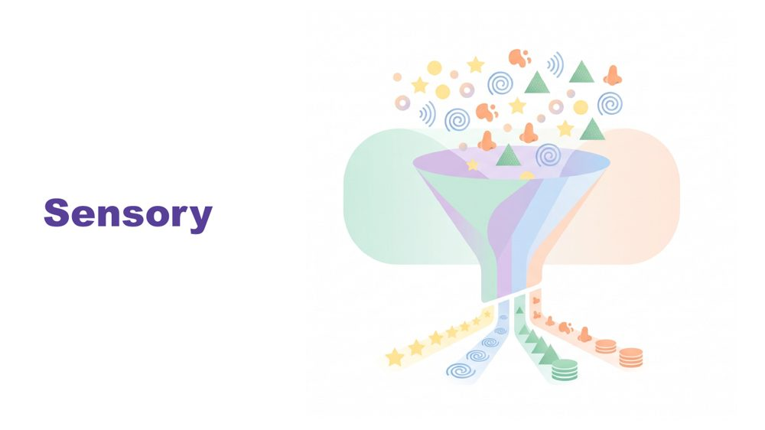 | Sensory  SUGGESTED TIME  1 min  CLOCK  9:47 - 9:48

Set sensory experience as the foundation for everything that follows.
WHAT TO DO  - Introduce sensory as the starting point, before thinking, communication or connection.  - Pause briefly.  - Move to the senses. | KEY MESSAGES  - Sensory inquiry should include joy and authentic expression as well as discomfort or overload.  - Observation is a starting point for curiosity, not proof of what a student feels.  - Context matters.

YOU MIGHT SAY
Before we talk about thinking, or communication, or connection - we start here. With the senses.
Because before a student has thought a single thought, the world has already arrived. And how it arrives matters.

KEEP IN MIND
- Avoid a long content lecture before the sensory activity.

Thread Sensory is the foundation. Later in the day, name explicitly that thinking, communication and connection all flow from this starting point.

SESSION 2 | Understanding Autistic Experience | SLIDE 3 of 23

 | What is sensory processing?  SUGGESTED TIME  1 min  CLOCK  9:48 - 9:49

Establish a shared definition of sensory processing.
WHAT TO DO
- Ask the room: What is sensory processing?
- Take one or two quick answers.
- Give the definition.

YOU MIGHT SAY
Sensory processing is the way the brain receives, processes and responds to information from the senses.

SESSION 2 | Understanding Autistic Experience | SLIDE 4 of 23

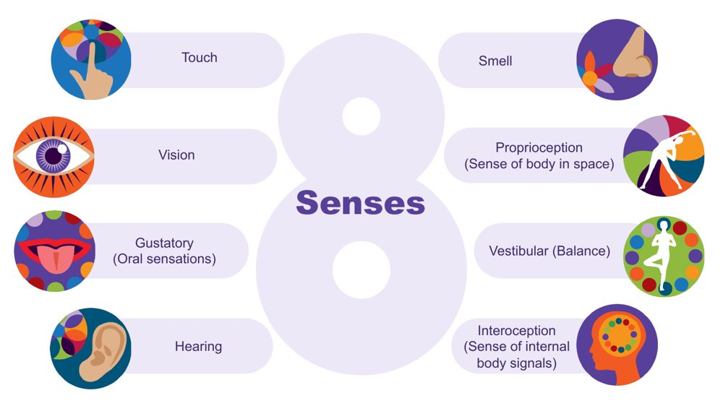 | The eight senses  SUGGESTED TIME  3 min  CLOCK  9:49 - 9:52

Extend the familiar five senses to eight and introduce interoception to return to later.
WHAT TO DO  - Start from the five senses many of us were taught: touch, vision, taste, hearing and smell.  - Ask the room to name the three less well known senses. Give time to respond.  - Name them: proprioception, vestibular and interoception.  - Describe proprioception and vestibular with a school example for each.  - Name interoception and park it: say you will come back to it.  - Connect the senses to everyday school environments. | KEY MESSAGES  - There are 8 senses, not 5.  - The hidden three are often where Autistic differences are most significant.  - Interoception is flagged here and developed in depth later - plant that seed.

YOU MIGHT SAY
Proprioception is the sense of where the body is in space. Students who crash into things, seek heavy pressure, or need to feel their body may be seeking proprioceptive input.
Vestibular is balance and movement. A student who needs to rock, spin, or keep moving in class may be regulating through this sense.
Interoception is the body's inside sense - and it is one of the most important for understanding a student's experience at school. Park it for now.
We will come back to interoception, it connects to a lot of what follows.

Background Touch (tactile) gives information about texture, pain, pressure and temperature. Vision gives depth, colour, size, shape and position. The gustatory sense includes taste and other oral sensations such as texture, temperature and how much pressure is needed when chewing. Hearing (auditory) tells us how far away, how loud and how familiar a sound is, and its pitch. Smell (olfactory) can link strongly to emotional memory. Proprioception comes through joints, muscles, ligaments and deep in the skin; differences may mean bumping into things. The vestibular sense sits in the middle ear, tracks speed and direction of head movement and supports balance; a student may love spinning, or may feel off balance on stairs. There is lots of crossover between the senses: in any situation we use all or most of them.
Thread Interoception returns as a full section in the internal signals slides at the end of this session.
RESOURCES
- Interoception webinar recording and resources on the Positive Partnerships website

SESSION 2 | Understanding Autistic Experience | SLIDE 5 of 23

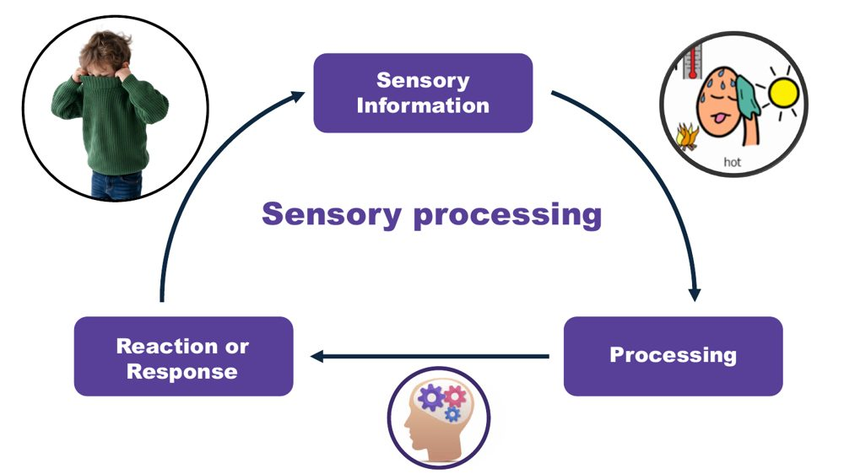 | Sensory processing: information, processing, response  SUGGESTED TIME  2 min  CLOCK  9:52 - 9:54

Show the three steps of sensory processing and that the response is not a choice.
WHAT TO DO  - Walk through the three steps using the jumper example.  - List what sensory processing helps us do.  - Finish on the point that the response is not a choice. | KEY MESSAGES  - The way the brain processes and responds to sensory information is not a choice.

YOU MIGHT SAY
Think about what is involved in someone taking their jumper off when they get too hot. First, sensory information is received to tell them they are getting too hot. This is processed and related to previous experiences. A response is generated - taking the jumper off.
Sensory processing helps us stay safe, keep track of what our body is doing, understand our environment, learn, and filter out information so we can pay attention and engage.
The way our brain processes sensory information and responds is not a choice.

SESSION 2 | Understanding Autistic Experience | SLIDE 6 of 23

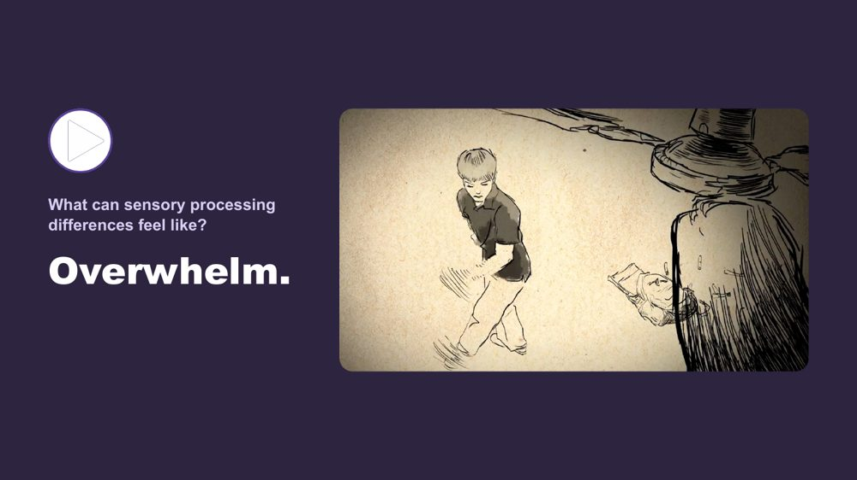 | What can sensory processing differences feel like? Overwhelm  SUGGESTED TIME  3 min  CLOCK  9:54 - 9:57

Help participants understand what sensory overload can feel like, through a first-person account.
WHAT TO DO
- Introduce the two short clips before playing the first.
- Name the pattern: at a few points today we stop and hear from Autistic people directly.
- Play the overwhelm clip.
- After the clip, give a moment. Do not speak immediately.

YOU MIGHT SAY
We are going to watch two short clips. One shows what sensory overload can feel like from the inside. One shows sensory joy - what it is like when the senses are working with you rather than against you. Both are real. Both belong in the room.
We do this in a few places today - we stop and hear from Autistic people directly. That is not an add-on. It is the evidence.
Some of you will have seen something you recognised. Some of you may not have. Both responses are fine.

Thread This video does the same job as the thinking video and the communication video later in the day - it shifts the room from intellectual understanding to felt recognition.

SESSION 2 | Understanding Autistic Experience | SLIDE 7 of 23

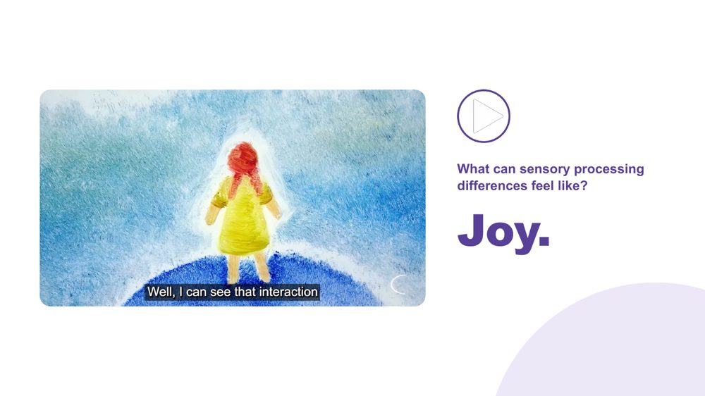 | What can sensory processing differences feel like? Joy  SUGGESTED TIME  3 min  CLOCK  9:57 - 10:00

Balance the overwhelm clip with sensory joy so sensory experience is not framed only through distress.
WHAT TO DO  - Play the joy clip.  - Name that sensory experience is a source of richness as well as difficulty. | KEY MESSAGES  - Sensory experience includes both difficulty and joy.  - First-person accounts are more powerful than any explanation.  - Recognition - not information - is the goal here.

YOU MIGHT SAY
Sensory experience is not only a source of difficulty. For many Autistic people, it is also a source of richness, depth, and genuine pleasure.
The same nervous system that can be overwhelmed by sound can be transported by music. Both are true.

SESSION 2 | Understanding Autistic Experience | SLIDE 8 of 23

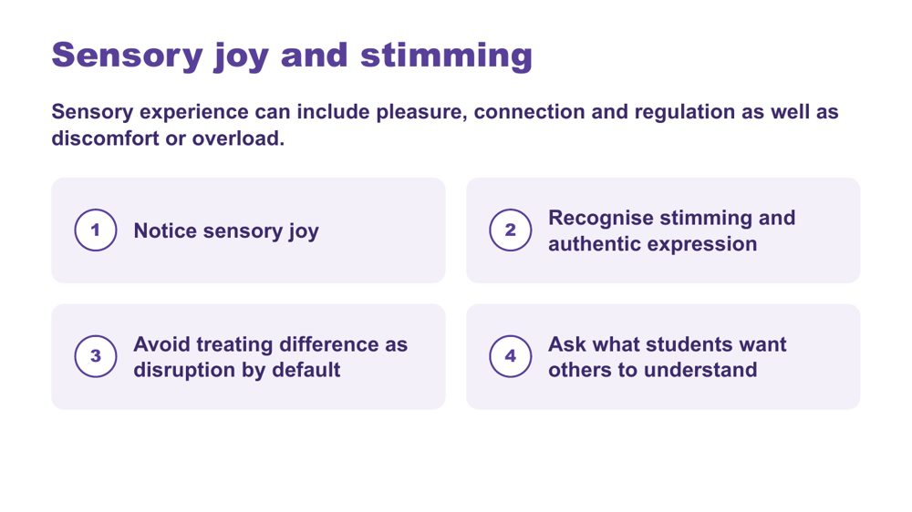 | Sensory joy and stimming  SUGGESTED TIME  2 min  CLOCK  10:00 - 10:02

Recognise sensory joy, stimming and authentic expression as part of sensory experience.
WHAT TO DO  - Read the framing line: sensory experience can include pleasure, connection and regulation as well as discomfort or overload.  - Walk through the four points on the slide.  - Ask participants where they see sensory joy in the students they have in mind. | KEY MESSAGES  - Sensory inquiry should include joy and authentic expression as well as discomfort or overload.  - Stimming can be pleasure, connection, regulation and authentic expression.  - Ask what students want others to understand.

KEEP IN MIND
- Do not discourage harmless stimming.
- Do not frame typical-looking behaviour as the goal.
- Avoid treating difference as disruption by default.

SESSION 2 | Understanding Autistic Experience | SLIDE 9 of 23

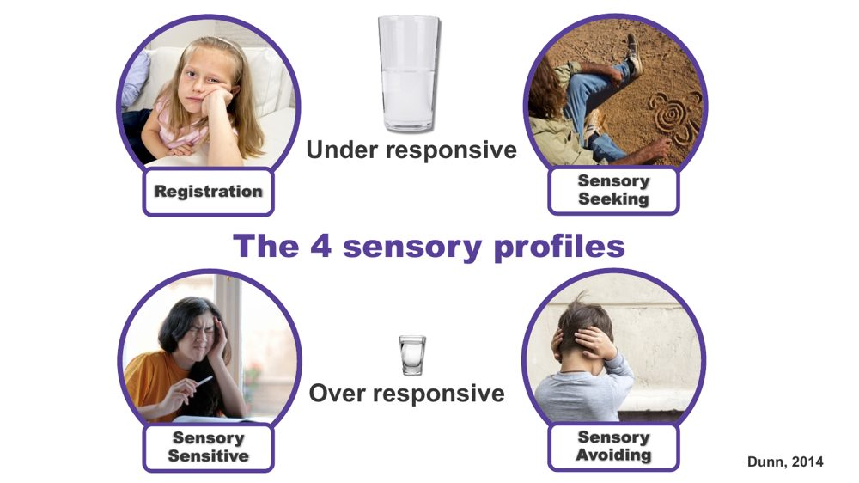 | The 4 sensory profiles  SUGGESTED TIME  3 min  CLOCK  10:02 - 10:05

Introduce four patterns of sensory response as a way to understand a student, not as labels.
WHAT TO DO  - Explain that these are patterns of sensory response, not types of autism.  - Talk through each pattern briefly.  - Name that a student can be seeking in some senses and avoiding in others.  - Mention where educators may meet this framework: occupational therapy reports or a Sensory Profile questionnaire such as the School Companion form. | KEY MESSAGES  - Four patterns: registration, seeking, sensitive, avoiding.  - Students can show different patterns across different senses.  - Patterns can shift with load and context.  - All patterns are the nervous system doing what it needs.  - A sensory profile is not a choice.

YOU MIGHT SAY
Registration (under-responsive): doesn't notice what others notice. May seem to miss cues others respond to.
Sensory seeking: actively looks for more input. Movement, touch, sound. The body asking for what it needs.
Sensory sensitive (over-responsive, passive): notices everything. Distracted, finds busy environments very hard, but does not necessarily act on it.
Sensory avoiding (over-responsive, active): actively works to reduce input. Covers ears, avoids crowds, avoids certain textures.
This is a map, not a label.

KEEP IN MIND
- Treat observations of seeking or avoiding as a starting point for curiosity, not certainty about internal experience.

Background These four profiles are part of a sensory processing framework developed by Professor Winnie Dunn, an occupational therapist at the University of Missouri. The profiles are also called seeker, bystander (registration), avoider and sensor. Everyone has a different comfort level (a different sized cup) for sensory information, and a person may have a different sized cup for different senses, so they can show several profiles. A student may show more than one pattern, and it may shift with the day, the environment or the load they are already carrying. Understanding how sensory differences affect individuals in all environments is critical to supporting success.

SESSION 2 | Understanding Autistic Experience | SLIDE 10 of 23

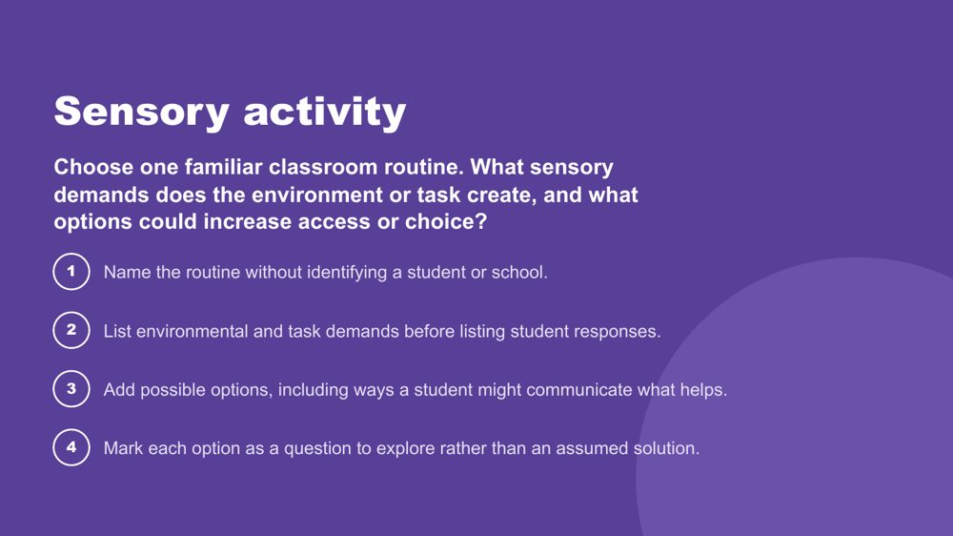 | Sensory activity  SUGGESTED TIME  8 min  CLOCK  10:05 - 10:13  GROUPING  Small groups  PARTICIPANT GUIDE  Page 7 - Sensory activity

Apply an environment-first sensory lens to a familiar classroom routine, without simulating Autistic experience.
WHAT TO DO  - Set up small groups.  - Read the prompt on the slide.  - Run the four steps.  - Ask participants to identify options and choice rather than one support for every student.  - Bring the room back and ask what educators can change, offer or investigate. | KEY MESSAGES  - Look at environmental and task demands before student responses.  - Options are questions to explore, not assumed solutions.

ACTIVITY | Environment-first sensory review small groups · 8 minutes
Choose one familiar classroom routine. What sensory demands does the environment or task create, and what options could increase access or choice?
- Name the routine without identifying a student or school.
- List environmental and task demands before listing student responses.
- Add possible options, including ways a student might communicate what helps.
- Mark each option as a question to explore rather than an assumed solution.
Bring the room back
- What could educators change, offer or investigate before increasing demands on the student?
Close: Ask what educators can change, offer or investigate before increasing demands on the student.

KEEP IN MIND
- Do not run an autism simulation.
- Keep students and schools unidentifiable.
- Treat lighting, sound, movement, proximity, transitions and materials as participant-generated examples, not universal triggers.

SESSION 2 | Understanding Autistic Experience | SLIDE 11 of 23

 | Thinking  SUGGESTED TIME  1 min  CLOCK  10:13 - 10:14

Move from sensory into Autistic thinking.
WHAT TO DO
- Name the shift from how the world arrives to how the mind works with it.
- Remind participants to keep the students they have in mind.

KEEP IN MIND
- Do not present these thinking concepts as universal features of every Autistic student.

SESSION 2 | Understanding Autistic Experience | SLIDE 12 of 23

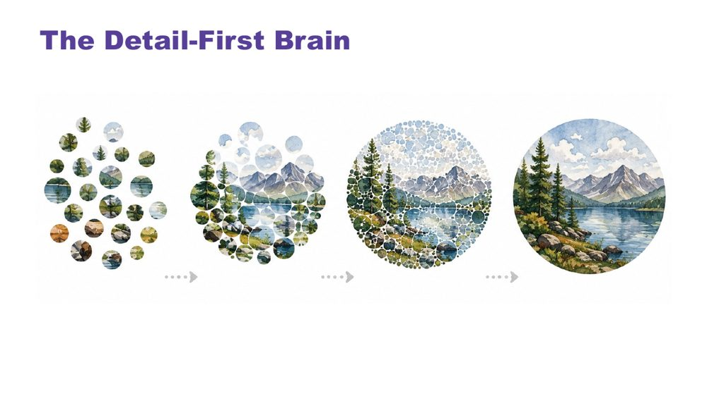 | The Detail-First Brain  SUGGESTED TIME  3 min  CLOCK  10:14 - 10:17  PARTICIPANT GUIDE  Page 8 - Strengths I can see

Introduce bottom-up, detail-first processing and the strengths it produces.
WHAT TO DO  - Open with the contrast between filtering first and taking in what is actually there.  - Name this as bottom-up processing.  - Connect it to sensory intensity, literal language, pattern recognition and deep focus.  - Move through the strengths slowly: pattern recognition, systems thinking, deep memory, logical precision, honesty and directness, depth of connection, intense engagement.  - For each strength, invite the room to connect it to the students they have in mind.  - Invite participants to note strengths for Student A, B and C on p. 8 - Strengths I can see, now or during the thinking discussion. | KEY MESSAGES  - Autistic cognition builds from detail up - bottom-up processing.  - This connects to sensory intensity, literal language, and everything that follows.  - The strengths listed are genuine features, not compensations.  - Educators who leave with vocabulary for these strengths will notice and build on them in the classroom.

YOU MIGHT SAY
Most brains filter first - they predict what is there based on expectation and fill in the rest. The detail-first brain does not filter first. It takes in what is actually there. Then it builds the whole picture from those pieces upward. That is bottom-up processing.
This is the architecture that connects sensory intensity, literal language, pattern recognition, and deep focus. They are not a list of separate Autistic traits. They are features of the same way of taking in the world.
Pattern recognition - where do you see this in class, and in which student?
Deep memory - what does one of them know by heart? Does it look different in another?
Honesty and directness - how does this show up at school?
These are not future potential. They are present now.

KEEP IN MIND
- Some educators may be used to a deficit or "despite" lens ("despite X they can Y"), a consolation prize approach. These are genuine features of how this brain works.
- Avoid turning the content into a deficit list.

Background Bottom-up processing is supported by neuroimaging research showing stronger bottom-up signalling in Autistic brains, with less dominant top-down filtering. The environment is registered more fully, more specifically and less pre-organised before reaching conscious awareness. This produces precision and depth. It also produces load: the same fuller intake that supports pattern recognition can also lead to sensory overload. A student may pick up a tiny change in routine, a background sound, or an inconsistency in what someone said. They are not being pedantic. They are seeing accurately. The educator who names a student's pattern recognition as a strength is doing something meaningful for that student's identity and sense of self, and for how peers see them.

SESSION 2 | Understanding Autistic Experience | SLIDE 13 of 23

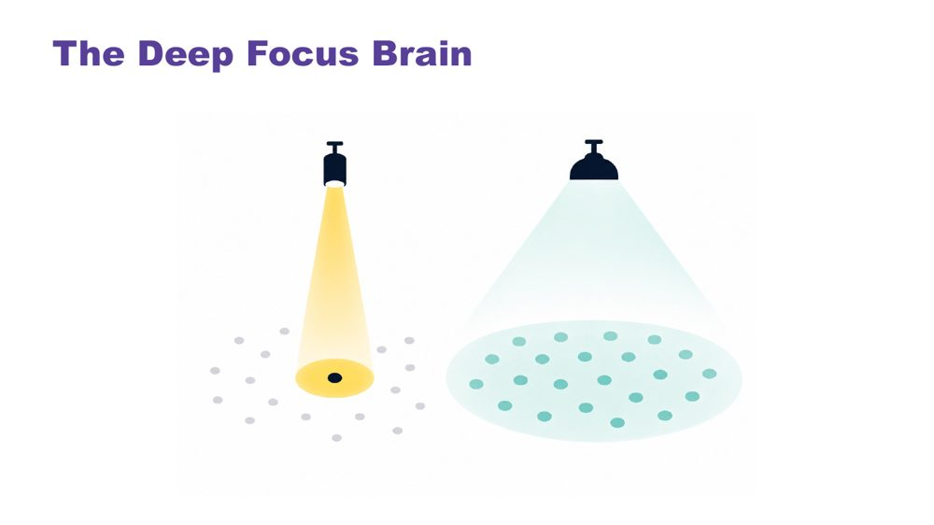 | The Deep Focus Brain  SUGGESTED TIME  3 min  CLOCK  10:17 - 10:20

Introduce monotropism: deep focus, deep interests, transitions and flow.
WHAT TO DO  - Open with a question: do your thoughts travel across many topics, or go deep on one?  - Give the room a moment to reflect.  - Move to the definition, using the visual on the slide.  - Name the key ideas: deep interests, transitions, flow.  - Use the recess example to show the cost of switching. | KEY MESSAGES  - Monotropism: deep focus on fewer things at a time, not distraction or obsession.  - Deep interests are the brain's most reliable route to learning, memory, and genuine engagement.  - Transitions have a real neurological cost - the attention is genuinely invested.  - Flow is the positive expression of this architecture - the brain at its best.  - Developed and extended with Autistic people.

YOU MIGHT SAY
Torch and floodlight: the non-Autistic brain tends to spread attention across many things at once, like a floodlight. The Autistic brain tends to channel it fully into one thing at a time, like a torch beam. Neither is wrong. They illuminate different things.
Tendril theory: the tendrils extend into whatever the mind is focused on. Switching means retracting all of them. That takes time and costs something.
River: the branching river spreads across many channels - broad, covering ground, but shallower in each stream. The single deep river goes all the way in one direction. Neither is wrong. The Autistic thinking brain tends to be the deep river, not scattered, not unfocused, going somewhere completely.
Deep interests are not obsessions or fixations. They are the brain's most natural access to learning, memory, and joy.
Transitions are hard not because the student is being difficult - but because the attention is genuinely, neurologically invested. The river does not change course quickly. With warning and scaffolding this becomes more manageable. The cost is always real.
Flow - full absorption, time disappearing - is this brain at its most powerful. It is worth protecting.
Asking a student absorbed in a construction task, reading about space, drawing or researching a topic they love to stop and pack up for recess is not a simple request. Their attention is fully in that task.

KEEP IN MIND
- Many educators will recognise this in themselves. That is fine to acknowledge, but keep the focus on the students.

Background Monotropism was developed as a framework by Dinah Murray, Mike Lesser and Wenn Lawson, and has been extended by Autistic community voices. It proposes that the core feature of Autistic attention is channelling into fewer things with greater depth, rather than distributing broadly. This explains deep interests, transition difficulty and the experience of flow.
Thread This connects directly to the detail-first brain: the same processing style, one explaining how the world arrives, one explaining where attention goes once it has.
RESOURCES
- Tendril theory comic - https://eisforerin.com/2015/08/10/tendril-theory/

SESSION 2 | Understanding Autistic Experience | SLIDE 14 of 23

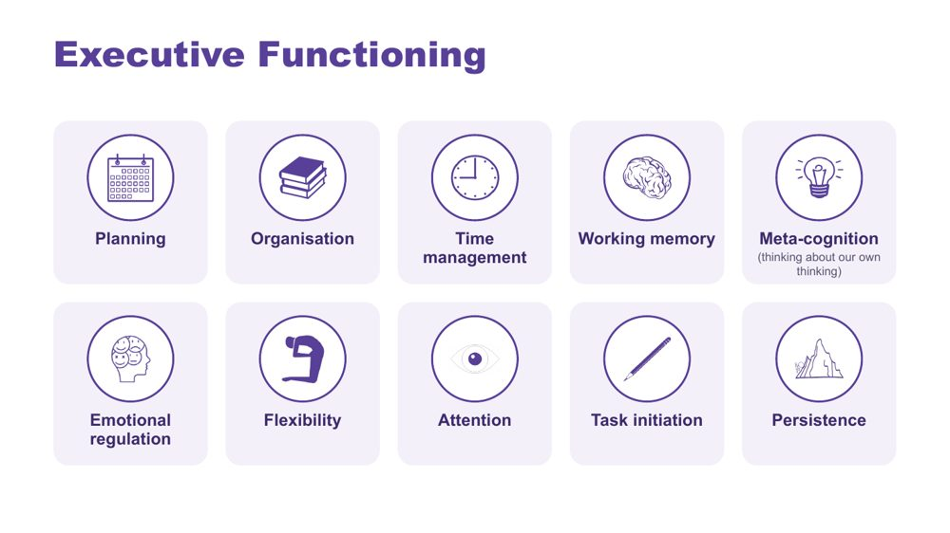 | Executive Functioning  SUGGESTED TIME  2 min  CLOCK  10:20 - 10:22

Name the ten areas of executive functioning and link each to the demands of a school day.
WHAT TO DO  - Name the ten areas on the slide.  - Ask what a task asks the student to plan, start, remember, sequence, organise, switch and complete.  - Ask participants where each area shows up across an ordinary school day for the students they have in mind. | KEY MESSAGES  - The terms are lenses for inquiry, not a checklist.  - Task design, timing and support can affect access.  - Explain each term before applying it.

YOU MIGHT SAY
Useful support responds to the specific demand rather than assuming a lack of effort or motivation. Different demands may need different kinds of support.

KEEP IN MIND
- Consider how instructions, interruptions, switching, starting, sequencing and task completion are organised in the setting, without claiming a single cause.
- Keep the focus on matching support to the individual student and context.

SESSION 2 | Understanding Autistic Experience | SLIDE 15 of 23

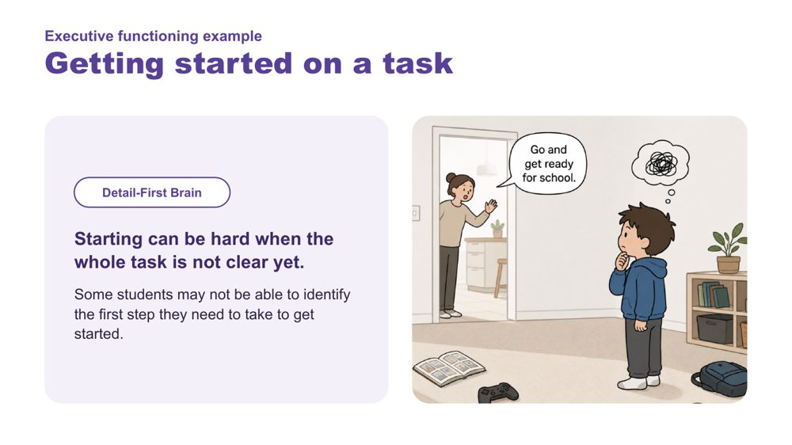 | Executive functioning example: Getting started on a task  SUGGESTED TIME  1 min  CLOCK  10:22 - 10:23

Link the detail-first brain to difficulty getting started.
WHAT TO DO  - Read the example.  - Link it back to the detail-first brain: starting can be hard when the whole task is not clear yet. | KEY MESSAGES  - Some students may not be able to identify the first step they need to take to get started.

SESSION 2 | Understanding Autistic Experience | SLIDE 16 of 23

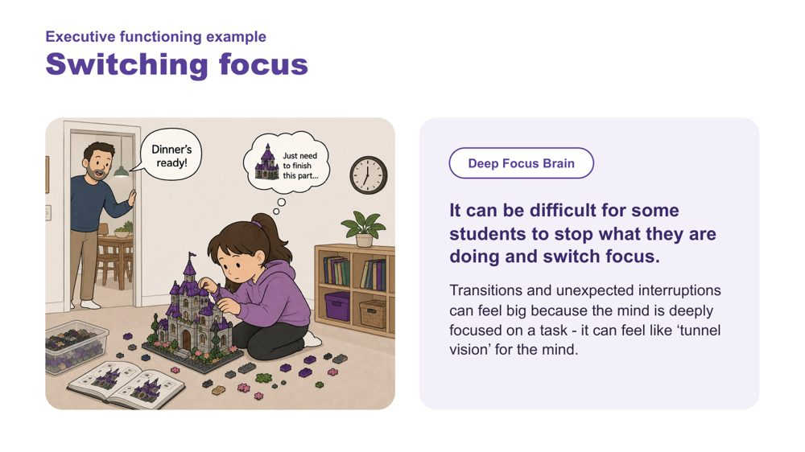 | Executive functioning example: Switching focus  SUGGESTED TIME  1 min  CLOCK  10:23 - 10:24

Link the deep focus brain to difficulty switching focus.
WHAT TO DO  - Read the example.  - Link it back to the deep focus brain and the recess example. | KEY MESSAGES  - Transitions and unexpected interruptions can feel big because the mind is deeply focused on a task - it can feel like 'tunnel vision' for the mind.

SESSION 2 | Understanding Autistic Experience | SLIDE 17 of 23

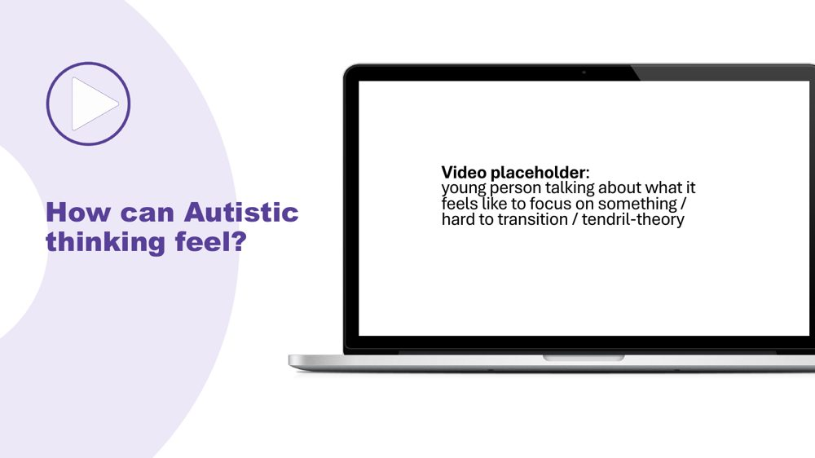 | How can Autistic thinking feel?  SUGGESTED TIME  2 min  CLOCK  10:24 - 10:26

Hear directly from an Autistic young person about deep focus and transitions.
WHAT TO DO  - Play the clip.  - Give a moment before moving on. | KEY MESSAGES  - Hearing from Autistic people directly is a central part of the learning.

Thread Same pattern as the sensory videos: from intellectual understanding to felt recognition.

SESSION 2 | Understanding Autistic Experience | SLIDE 18 of 23

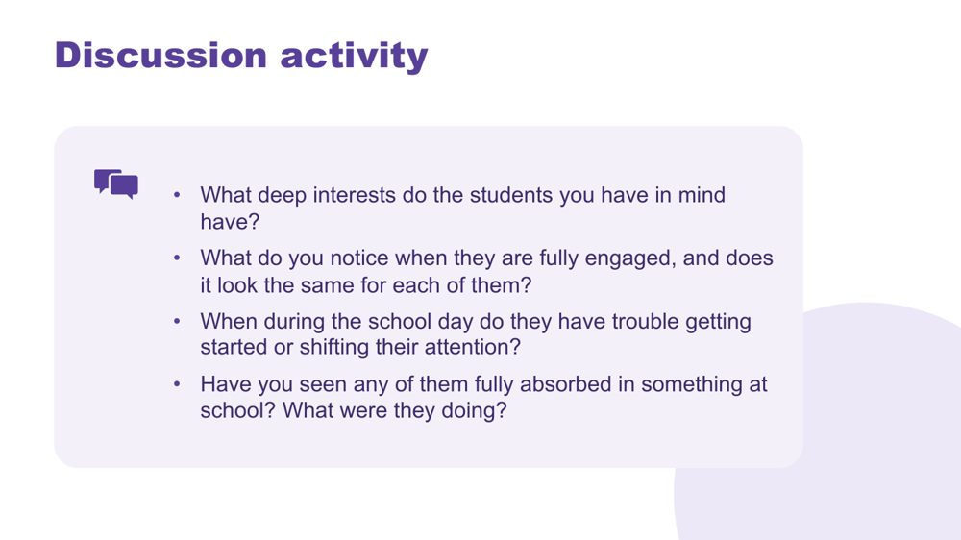 | Thinking discussion  SUGGESTED TIME  9 min  CLOCK  10:26 - 10:35  GROUPING  Pairs  PARTICIPANT GUIDE  Page 8 - Thinking discussion

Consolidate the thinking concepts through personal recognition of the students participants have in mind.
WHAT TO DO  - Direct people to the four questions on the slide.  - Give 8 minutes in pairs.  - Bring the room back and take 2-3 responses.  - Hold the space rather than adding more content.  - Optional extension if time allows: a task-demand review. Ask what a classroom task asks the student to notice, start, hold, switch, sequence or complete. Write the task in neutral language, list its demands in order, mark where the environment or instruction could reduce unnecessary demand, and write one question to explore with the student or team. | KEY MESSAGES  - This activity personalises the concepts: participants move from "I understand this" to "I can see this in the students I have in mind".  - The questions connect to the concepts: deep interests, starting and shifting, and flow.  - Educators who can name these things in a student leave the room with something practical to use in the classroom.  - The activity surfaces strengths alongside challenges: flow and deep interests sit alongside starting and shifting.

YOU MIGHT SAY
Everything you have just described, that IS the thinking brain at work. Noticing it is the beginning of working with it rather than against it.

ACTIVITY | Discussion pairs · 8 minutes
Think about the students you have in mind.
- What deep interests do the students you have in mind have?
- What do you notice when they are fully engaged, and does it look the same for each of them?
- When during the school day do they have trouble getting started or shifting their attention?
- Have you seen any of them fully absorbed in something at school? What were they doing?
Bring the room back
- What came up for people?
Close: Everything you have just described, that IS the thinking brain at work. Noticing it is the beginning of working with it rather than against it.

KEEP IN MIND
- You do not need to comment extensively on each response; the room hearing each other is the consolidation.
- Separate what a task requires from what the student appears to do; avoid inferring internal processes from behaviour alone.

Background The activity follows the same pattern as the sensory activity. The purpose is consolidation through personal recognition, not information transfer. What participants say to each other will likely do more work than the preceding slides.
Thread The last question, flow, sets up a question for Session 3: what happens to that focus when the student tries to communicate or connect?

SESSION 2 | Understanding Autistic Experience | SLIDE 19 of 23

 | Internal signals  SUGGESTED TIME  1 min  CLOCK  10:35 - 10:36

Introduce the final part of the session: what is happening inside.
WHAT TO DO  - Return to interoception, parked earlier in the sensory section.  - Name that internal experience may not be visible to an observer. | KEY MESSAGES  - Internal experience may not be visible to an observer.

Thread Interoception was named with the eight senses; this is where it comes back.

SESSION 2 | Understanding Autistic Experience | SLIDE 20 of 23

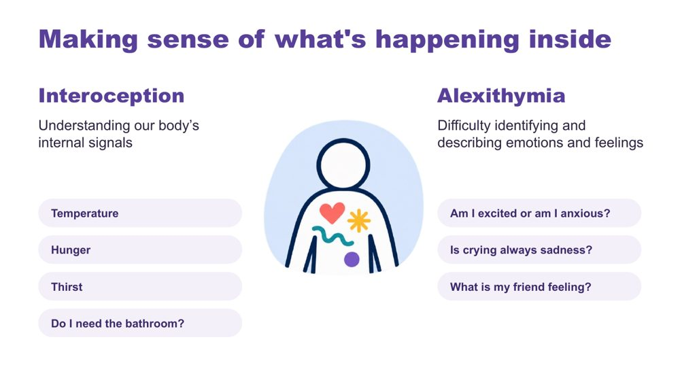 | Making sense of what's happening inside  SUGGESTED TIME  2 min  CLOCK  10:36 - 10:38

Introduce interoception and alexithymia using the examples on the slide.
WHAT TO DO  - Introduce interoception: understanding our body's internal signals (temperature, hunger, thirst, needing the bathroom).  - Introduce alexithymia: difficulty identifying and describing emotions and feelings.  - Use the slide's questions as examples: Am I excited or am I anxious? Is crying always sadness? What is my friend feeling? | KEY MESSAGES  - Interoception helps answer the question "how am I doing?"  - Internal experience may not be visible to an observer.

KEEP IN MIND
- Name interoception and alexithymia without improvising definitions.
- Do not assume a student's internal state from outward behaviour.

Background Interoception is needed for knowing when to go to the toilet; knowing when you are tired, hungry or thirsty; knowing if you are hot or cold; being aware that you are becoming angry or upset. It plays a part in being able to self-regulate.

SESSION 2 | Understanding Autistic Experience | SLIDE 21 of 23

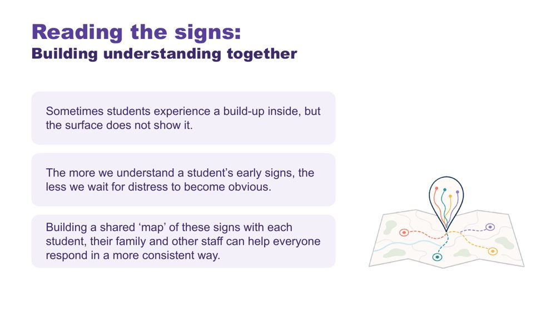 | Reading the signs: building understanding together  SUGGESTED TIME  2 min  CLOCK  10:38 - 10:40

Show why understanding a student's early signs, together, matters.
WHAT TO DO  - Read the three points on the slide.  - Name who builds the shared map: each student, their family and other staff. | KEY MESSAGES  - Sometimes students experience a build-up inside, but the surface does not show it.  - The more we understand a student's early signs, the less we wait for distress to become obvious.  - A shared map of signs helps everyone respond in a more consistent way.

KEEP IN MIND
- Analogies and observations support discussion but do not replace the student's own communication.

SESSION 2 | Understanding Autistic Experience | SLIDE 22 of 23

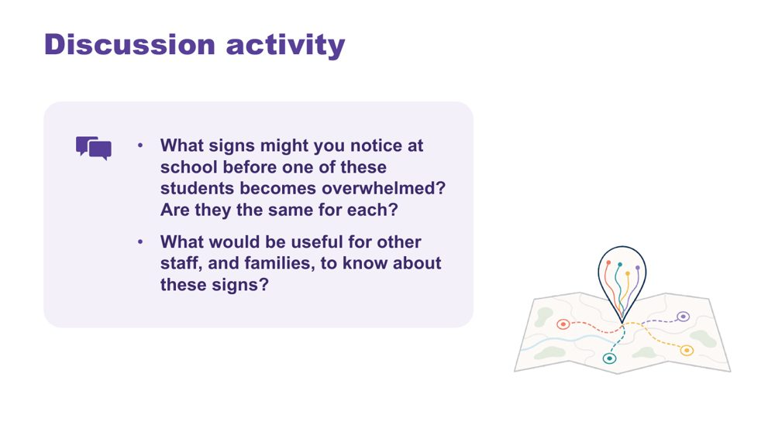 | Reading the signs discussion  SUGGESTED TIME  4 min  CLOCK  10:40 - 10:44  GROUPING  Pairs  PARTICIPANT GUIDE  Page 9 - Reading the signs

Help participants think about early signs of overwhelm at school and who needs to know them.
WHAT TO DO  - Read the two questions on the slide.  - Give pairs a few minutes.  - Take one or two responses. | KEY MESSAGES  - Signs may differ between students.  - Families and other staff are part of reading the signs.

ACTIVITY | Discussion pairs · 3 minutes
What signs might you notice at school before one of these students becomes overwhelmed? Are they the same for each?
- Note the signs you might see at school for each of the students you have in mind.
- Compare: are they the same for each?
- Discuss what would be useful for other staff, and families, to know about these signs.
Bring the room back
- What would be useful for other staff, and families, to know about these signs?

KEEP IN MIND
- Do not assume a student's internal state from outward behaviour.
- Use initials or roles only.

Thread Invite participants to consider how students can communicate capacity and what the environment can do with that information. This sets up the partnership work in Session 5.

SESSION 2 | Understanding Autistic Experience | SLIDE 23 of 23

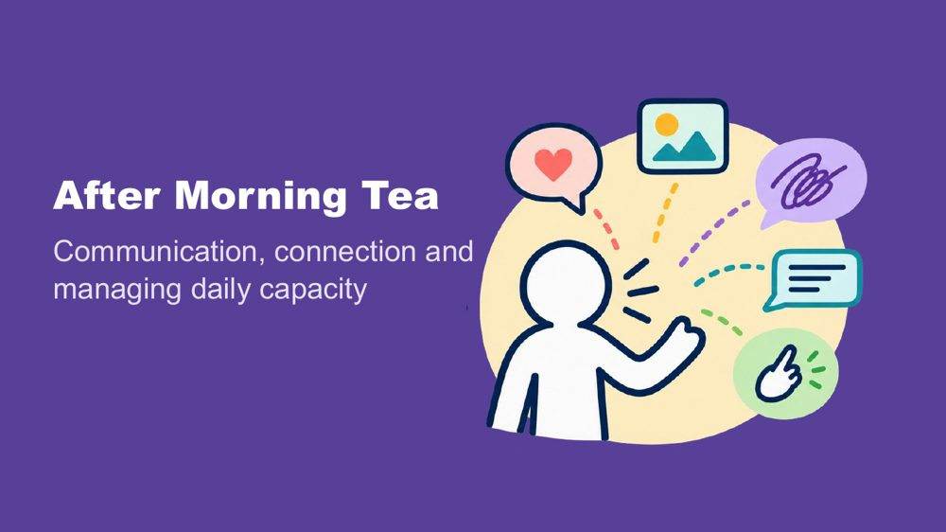 | After Morning Tea  SUGGESTED TIME  1 min  CLOCK  10:44 - 10:45

Close Session 2, confirm the tea break and preview what comes next.
WHAT TO DO  - Confirm the tea break (10:45 - 11:00).  - Preview Session 3: communication, connection and managing daily capacity across a school day. | KEY MESSAGES  - The next session maps demand and capacity through a school day.

SESSION  3 | 11:00 - 12:30 · 90 MINUTES · 26 SLIDES  Autistic Experience at School  Communication, Connection and Identity

SESSION INTENT
Connect communication, connection, capacity, masking, identity and belonging to the school day, then widen the lens to the school as a whole. Participants map a school day as the students they have in mind experience it, look for patterns across the school, consider their Autistic staff, audit one school-level routine or process and choose a focus to carry into design after lunch.
PARTICIPANTS LEAVE WITH
- recognise that communication is multimodal and that how much a student speaks does not show how much they understand
- use double empathy to ask whose expectations shape an interaction, and name school practices that favour one way of connecting
- map a school day, including whole-school routines, marking what costs, what lightens and what is not yet known, and look for patterns across the school
- consider how the same thinking about load, predictability and communication applies to Autistic staff, without inviting disclosure
- audit one school-level routine or process and choose one thing to keep, reduce and explore in Session 4

RUN SHEET
Clock | Segment | Slides | Minutes
11:00 - 11:02 | Welcome back | 1 | 2
11:02 - 11:25 | Communication | 2-9 | 23
11:25 - 11:38 | Connection and double empathy | 10-13 | 13
11:38 - 11:43 | Managing daily capacity | 14-16 | 5
11:43 - 11:58 | Map the school day: costs, lightens and patterns | 17-19 | 15
11:58 - 12:08 | Masking | 20-22 | 10
12:08 - 12:13 | Your Autistic staff | 23 | 5
12:13 - 12:27 | Audit at school level and carry into design | 24-25 | 14
12:27 - 12:30 | Close: positive Autistic identity | 26 | 3

PREPARE
☐ Participant Guide for every participant (pages 11 to 16)
☐ Purple, blue and orange Post-it notes on each table, and wall space to group them by colour
☐ Communication experiences video and masking video cued, with captions and a transcript
☐ Pens in at least two colours for the day map
☐ Optional: participants have their school's bell times or weekly timetable to hand
☐ Carry into design card: one per participant, if using the printed card as well as p. 16
☐ Closing image for slide 26 in place

SESSION 3 | Autistic Experience at School | SLIDE 1 of 26

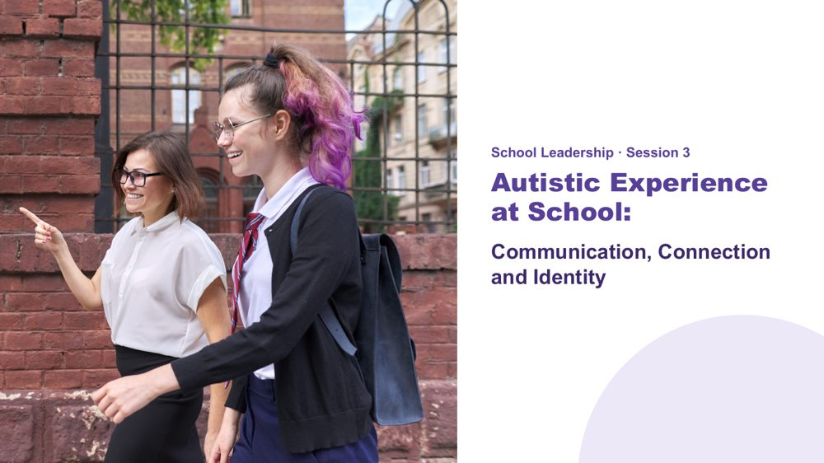 | Autistic Experience at School  SUGGESTED TIME  2 min  CLOCK  11:00 - 11:02  PARTICIPANT GUIDE  Page 10 - Session 3 summary

Welcome participants back and introduce communication, connection and capacity across the school day, seen from a school leadership position.
WHAT TO DO  - Welcome participants back from the break.  - Ask participants to bring back the two or three students they have in mind.  - Explain that the session starts with communication and connection, follows the school day as students experience it, then widens to patterns across the school, your Autistic staff and a school-level audit.  - Name the leadership lens: this session looks at the school conditions that shape each student's day.  - Ask participants to keep observations separate from assumptions and not to name a school, student or staff member. | KEY MESSAGES  - The school day is experienced through more than the timetable.  - Communication, connection, demand and belonging interact across the day.  - Leaders can use one student's experience to ask wider questions without treating that student as representative of everyone.

Thread Builds on the picture of the students started in Sessions 1 and 2, and leads into the school design work in Session 4 after lunch.

SESSION 3 | Autistic Experience at School | SLIDE 2 of 26

 | Communication  SUGGESTED TIME  1 min  CLOCK  11:02 - 11:03

Open the communication section.
WHAT TO DO  - Introduce the communication section: multimodal communication, understanding and expressing, and AAC.  - Set the frame: speech is not the only valid way to communicate, and the amount of speech does not tell us how much a student understands. | KEY MESSAGES  - Communication access belongs in school design and school systems.  - Students may need different ways to understand, respond, ask, pause or decline.  - Keep explanations practical and refer specialist questions through the appropriate channel.

KEEP IN MIND
- Use examples from both primary and secondary settings.
- Avoid presenting one communication approach as suitable for every student.

SESSION 3 | Autistic Experience at School | SLIDE 3 of 26

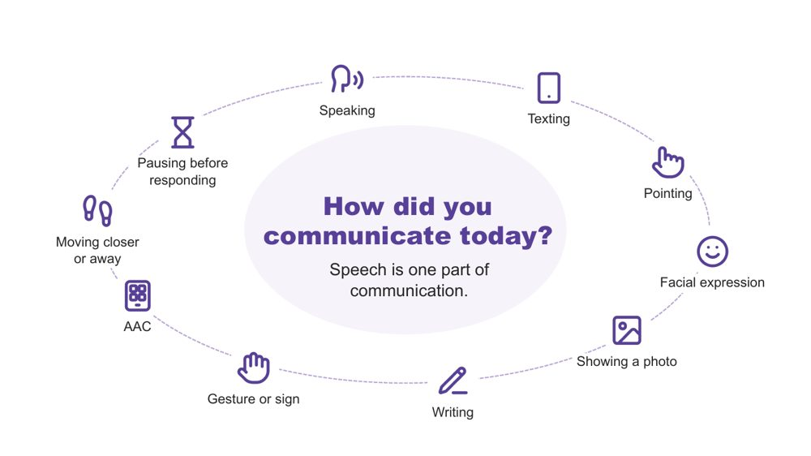 | How did you communicate today?  SUGGESTED TIME  2 min  CLOCK  11:03 - 11:05

A quick warm-up showing that everyone communicates in many ways, every day.
WHAT TO DO  - Invite a quiet think: three ways participants have communicated since waking.  - Pause for about 20 seconds.  - Invite two or three people to share one. Sharing is optional.  - Reflect back the variety you hear, for example a text message, a wave, a look, or taking a moment before answering. | KEY MESSAGES  - Everyone communicates in many ways, every day. Speech is one part of communication.

YOU MIGHT SAY
Let's start with a quick, quiet think. Since you woke up this morning, how have you communicated? See if you can think of three different ways.
Would two or three people be happy to share one?
We all move between different ways of communicating, often without noticing. Every way on this slide is real communication. No way is more valid than another.

KEEP IN MIND
- Keep this brief (1 - 1.5 minutes). It is a warm-up, not a discussion.
- Do not use percentages or claims about how much of communication is spoken or non-spoken.

Background Many students hear "use your words" at school. This is a gentle reframe for educators: pointing, a device, a look or moving away are all ways of communicating.

SESSION 3 | Autistic Experience at School | SLIDE 4 of 26

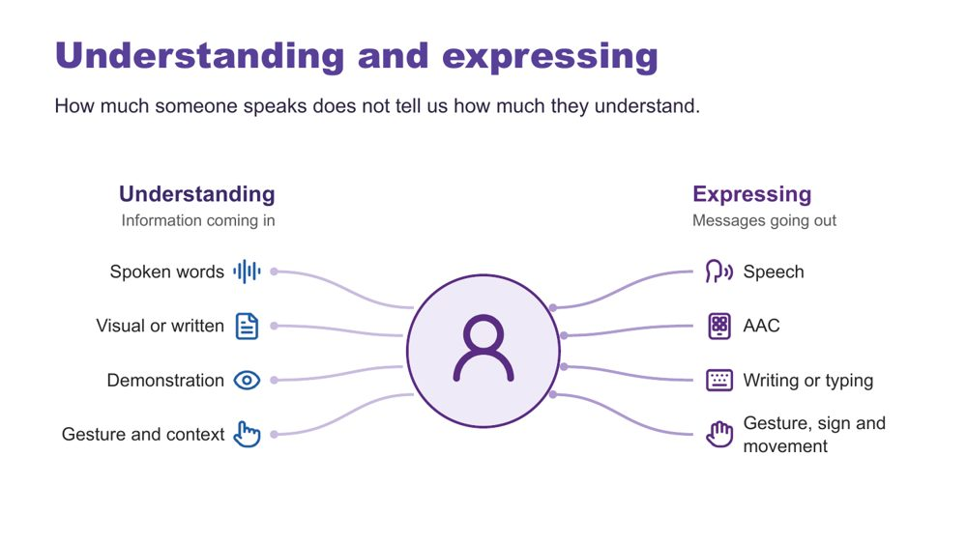 | Understanding and expressing  SUGGESTED TIME  2 min  CLOCK  11:05 - 11:07

Separate understanding (receptive) from expressing (expressive) communication.
WHAT TO DO  - Explain that Autistic people have varied communication profiles.  - Name that someone may express a great deal but need support to understand spoken information, and someone else may understand more than they can easily express.  - Note that communication can change depending on the person, place, demands and how someone is feeling.  - Give the plain AAC explanation.  - Ask what communication access the environment and task provide, and where school routines, documents or expectations assume speech is the standard. | KEY MESSAGES  - How much someone speaks does not tell us how much they understand.  - Do not assume fluent speech means full understanding. Do not assume limited speech means limited understanding.  - Expressive and receptive communication do not necessarily look the same.

KEEP IN MIND
- Do not teach gestalt language processing (GLP) or Natural Language Acquisition stages here. It is background only.
- Do not ask participants to identify or diagnose a student as a gestalt language processor.
- Refer individual assessment or intervention questions to the student's speech pathologist or relevant team.

Background Receptive communication means how a person receives and makes sense of information. At school this includes teacher instructions, questions, class discussion, assembly announcements, playground or yard language, notes home, changes to routines and information about what is happening next. Expressive communication means how a person shares messages, ideas, feelings and choices through any communication method. AAC (augmentative and alternative communication) may include gesture, signs, a communication board or book, typing or a communication device; some people use it alongside speech and some instead of speech. Echolalia means repeating words or phrases, immediately or later, and can have communicative meaning. Gestalt language processing is a term used in a proposed account of learning language through larger phrases or chunks; the two terms are not interchangeable. Hutchins et al. (2024) question the evidence for these categories and stages. This does not diminish the value of repeated or scripted language: consider the possible context, intent and meaning, listen before correcting the form, and notice when and where it occurs and what follows. A student does not need a GLP label before their communication is respected or supported.
RESOURCES
- Hutchins et al. (2024) - https://doi.org/10.1177/23969415241249944

SESSION 3 | Autistic Experience at School | SLIDE 5 of 26

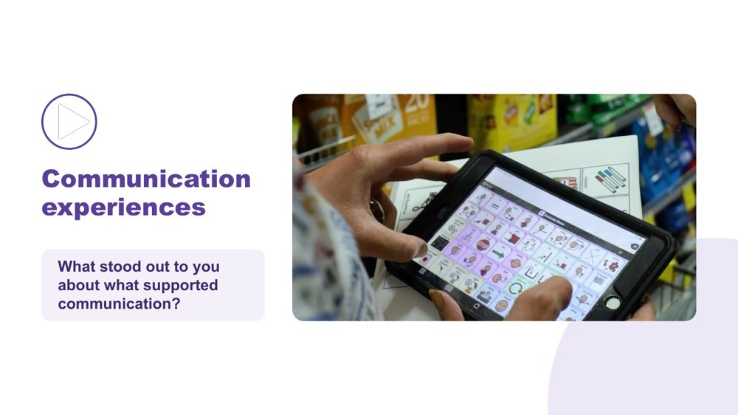 | Communication experiences  SUGGESTED TIME  4 min  CLOCK  11:07 - 11:11  GROUPING  Whole room

Hear Autistic people describe what helps them communicate.
WHAT TO DO  - Check captions are switched on.  - Read the prompt: "As you watch, notice what supports communication. Choose one idea that stands out to you."  - Play the video (around 2.5 minutes).  - Click once to reveal the question.  - Take one response, or two if time allows.  - Use the optional prompts only if the room is quiet. | KEY MESSAGES  - There is no single Autistic communication profile. Autistic people describe what helps them communicate in many different ways.  - A student's AAC needs to be available where communication happens, not only during a specific activity or therapy session.

YOU MIGHT SAY
As you watch, notice what supports communication. Choose one idea that stands out to you.
What stood out to you about what supported communication?

ACTIVITY | Video and brief whole-room response whole room · 4 minutes
What stood out to you about what supported communication?
- Watch the clip.
- Take one or two responses.
Bring the room back
- What communication strengths did you notice?
- What did another person do that helped?
- What difference did the environment or available communication method make?

KEEP IN MIND
- Let the voices in the video lead. Avoid summarising or generalising what speakers said.
- Use accurate, edited captions (not auto-generated only) and have a transcript available.
- If the video is set to play on click, the question appears on the following click.

Background AAC adds to or provides an alternative to speech. At school this may include signs, communication boards or books and speech-generating devices, and it may be used alongside speech. The school's role is not to assess or prescribe AAC. The focus for leaders is making sure AAC is available, understood and respected across staff, places and routines, recognising and supporting the student's ways of communicating and working with the student, family and relevant team.

SESSION 3 | Autistic Experience at School | SLIDE 6 of 26

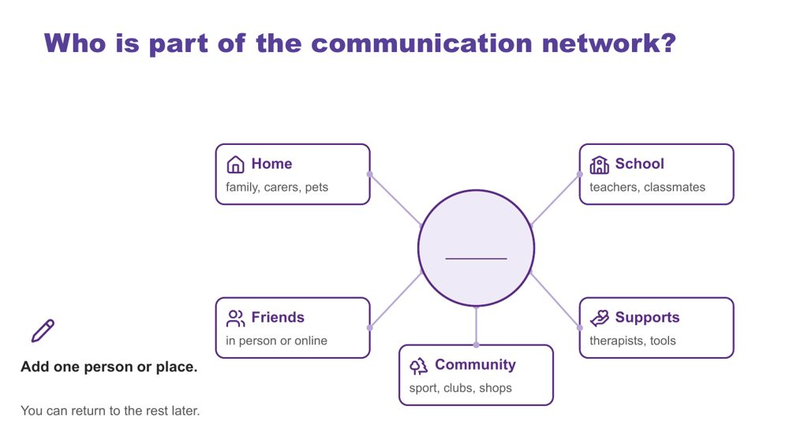 | Who is part of the communication network?  SUGGESTED TIME  3 min  CLOCK  11:11 - 11:14  GROUPING  On your own  PARTICIPANT GUIDE  Page 11 - Who is part of the communication network?

Map the people and places around one of the students participants have in mind.
WHAT TO DO  - Ask participants to put one of the students they have in mind in the centre of page 11 of the Participant Guide or a sheet of paper.  - Invite them to add one person or place, using roles rather than names.  - Allow about 1.5 minutes of quiet time.  - Offer to write for anyone who would like help.  - Share the points below while people write. | KEY MESSAGES  - Students communicate with many people in many places. Each person, at school and beyond, may see a different part of the communication picture.

YOU MIGHT SAY
Use your Participant Guide or a sheet of paper. Put one of the students you have in mind in the centre. Around them are home, school, friends, community and supports.
Think about who is part of this student's communication network. Use roles rather than names. Add one person or place now. You can return to the rest later.
You can write roles, draw or use dot points.

ACTIVITY | Quiet individual mapping on your own · about 1.5 minutes of writing
Who is part of this student's communication network? Add one person or place.
- Place the student in the centre.
- Add one person or place around home, school, friends, community or supports.
- Use roles, not names.
Close: You can return to the rest later.

KEEP IN MIND
- Networks can be small or changing. Normalise empty boxes.
- Keep the student anonymised. Use roles, not names.
- This activity is not about deciding who understands the student best.

Background You do not need to complete every box. A box can hold many people, one person, or nobody yet. Different people may see different parts of the student's communication, and the network may look very different for another of the students. A classroom teacher, a support worker, a specialist teacher and a parent may each notice something different. The parts of the network participants know little about are questions to explore with the student and their family.

SESSION 3 | Autistic Experience at School | SLIDE 7 of 26

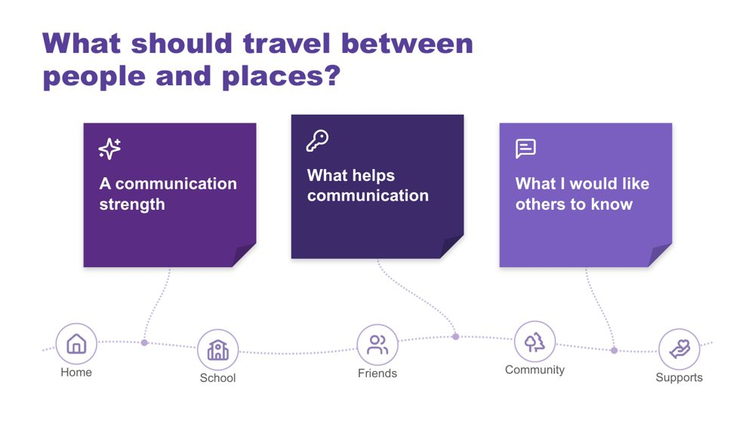 | What should travel between people and places?  SUGGESTED TIME  6 min  CLOCK  11:14 - 11:20  GROUPING  On your own  PARTICIPANT GUIDE  Page 11 - What should travel between people and places?

Name what a student's communication partners need to know so the student does not have to start again with every new person.
WHAT TO DO  - Check purple, blue and orange Post-it notes are on each table and a wall or board space is ready.  - Explain the colours.  - Allow about 3 minutes of writing.  - Invite optional sharing for about 3 minutes: add a note to the board or read one out.  - Group notes on the board by colour.  - Ask what school systems help this information travel, and notice themes on the blue notes. You will return to them on the next slide. | KEY MESSAGES  - Educators, families and specialists each hold valuable knowledge about a student's communication.  - When that knowledge travels between classrooms, specialist lessons, the playground, relief teachers and home, students do not have to start again with every new person.  - Leaders decide whether this knowledge travels by chance or through a system, such as student profiles, handover notes and relief-day information.

YOU MIGHT SAY
Let's think about what should travel with one of the students you have in mind between people and places.
Purple is a communication strength. Blue is something that helps communication. Orange is something you would like others to know.
You can write one note, two or all three. You can use one of the students you have in mind, anonymised, or a made-up example. You can keep your notes private if you prefer.
If you are comfortable, add a note to the board or read one out.

ACTIVITY | Colour-coded Post-it notes with optional sharing on your own · 6 minutes (about 3 writing, about 3 sharing)
What should travel with this student between people and places?
- Purple: a communication strength.
- Blue: something that helps communication.
- Orange: something you would like others to know.
- Write one, two or all three notes.
- Add to the board or read one out, if comfortable.
Bring the room back
- What similarities do you notice?
- What strengths might be missed if we look only for speech?
- What information would help a relief teacher, a specialist teacher or yard duty staff?
- What system in your school carries this information now, and where does it rely on one person remembering?
Close: Notice the themes on the blue notes and carry them into the next slide.

KEEP IN MIND
- Do not ask individuals to share. Sharing is optional.
- Thank every contribution without ranking it.
- If a note names a child or school, invite the writer to keep it.

SESSION 3 | Autistic Experience at School | SLIDE 8 of 26

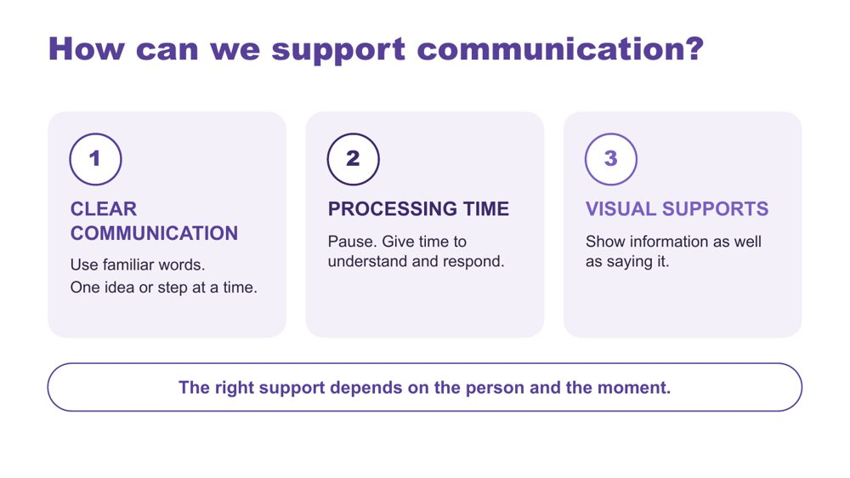 | How can we support communication?  SUGGESTED TIME  3 min  CLOCK  11:20 - 11:23

Introduce three ways to support communication across the school day.
WHAT TO DO  - Link back to the themes on the blue notes.  - Walk through the three strategies on the slide. | KEY MESSAGES  - The right support depends on the person and the moment.  - When these supports are expected across the school, students do not depend on one staff member to provide them.

YOU MIGHT SAY
There are three strategies we can use. Clear communication means using familiar words and giving one idea or step at a time. Processing time means pausing so the person has time to understand and respond. Visual supports mean showing information as well as saying it. Let's look at what these can look like.

KEEP IN MIND
- These are options to match to the person, not a checklist or a guarantee.
- Avoid filling every pause with more words.
- Keep AAC available and allow responses through the person's preferred methods, including refusal.

Background Processing time is time to make sense of information, organise a response and communicate it. Clear communication means familiar, specific language in a form and amount the person can access. Communication partner guidance includes adapting language and allowing response time, and AAC guidance also includes visual supports and access across settings (ASHA, n.d.; Brady et al., 2016). There is no activity on this slide.
RESOURCES
- ASHA (n.d.) - full reference in the facilitator guide references
- Brady et al. (2016) - full reference in the facilitator guide references

SESSION 3 | Autistic Experience at School | SLIDE 9 of 26

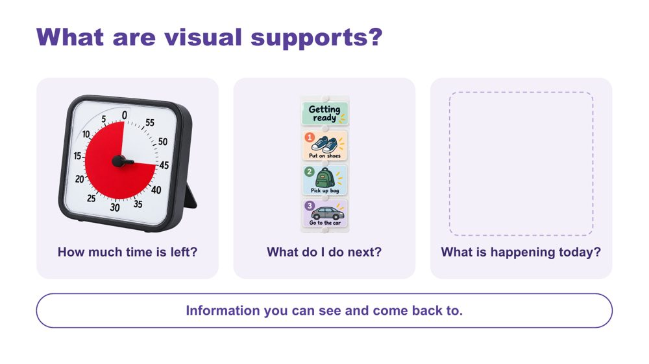 | What are visual supports?  SUGGESTED TIME  2 min  CLOCK  11:23 - 11:25

Help educators recognise what visual supports are through familiar examples.
WHAT TO DO  - Walk through the three examples: a timer, a sequence, a daily schedule.  - If time allows, ask the optional question and take one brief example. | KEY MESSAGES  - Visual supports are information you can see and come back to.  - A visual support offers information, not a condition for access to a preferred activity.

YOU MIGHT SAY
Visual supports help make information clear. They give us something to look at and come back to. This timer shows how much time is left. A sequence shows what to do next. A daily schedule shows what is happening today. You might already use a calendar, shopping list or reminder on your phone. The useful format will be different for each person.
Where is visual information already used across your school, for example in timetables, signage, assemblies or notices home?

KEEP IN MIND
- This is an introduction, not another task to complete.
- These images illustrate formats, not recommended products.
- Visual supports and AAC can overlap, but they are not interchangeable. Keep the person's communication methods available.
- Use the evidence to explain options, not to promise the same result for every person.

Background Visual supports can include objects, real photos, written words or symbols, on paper or a device. Check that the person understands the information and can access it when needed. The written sequence is an example of accessible information, not a test of compliance. Match the format to the person and invite their preferences. Optional prompts: What information would help each of these students? What format makes sense to them? Where could it stay available?
Thread Session 4 returns to visual supports and predictability as design options for the whole school.
RESOURCES
- Avery et al. (2025) - review of caregiver-implemented visual supports; full reference in the facilitator guide references
- ASHA AAC Practice Portal - visual schedules and other visual supports; full reference in the facilitator guide references

SESSION 3 | Autistic Experience at School | SLIDE 10 of 26

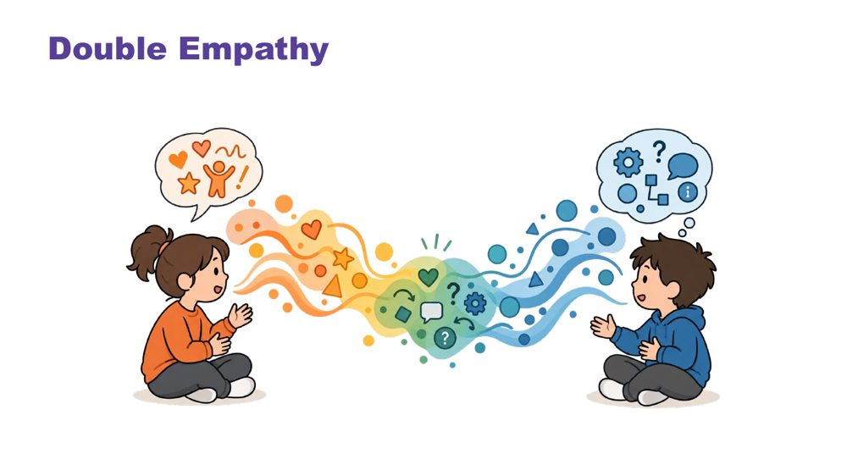 | Double empathy  SUGGESTED TIME  4 min  CLOCK  11:25 - 11:29

Explore interaction and connection without treating one social style as the standard.
WHAT TO DO  - Explain double empathy: when people have different experiences and ways of communicating, understanding one another can be more difficult in both directions.  - Ask whose expectations shape an interaction and what would make connection safer or clearer.  - Consider the expectations operating in class discussion, group work, assemblies, the playground or yard, and interactions with adults and peers.  - Ask leaders which school practices favour one social style, for example how groups are formed, what is recognised at assemblies or what counts as participation.  - Use "how each student connects" throughout the discussion. | KEY MESSAGES  - Connection does not need to look one way.  - Interaction is shaped by expectations and context as well as by the student.  - Social misunderstanding does not automatically sit within the Autistic student.  - Leaders can examine which social expectations are built into school practice.

YOU MIGHT SAY
Whose expectations are shaping this interaction?

KEEP IN MIND
- Move away from locating every social misunderstanding within the Autistic student.

SESSION 3 | Autistic Experience at School | SLIDE 11 of 26

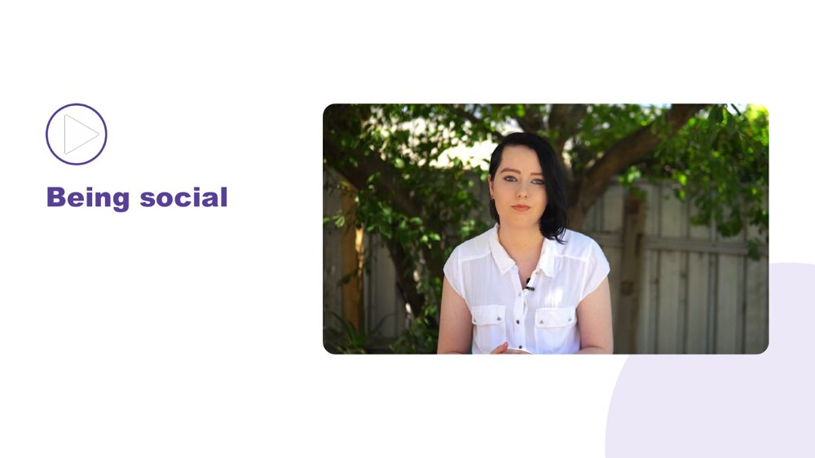 | Being social  SUGGESTED TIME  2 min  CLOCK  11:29 - 11:31

Open the section on how each student connects.
WHAT TO DO  - Introduce the move from double empathy to the many ways students connect.  - Invite participants to notice preferred people, places, activities and ways of joining without interpreting difference as absence of connection. | KEY MESSAGES  - Connection does not need to look one way.

SESSION 3 | Autistic Experience at School | SLIDE 12 of 26

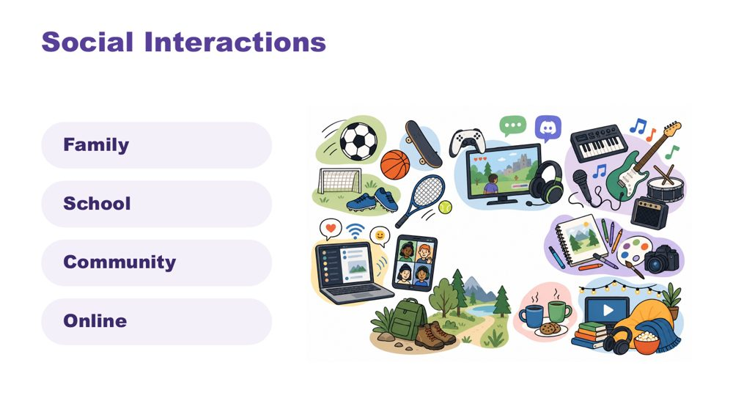 | Social interactions  SUGGESTED TIME  2 min  CLOCK  11:31 - 11:33

Widen the picture of how students interact, across family, school, community and online.
WHAT TO DO  - Identify a range of ways a student may interact, for example 1:1, parallel play or engagement, info dumping, irregular contact.  - Make connections to culture.  - Name in-person, online and third spaces without making assumptions about a student's communities. | KEY MESSAGES  - Connection can occur in person, online and in third spaces, and each student's experience is individual.

KEEP IN MIND
- Do not ask participants to disclose a student's online activity, identity or community membership.

SESSION 3 | Autistic Experience at School | SLIDE 13 of 26

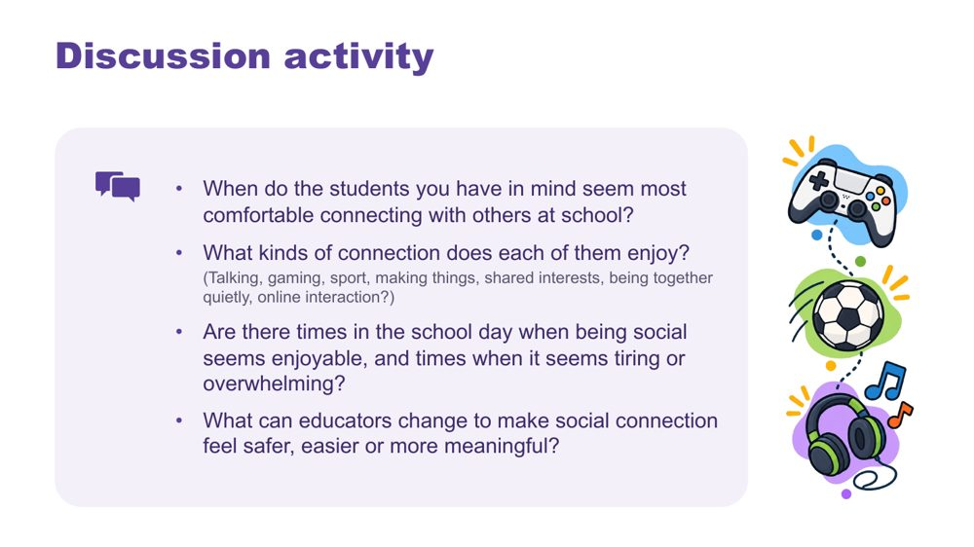 | Discussion activity: connection  SUGGESTED TIME  5 min  CLOCK  11:33 - 11:38  GROUPING  Pairs  PARTICIPANT GUIDE  Page 12 - Connection discussion

Apply the ideas of connection to the students participants have in mind.
WHAT TO DO  - Put participants in pairs.  - Work through the four questions on the slide.  - Bring the room back and take a few responses, focusing on what the school can change. | KEY MESSAGES  - Connection does not need to look one way.  - What educators change around a student can make social connection feel safer, easier or more meaningful.

ACTIVITY | Guided discussion pairs · about 4 minutes
When do the students you have in mind seem most comfortable connecting with others at school?
- When do the students you have in mind seem most comfortable connecting with others at school?
- What kinds of connection does each of them enjoy? (Talking, gaming, sport, making things, shared interests, being together quietly, online interaction?)
- Are there times in the school day when being social seems enjoyable, and times when it seems tiring or overwhelming?
- What can educators change to make social connection feel safer, easier or more meaningful?
Bring the room back
- What could the school change to make social connection feel safer, easier or more meaningful, for example lunchtime clubs, a quiet space at break or how groups are formed?

KEEP IN MIND
- Do not ask participants to disclose a student's online activity, identity or community membership.
- Avoid interpreting difference as absence of connection.

SESSION 3 | Autistic Experience at School | SLIDE 14 of 26

 | Managing daily capacity  SUGGESTED TIME  1 min  CLOCK  11:38 - 11:39

Open the section on energy and capacity across the day.
WHAT TO DO
- Introduce the move from connection to how much energy the school day takes.

Thread Capacity language (battery, spoons) returns on the day map as what costs and what lightens.

SESSION 3 | Autistic Experience at School | SLIDE 15 of 26

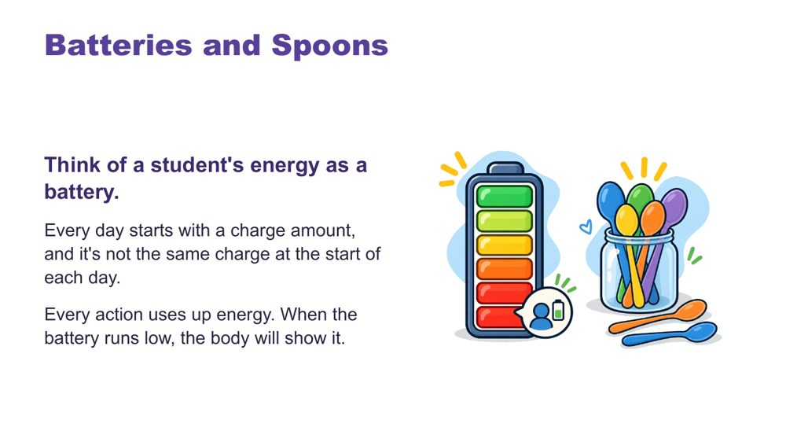 | Batteries and spoons  SUGGESTED TIME  2 min  CLOCK  11:39 - 11:41

Give a shared language for energy and capacity.
WHAT TO DO  - Talk through the battery image.  - Introduce spoons as language many in the Autistic community use.  - Close on recharging: the right supports can restore some capacity. | KEY MESSAGES  - Each day starts with a different charge.  - The right supports can recharge.

YOU MIGHT SAY
Think of a student's energy as a battery. Every day starts with a charge amount, and it's not the same charge at the start of each day. Every action uses up energy. When the battery runs low, the body will show it.
In the Autistic community, many like to describe this as having a set of spoons. Each action uses up one or some spoons. When "spoons are low", actions are hard to manage.
You can recharge! The right supports can regain some battery charge or extra spoons.

SESSION 3 | Autistic Experience at School | SLIDE 16 of 26

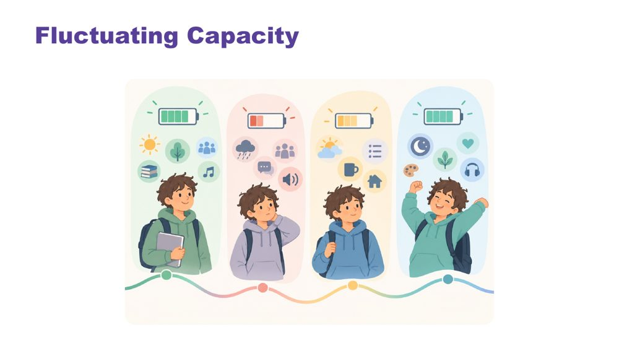 | Fluctuating capacity  SUGGESTED TIME  2 min  CLOCK  11:41 - 11:43

Name that capacity changes from day to day.
WHAT TO DO  - Explain that capacity changes with stress, energy, sensory demands and what else is happening. | KEY MESSAGES  - Capacity is not fixed. The same student may manage something one day and not the next.

YOU MIGHT SAY
Like all people, Autistic students have good days and harder days. Their ability to manage school, social situations, communication, or daily tasks may change depending on stress, energy levels, sensory demands, and what else is happening in their life.

SESSION 3 | Autistic Experience at School | SLIDE 17 of 26

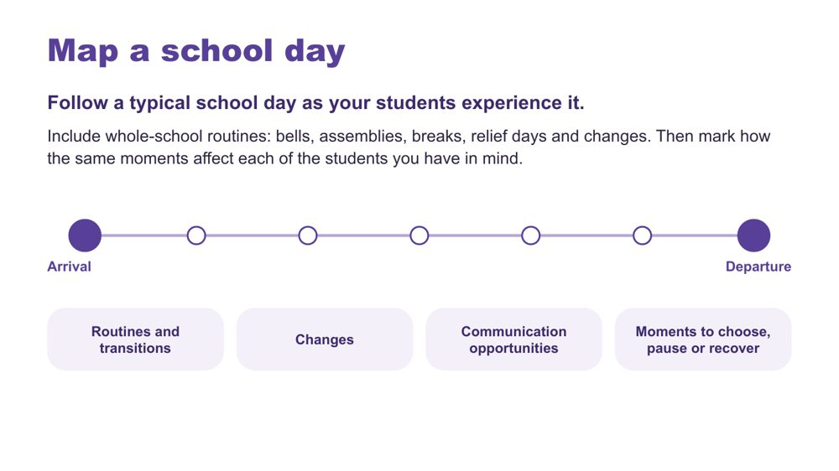 | Map a school day  SUGGESTED TIME  8 min  CLOCK  11:43 - 11:51  GROUPING  On your own  PARTICIPANT GUIDE  Page 13 - Map a school day

Build a map of the school day as students experience it, including whole-school routines, then look for patterns across the school.
WHAT TO DO  - Ask participants to follow a typical school day as the students they have in mind experience it, from arrival to departure.  - Ask them to include whole-school routines: bells, assemblies, recess and lunch, relief days and changes. In a primary school this may include specialist lessons and the playground; in a secondary school, moving between rooms and teachers each period.  - Ask them to mark how the same moments affect each of the students they have in mind, using the marks on page 13: R routine or transition, C change, T communication opportunity, P moment to choose, pause or recover.  - Encourage them to follow the students' experience rather than copying the official timetable.  - Link to capacity from the previous slides.  - Then add the leadership lens: step back and ask where signals cluster across the school by period, day or term.  - Leave room to add costs and lighteners on the next slide. | KEY MESSAGES  - The map is a working picture to extend, not a judgement of the student or school.  - Patterns across the school help leaders decide where to look at design.  - The bell schedule, assemblies and relief arrangements shape the load for every student at once.

YOU MIGHT SAY
Now step back from the individual student. Across your school, where do things tend to cluster? Is it a particular period, a day of the week, or a point in the term?

ACTIVITY | Individual map with optional paired discussion on your own · about 7 minutes
Follow a typical school day as your students experience it, including whole-school routines. How do the same moments affect each of the students you have in mind?
- Draw a simple timeline from arrival to departure.
- Add whole-school routines: bells, assemblies, breaks, relief days and changes.
- Mark where each student can communicate, choose, pause or recover.
- Note where signals seem to cluster across the school by period, day or term.
- Keep the map private unless you choose to discuss it.
Bring the room back
- Where do signals seem to cluster in your school: a period, a day, a point in the term?
Close: The map is a working picture to extend, not a judgement of the student or school.

KEEP IN MIND
- Avoid names, school identifiers or unique incidents.
- Keep the pattern question at school level. Use what the school already knows in general, such as attendance, visits to sick bay or student services, or exits from class by time of day. This is not about monitoring individual students.
- Patterns point to design questions. They do not label students.
- Include communication opportunities, sensory demands, task changes, waiting, movement, breaks and recovery only where participants identify them from their context.

Background Examples of patterns leaders sometimes notice: more requests to leave class after lunch, attendance dips on days with whole-school events, harder days after an assembly moves or a relief-heavy week, or the last weeks of term. These are examples to prompt thinking, not findings.
Thread Session 4 builds on this map.

SESSION 3 | Autistic Experience at School | SLIDE 18 of 26

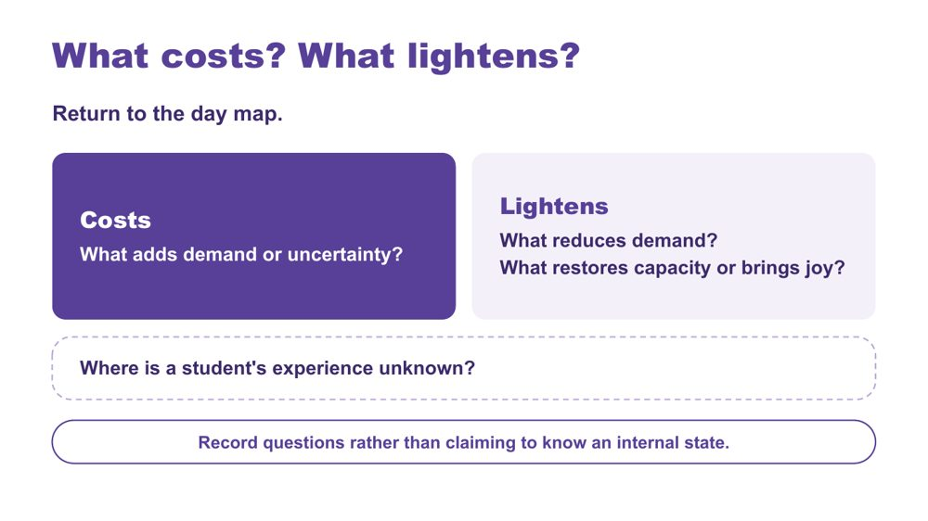 | What costs? What lightens?  SUGGESTED TIME  5 min  CLOCK  11:51 - 11:56  GROUPING  On your own  PARTICIPANT GUIDE  Page 14 - What costs? What lightens?

Extend the day map to show demand, relief and what is not yet known.
WHAT TO DO  - Ask participants to return to the day map.  - Ask them to mark what adds demand or uncertainty (costs).  - Ask them to mark what reduces demand, restores capacity or brings joy (lightens).  - Ask them to add questions where a student's experience is unknown.  - Link back to the battery language: what drains, what recharges.  - Ask where access depends on one person, and where the school provides recovery points any student can use. | KEY MESSAGES  - A single moment sits within the demands and supports accumulated across the day.  - The map should include what lightens and restores as well as what costs.  - Record questions rather than claiming to know an internal state.

ACTIVITY | Extend the school-day map on your own · about 4 minutes
What costs? What lightens? Where is a student's experience unknown?
- Use one mark or colour for what costs.
- Use another for what lightens or restores.
- Add questions where the student's experience is not known.
Close: Look for patterns in the day that can inform the school-level audit.

KEEP IN MIND
- Do not turn the map into a score or a claim about internal state.
- Do not infer a student's internal state from a single behaviour or moment.
- Include strengths, joy, safe connection and belonging alongside costs.

Background Something can be enjoyable, valued or successfully completed and still require considerable effort. What costs or lightens will differ between students, and may differ for the same student across contexts and days.

SESSION 3 | Autistic Experience at School | SLIDE 19 of 26

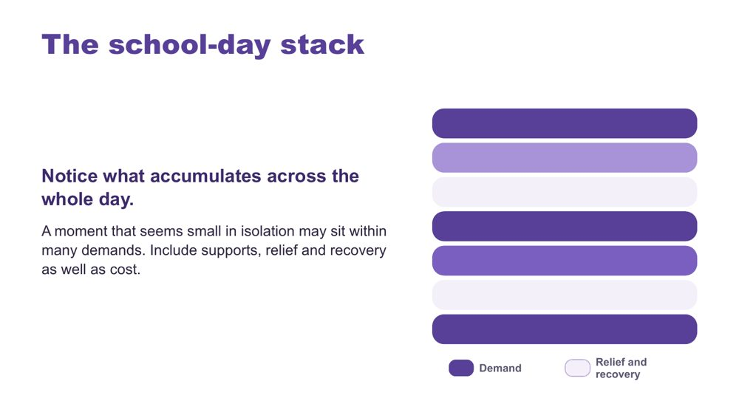 | The school-day stack  SUGGESTED TIME  2 min  CLOCK  11:56 - 11:58

Show how demand accumulates across the whole day.
WHAT TO DO  - Use the stack model as presented.  - Point out that darker bars show demand and lighter bars show relief and recovery.  - Keep the discussion qualitative.  - Ask leaders what their bell schedule, assembly times and relief arrangements add to the stack, and where the week provides recovery. | KEY MESSAGES  - A moment that seems small in isolation may sit within many demands.  - Include supports, relief and recovery as well as cost.  - Whole-school routines add to, or relieve, the stack for every student at once.

KEEP IN MIND
- The stacked bars are a visual cue only. Do not score students.

SESSION 3 | Autistic Experience at School | SLIDE 20 of 26

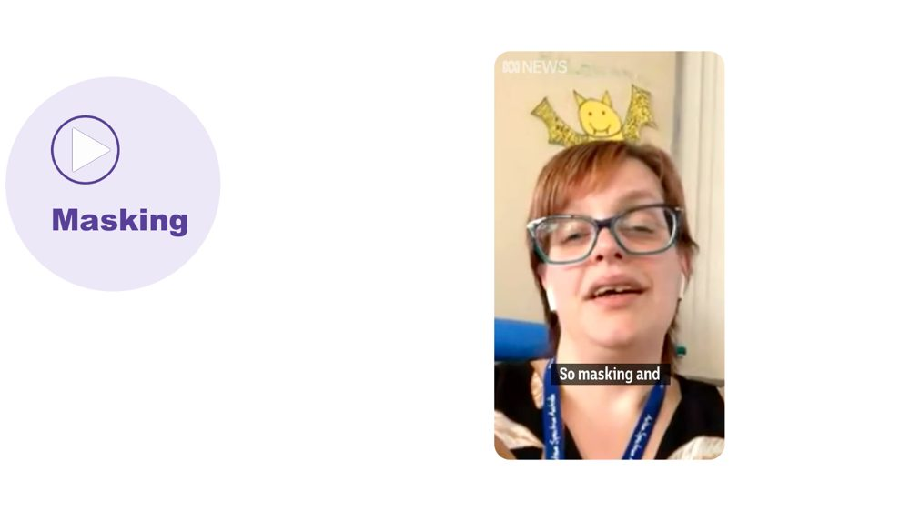 | Masking  SUGGESTED TIME  4 min  CLOCK  11:58 - 12:02

Introduce masking as another thing that draws on a student's battery.
WHAT TO DO
- Link from the stack: there are other things that can affect batteries or spoons.
- Play the masking video.

YOU MIGHT SAY
There are other things that can impact our batteries or spoons... let's watch a video about masking.

SESSION 3 | Autistic Experience at School | SLIDE 21 of 26

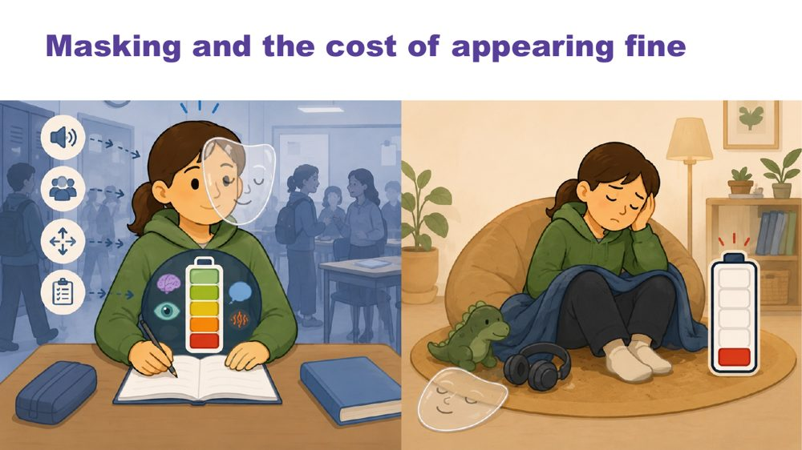 | Masking and the cost of appearing fine  SUGGESTED TIME  2 min  CLOCK  12:02 - 12:04

Name what may be missed if educators look only at outward behaviour.
WHAT TO DO  - Introduce masking in relation to identity and belonging.  - Pose the four questions in the notes for the room to think about.  - Ask what may be missed if staff look only at outward behaviour or task completion.  - Name the leadership point: leaders cannot see masking from the office, but they can shape a school where students need to mask less. | KEY MESSAGES  - Outward behaviour does not show everything a student is managing.  - What is visible does not provide a complete account of capacity, identity or belonging.  - Students who mask well are often the last to be offered support.

KEEP IN MIND
- Avoid assuming that a student is coping because they are quiet, compliant or completing work.
- Some participants may recognise their own child or themselves. Remind the room they can step out and return at any time.
- Include strengths, joy, safe connection and belonging alongside costs.

Background Prompts to pose: What might the student be working hard to manage or hide? Where can they be recognised and included? What supports belonging without requiring them to appear less Autistic? What does the student want others to understand?

SESSION 3 | Autistic Experience at School | SLIDE 22 of 26

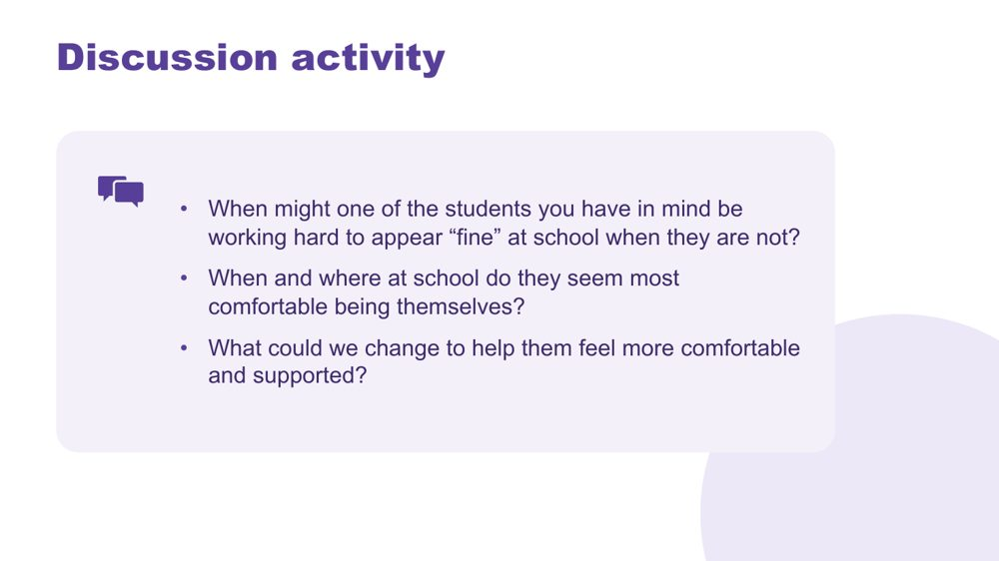 | Discussion activity: masking  SUGGESTED TIME  4 min  CLOCK  12:04 - 12:08  GROUPING  Pairs  PARTICIPANT GUIDE  Page 12 - Masking discussion

Apply masking to the students participants have in mind.
WHAT TO DO
- Put participants in pairs.
- Work through the three questions on the slide.
- Bring the room back and take one or two responses on what the school could change.

ACTIVITY | Guided discussion pairs · about 3 minutes
When might one of the students you have in mind be working hard to appear "fine" at school when they are not?
- When might one of the students you have in mind be working hard to appear "fine" at school when they are not?
- When and where at school do they seem most comfortable being themselves?
- What could we change to help them feel more comfortable and supported?
Bring the room back
- What could we change to help them feel more comfortable and supported?

KEEP IN MIND
- Avoid assuming that a student is coping because they are quiet, compliant or completing work. Ask participants to think about their quietest Autistic students and what is actually known about their experience.
- Keep examples anonymised.

SESSION 3 | Autistic Experience at School | SLIDE 23 of 26

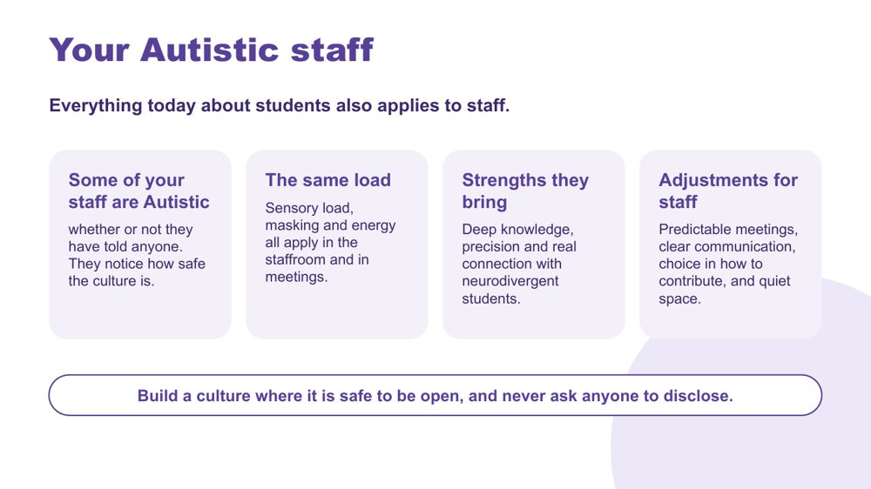 | Your Autistic staff  SUGGESTED TIME  5 min  CLOCK  12:08 - 12:13  GROUPING  On your own  PARTICIPANT GUIDE  Page 10 - Session 3 summary (Your Autistic staff)

Extend the session's thinking from students to staff, as a matter of school culture and systems.
WHAT TO DO  - Read the opening line on the slide: everything today about students also applies to staff.  - Walk through the four panels: some of your staff are Autistic, the same load, strengths they bring, adjustments for staff.  - Explain that this is about culture and systems. It is not about identifying anyone.  - Invite a short private reflection: choose one ordinary staff process, such as staff meetings, how changes are communicated to staff, or how relief is allocated. What is clear and predictable? Where is flexibility possible? What does a person have to ask for, or disclose, to get what they need?  - Do not ask for responses about individual staff. If people share, keep it to processes.  - Close on the final line on the slide. | KEY MESSAGES  - Autistic staff are part of the school community that leadership practice serves.  - Sensory load, masking and energy apply in the staffroom and in meetings too.  - Workplace access should not depend on personal disclosure. Predictable meetings, clear communication, choice in how to contribute and quiet space help many staff.  - Staff flourishing matters in its own right.  - Build a culture where it is safe to be open, and never ask anyone to disclose.

YOU MIGHT SAY
Everything we have talked about today for students also applies to staff. Some of your staff are Autistic, whether or not they have told anyone, and they notice how safe the culture is.
Take a minute on your own. Think about one ordinary staff process, like a staff meeting or how changes are communicated. What is clear and predictable? What would someone have to ask for, or disclose, to get what they need? This stays with you.

ACTIVITY | Private reflection on your own · about 2 minutes
Think about one ordinary staff process. What does a person have to ask for, or disclose, to get what they need?
- Choose a general staff process, not an individual person.
- Note what is already clear and predictable.
- Note where flexibility is possible.
- Note who should be involved before anything changes.
Close: This reflection stays with you. Carry any process question into Session 4.

KEEP IN MIND
- Never invite disclosure in the room, and do not ask participants to identify, speculate about or discuss individual staff members.
- Some participants may be Autistic, or have Autistic family members. Model the discretion the slide asks for.
- Present strengths as possibilities, not assumptions about any person. Keep support needs and workplace access visible alongside strengths.
- Individual workplace adjustments follow each system's own workplace and HR processes, which differ across government, Catholic and independent schools. Keep the discussion to culture and general practice.

Background The same design thinking used for students applies one level up: predictability, communicating in more than one way, meeting design and access to quiet space. Many of these practices help all staff and can be put in place without anyone needing to disclose.
Thread Session 4 returns to culture: what staff say and do follows what leaders model, and people are more likely to be open where the culture is safe.

SESSION 3 | Autistic Experience at School | SLIDE 24 of 26

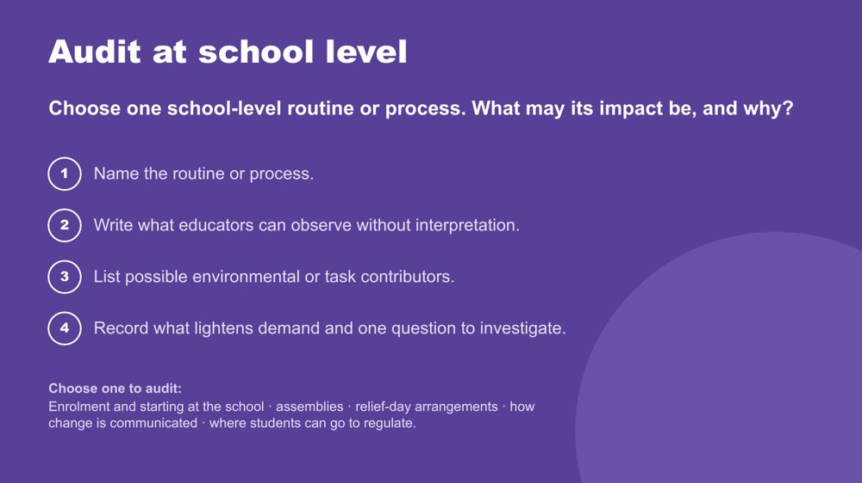 | Audit at school level  SUGGESTED TIME  10 min  CLOCK  12:13 - 12:23  GROUPING  On your own or with a colleague  PARTICIPANT GUIDE  Page 15 - Audit at school level

Follow students' experience through one school-level routine or process, and record what may affect access and why.
WHAT TO DO  - Read the prompt on the slide and the five options: enrolment and starting at the school, assemblies, relief-day arrangements, how change is communicated, and where students can go to regulate.  - Ask participants to choose one, on their own or with a colleague, and work through the four steps on page 15.  - Ask them to follow what a student encounters from the first point of contact to the next handover or outcome.  - Ask them to look for where access is built into the process and where it depends on one person or on the student asking.  - Allow about 7 minutes.  - Bring the room back and take two or three responses: one thing the audit confirmed and one thing that surprised them. | KEY MESSAGES  - A school-level audit follows experience through a process, not only through a classroom.  - Access is more dependable when the process supports it rather than leaving it to one person.  - These processes sit across different portfolios, such as the front office, daily organisation and the executive, so inclusion is part of every system.

YOU MIGHT SAY
Choose one of these school-level routines or processes. Follow what a student experiences from the first point of contact. Where is access built in, and where does it depend on one person remembering or on the student asking?

ACTIVITY | School-level audit on your own or with a colleague · about 7 minutes, then 2 - 3 minutes of responses
Choose one school-level routine or process. What may its impact be, and why?
- Name the routine or process.
- Write what educators can observe without interpretation.
- List possible environmental or task contributors.
- Record what lightens demand and one question to investigate.
Bring the room back
- What did the audit confirm?
- What surprised you?
- Where does access currently depend on one person?
Close: Select one routine or process to carry into the design work after lunch.

KEEP IN MIND
- Keep the audit reflective. Do not score or rank the school.
- The audit looks at the design of the process, not the performance of any staff member. Do not name or blame staff.
- Keep all examples anonymised.
- Look at the environment, task, timing, communication and expectations before the student.

Background Examples to prompt thinking. Enrolment and starting: first contact, orientation visits, starting mid-year, moving from primary to secondary. Assemblies: noise, seating, length, surprise announcements, whether a student can sit near an exit or step out. Relief-day arrangements: who tells the student, whether the relief teacher has the key information, whether routines stay the same. How change is communicated: how and when students and families hear about timetable changes, excursions, room changes or events. Where students can go to regulate: where it is, how a student gets there without asking in front of peers, who is there and whether it is available all day.
Thread Feeds the design brief in Session 4.

SESSION 3 | Autistic Experience at School | SLIDE 25 of 26

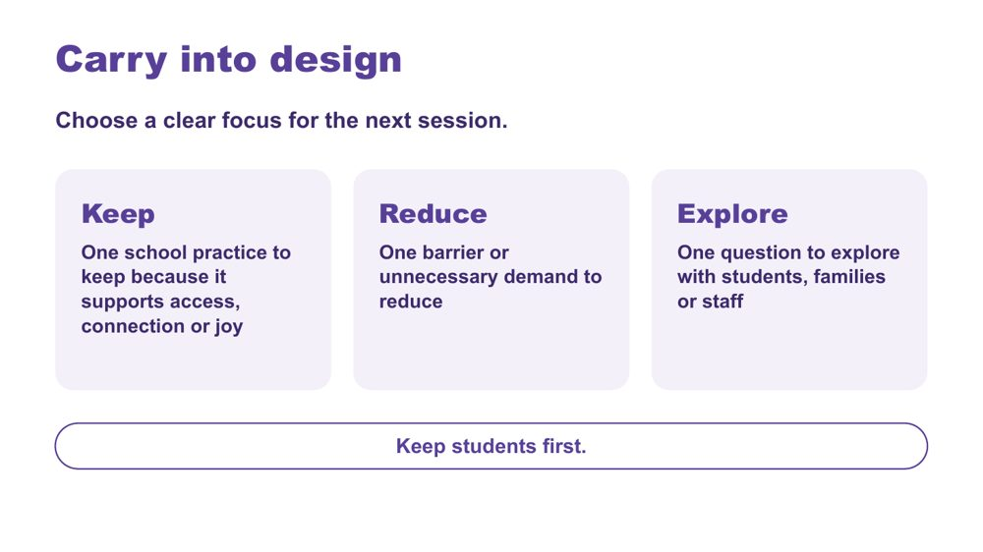 | Carry into design  SUGGESTED TIME  4 min  CLOCK  12:23 - 12:27  GROUPING  On your own  PARTICIPANT GUIDE  Page 16 - Carry into design

Consolidate the school-day map and audit and choose a focus for Session 4.
WHAT TO DO  - Invite participants to choose one school practice to keep, one barrier to reduce and one question to explore.  - Ask participants to tick whether their Reduce item is about culture and learning, routines, or teams and resourcing. They will use this to find a corner in Session 4.  - Keep responses private unless participants choose to share.  - Ask participants to keep their map and audit for the design activity.  - Preview the move from the school-day map and audit to one practical school change.  - Point out lunch at 12:30 - 1:00 and the 1:00 return. | KEY MESSAGES  - Design should protect what supports access, connection and joy as well as reduce barriers.  - Unanswered questions can guide consultation with students, families and staff.  - Keep students first.

ACTIVITY | Carry into design card (Keep, Reduce, Explore) on your own · about 3 minutes
Choose a clear focus for the next session.
- Keep: one school practice to keep because it supports access, connection or joy.
- Reduce: one barrier or unnecessary demand to reduce.
- Tick: culture and learning, routines, or teams and resourcing.
- Explore: one question to explore with students, families or staff.
Close: Keep your map and audit for the design activity after lunch.

Thread Leads directly into the Session 4 design brief.
RESOURCES
- Handout: PL Leadership - Session 3 - Carry into design card

SESSION 3 | Autistic Experience at School | SLIDE 26 of 26

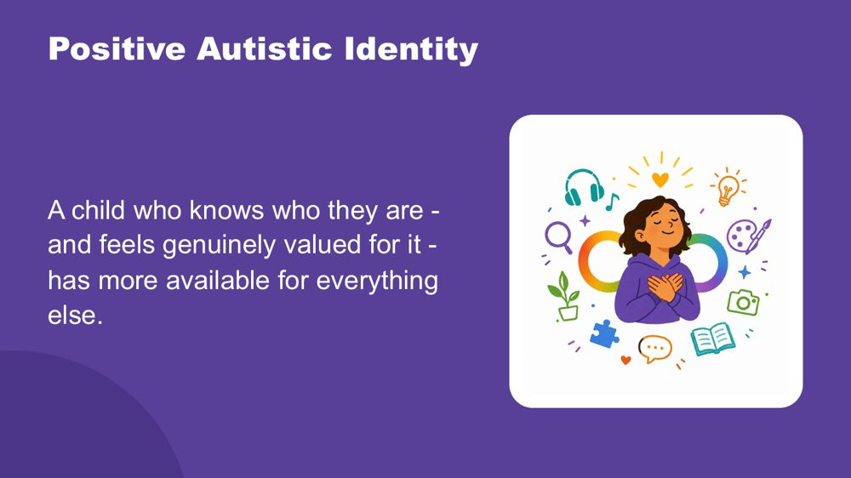 | Positive Autistic identity  SUGGESTED TIME  3 min  CLOCK  12:27 - 12:30

Close the morning by returning to the students participants have in mind, seen now with a fuller picture.
WHAT TO DO  - Wait for the room to settle before you begin.  - Read the spoken close slowly, with the image on the screen.  - The opening paragraph draws together what Sessions 2 and 3 covered.  - After the final sentence, pause briefly before moving on.  - Release to lunch. | KEY MESSAGES  - The cost includes masking, and also managing the whole of Autistic experience in a world not designed for it.  - Positive Autistic identity is a research-supported protective factor for mental health and wellbeing.  - Belonging comes first. When identity does not need to be managed on top of everything else, those resources become available for learning and connection.  - Agency is protective. Genuine choice over their own environment reduces cost directly.  - Autistic community connection is itself protective. Knowing other Autistic people share your experience matters.  - For leaders, belonging, agency and connection are things the whole school can plan for, through culture, routines and how staff are supported.

YOU MIGHT SAY
This morning, across Sessions 2 and 3, you have been building a picture of the students you have in mind.
How the world arrives through their senses, more fully, more specifically, less filtered. How their brain builds understanding from the detail up, focuses deeply, and thinks in ways that produce real and specific strengths. How their internal world works. How they reach toward other people, and what that costs when the conditions are not designed for them.
Managing all of that, every day, in a world that was largely built for a different nervous system, takes resources. Sensory management. Social interpretation. Executive effort. Communication across a gap. Holding it together when the signals inside are not arriving clearly. And sometimes, performing fine when fine is not what is happening.
A child who knows who they are - and feels genuinely valued for it - has more of those resources available for everything else.
Research supports what many Autistic adults already know: a positive sense of Autistic identity is connected to better mental health, less anxiety, and greater wellbeing. Belonging is the precondition for all of it. When a child does not need to spend resources managing their identity on top of everything else, those resources become available for learning, connection, and self-knowledge.
Agency matters too, genuine choice over how they communicate, where they sit, when they step back. And knowing that other Autistic people share their experience, that Autistic adults have found belonging and purpose, is protective in its own right.
These students are not alone in this. They are part of something.
The deepest thing you can do is support them to know themselves, and to know that who they are is worth knowing.

KEEP IN MIND
- Let participants make the connections themselves rather than telling them what to conclude.
- End on the final sentence. Some participants may need a moment before lunch.

Background Research on Autistic identity and wellbeing consistently shows that positive Autistic identity, knowing yourself as Autistic and valuing that, is associated with better mental health outcomes, reduced anxiety and greater resilience. This is distinct from general self-esteem: it is specifically the sense of Autistic identity as something to know and value, not manage or minimise, that provides protection. Belonging to Autistic peer networks amplifies this effect. The goal is not for students to fit in. The goal is for each student to know who they are, and to find the people and places where that is valued.
Thread Echoes the opening image of Session 2: the child coming into focus, piece by piece. The facilitator does not need to name this.

SESSION  4 | 1:00 - 2:15 · 75 MINUTES · 24 SLIDES  Learning Design  Designing an autism friendly school

SESSION INTENT
School leaders move from understanding to design. After three short inputs on culture, resourcing and leading change, trios redesign one school system (culture and learning; routines and predictability; or teams, resourcing and records) through an environment-first brief, a menu of school-level options and a universal-first accessibility check, and plan the change for this term, this year and the strategic plan. Each person then privately tests the design against the two or three students they have in mind, which opens the continuum of support and NCCD, before a gallery walk and a personal commitment.
PARTICIPANTS LEAVE WITH
- consider how leaders shape culture, direct resources and lead change that lasts
- write an environment-first brief for one school system, free from blame or deficit labels
- match one or two school-level options to a known demand and test the design for accessibility
- plan one school change for this term, this year and the strategic plan, and check it against the students they have in mind
- leave with one step to start this term and who on their executive they will share it with

RUN SHEET
Clock | Segment | Slides | Minutes
1:00 - 1:03 | Welcome and students come first | 1-2 | 3
1:03 - 1:12 | Start: culture, resourcing and change inputs | 3-5 | 9
1:12 - 1:13 | Session map | 6 | 1
1:13 - 1:18 | Start: regroup and students reminder | 7-8 | 5
1:18 - 1:24 | Brief | 9 | 6
1:24 - 1:36 | Options | 10-15 | 12
1:36 - 1:42 | Universal first | 16-17 | 6
1:42 - 1:54 | Design | 18 | 12
1:54 - 1:59 | Check | 19 | 5
1:59 - 2:06 | Continuum | 20-22 | 7
2:06 - 2:15 | Gallery and commit | 23-24 | 9

PREPARE
☐ Signs for three corners of the room: Culture and learning; Routines; Teams and resourcing.
☐ A3 School change sheet (PL Leadership - Session 4 - School change sheet): one per trio, sections 1 - 4 used across the session, with "My students" cards on page 2.
☐ "My students" card: one per person, for the private check and the commitment.
☐ Printed option cards on each table (Professional learning and coaching, Predictability as policy, Inclusion team and review cycles, Documentation that helps staff).
☐ Post-it notes and wall space to display A3 designs for the gallery walk.
☐ Ask participants to bring their Session 3 school-day map, school-level audit and Carry into design card (PL Leadership - Session 3 - Carry into design card).
☐ Current official NCCD information to point participants to.

SESSION 4 | Learning Design | SLIDE 1 of 24

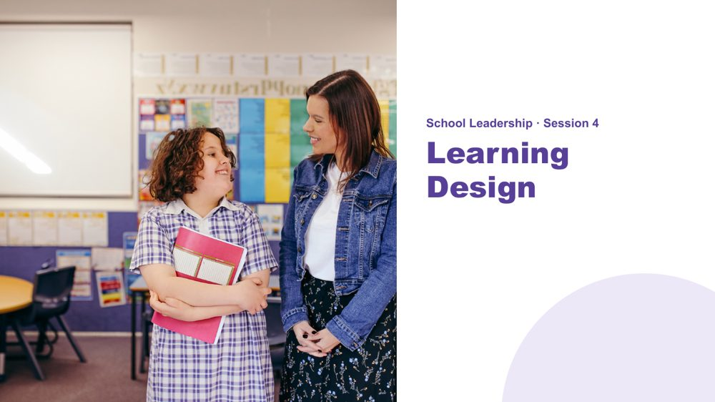 | Session 4 / Learning Design  SUGGESTED TIME  2 min  CLOCK  1:00 - 1:02  PARTICIPANT GUIDE  Page 17 - Session 4 summary

Shift from understanding experience to designing access across a whole school.
WHAT TO DO  - Welcome participants back from lunch.  - Ask them to have their Session 3 school-day map, school-level audit and Carry into design card to hand.  - Name the direction of the session: from what students experience to the systems the school creates.  - Explain that the session will produce one school change, planned for this term, this year and the strategic plan.  - Keep the focus on school systems, culture and resourcing rather than changing the student. | KEY MESSAGES  - What we know about students informs design; it is not a list of deficits.  - A school change should respond to a barrier or access question found in the school-day map or audit.

Thread Picks up the school-day map, school-level audit and Carry into design card from Session 3.

SESSION 4 | Learning Design | SLIDE 2 of 24

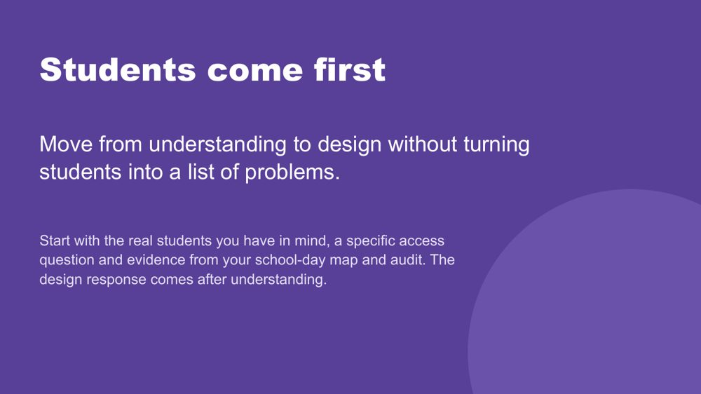 | Students come first  SUGGESTED TIME  1 min  CLOCK  1:02 - 1:03

Set the principle that understanding real students comes before any design response.
WHAT TO DO  - Point to the students participants have in mind and the school-day map from Session 3.  - Name that the session designs a change to a school system, then checks that design against the two or three students each person has in mind.  - Remind participants to include only what is known, and to hold unknowns as questions.  - Ask participants to separate an observation from an interpretation, and a question from a conclusion. | KEY MESSAGES  - Understand the student before choosing a strategy.  - A design brief connects what matters for students with what the school can change in its systems, routines and resourcing.  - Unknowns remain questions for consultation.

KEEP IN MIND
- Do not use what is known about students to diagnose, rank or reduce them to support needs.

Thread Draws on the school-day map from Session 3.

SESSION 4 | Learning Design | SLIDE 3 of 24

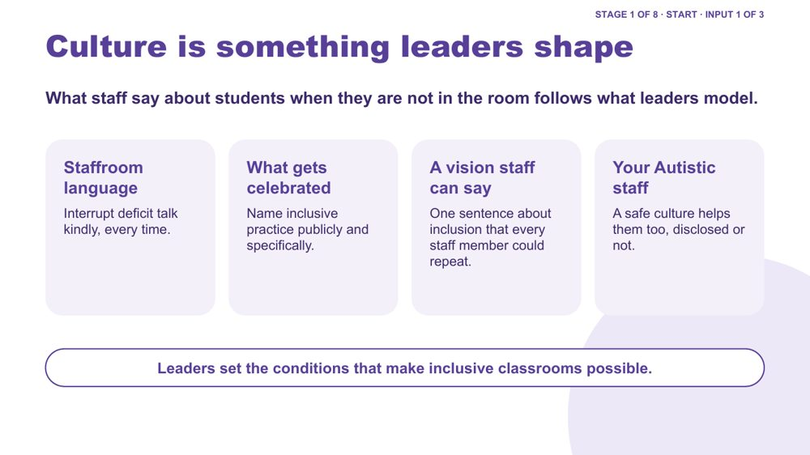 | Culture is something leaders shape  SUGGESTED TIME  3 min  CLOCK  1:03 - 1:06  PARTICIPANT GUIDE  Page 17 - Culture, resourcing and change

Input 1 of 3: culture as something leaders set through what they model, celebrate and say.
WHAT TO DO  - Keep this input to about three minutes.  - Walk the four boxes: staffroom language, what gets celebrated, a vision staff can say, your Autistic staff.  - Staffroom language: ask what gets said about students when they are not in the room, and what happens when deficit talk is interrupted.  - What gets celebrated: ask what inclusive practice has been named publicly in the last term, and how specifically.  - A vision staff can say: ask participants to write, privately, one sentence about inclusion that every staff member could repeat. Take one or two if people offer.  - Your Autistic staff: link back to Session 3. A safe culture helps staff too, whether or not they have disclosed.  - Keep the discussion at the level of patterns, not individual staff. | KEY MESSAGES  - Culture shows in everyday language, recognition and what happens when practice is questioned.  - Leaders can shape what becomes normal without blaming individuals.  - People affected by the culture, including students and staff, need a place in reviewing it.

YOU MIGHT SAY
What staff say about students when they are not in the room follows what leaders model.
Leaders set the conditions that make inclusive classrooms possible.

KEEP IN MIND
- Do not invite criticism of named staff or schools.
- Do not ask participants to identify, speculate about or disclose Autistic staff, including themselves.

Background Examples if needed. Staffroom language: a leader gently reframes "he's just being difficult" as "what is the lesson or the day asking of him?" and does so every time. What gets celebrated: a staff meeting or newsletter names a specific practice, such as a teacher who now gives change warnings before every relief lesson, rather than general thanks.
Thread Builds on the Session 3 slide on Autistic staff.

SESSION 4 | Learning Design | SLIDE 4 of 24

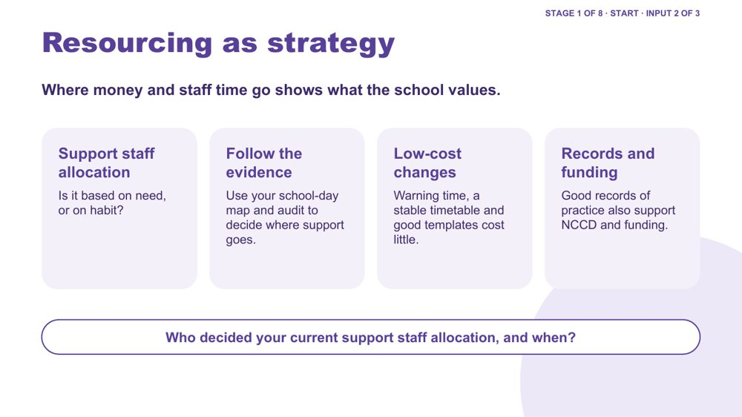 | Resourcing as strategy  SUGGESTED TIME  3 min  CLOCK  1:06 - 1:09  PARTICIPANT GUIDE  Page 17 - Culture, resourcing and change

Input 2 of 3: budget and staffing decisions as design decisions, linked to the Session 3 evidence.
WHAT TO DO  - Keep this input to about three minutes.  - Ask the question at the bottom of the slide: who decided your current support staff allocation, and when? Invite a show of hands or a quiet reflection; do not ask for details.  - Support staff allocation: ask whether hours are attached to students by need or by habit.  - Follow the evidence: link to the school-day map and audit from Session 3. They show where demand builds up across the day, which can guide where support goes.  - Low-cost changes: warning time, a stable timetable and good templates cost little.  - Records and funding: good records of everyday practice also support NCCD and funding processes. | KEY MESSAGES  - Resource decisions express school priorities.  - Consider whether access depends on one scarce resource, such as one support staff member, when the wider system also needs attention.  - Some of the most useful changes cost little.

YOU MIGHT SAY
Where money and staff time go shows what the school values.

KEEP IN MIND
- Keep principles general so they apply across government, Catholic and independent schools; do not give figures or funding rules.
- Do not ask participants to share budget figures or identifiable staffing arrangements.
- Keep discussion within local governance, industrial, staffing and funding processes.

Thread Uses the Session 3 school-day map and school-level audit as evidence for allocation.

SESSION 4 | Learning Design | SLIDE 5 of 24

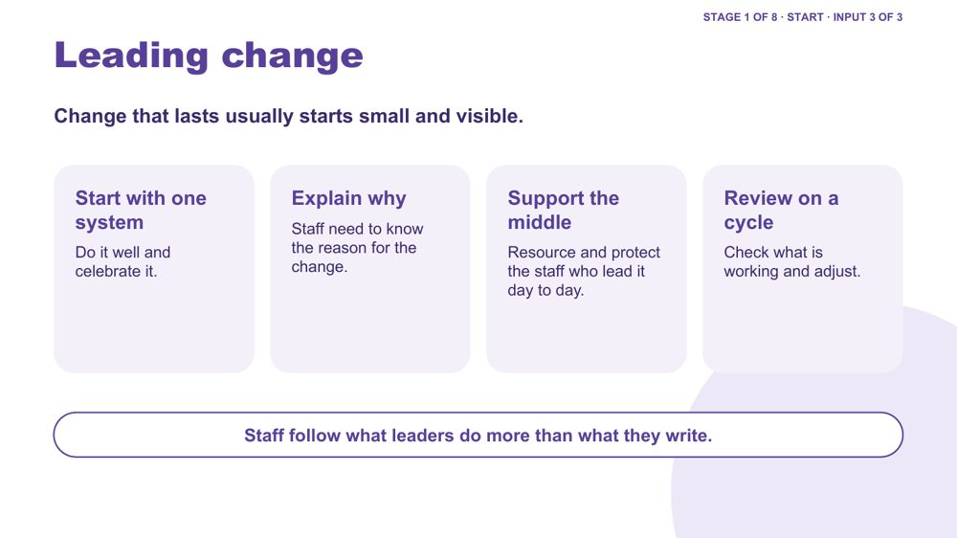 | Leading change  SUGGESTED TIME  3 min  CLOCK  1:09 - 1:12  PARTICIPANT GUIDE  Page 17 - Culture, resourcing and change

Input 3 of 3: how change that lasts is usually led in schools.
WHAT TO DO  - Keep this input to about three minutes.  - Walk the four boxes: start with one system, explain why, support the middle, review on a cycle.  - Use the two illustrative examples below and say that they are composites, not real schools.  - Ask participants which example is closer to their own school's next step.  - Link to the next move: trios will now choose one school system to work on. | KEY MESSAGES  - Start with one system, do it well and celebrate it.  - Staff need to know the reason for the change.  - The middle leaders and staff who carry the change day to day need time and support.  - Plan the review from the start.

YOU MIGHT SAY
Change that lasts usually starts small and visible.
Staff follow what leaders do more than what they write.

KEEP IN MIND
- Present the examples as illustrative, not as a model every school should copy.
- Do not name real schools or attach the examples to a sector or region.

Background Illustrative composite examples, for discussion only. Example 1: a school started with relief-day arrangements. It agreed one relief-day plan, a way of warning students about a change of teacher and a short handover note, so students and relief staff knew what was happening. Staff saw the benefit quickly, and this built trust for later changes. Example 2: a school started with a one-page student profile that travels between teachers, year levels and relief staff, so what is known about a student is not lost when staff change.

SESSION 4 | Learning Design | SLIDE 6 of 24

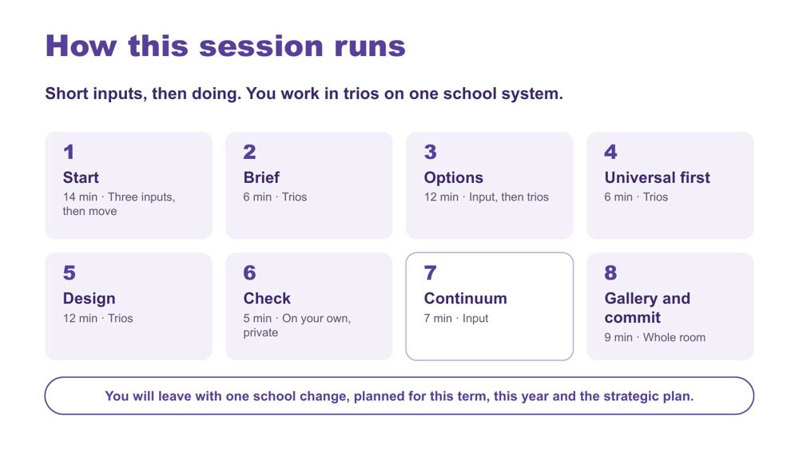 | How this session runs  SUGGESTED TIME  1 min  CLOCK  1:12 - 1:13

Show the rhythm of the session: short inputs, then doing, in trios working on one school system.
WHAT TO DO  - Walk the eight stages briefly: Start, Brief, Options, Universal first, Design, Check, Continuum, Gallery and commit.  - Name that each person keeps their own school and students in view while the trio designs together.  - Name the end point: one school change, planned for this term, this year and the strategic plan. | KEY MESSAGES  - Short inputs, then doing.

YOU MIGHT SAY
We have heard three short inputs. Now we move, form trios around one school system, listen briefly for options, design, test the design against our own students, and finish with a gallery and a commitment.

Background The eight stages total 71 minutes; the other 4 minutes cover the title, Students come first and this session map. The first stage (Start, 14 minutes) includes the three inputs on slides 3 to 5, the regroup and the students reminder.

SESSION 4 | Learning Design | SLIDE 7 of 24

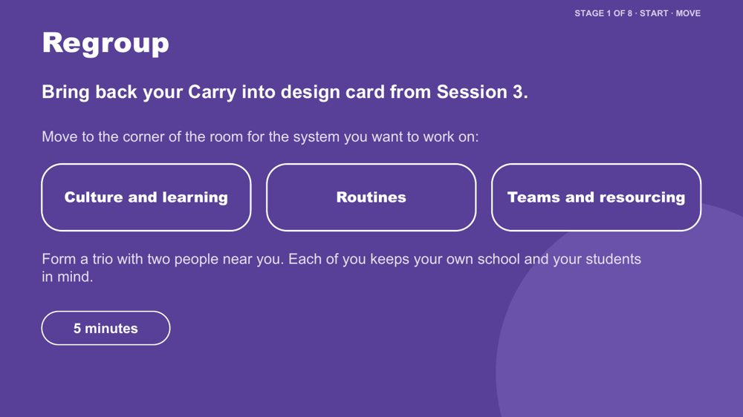 | Regroup  SUGGESTED TIME  4 min  CLOCK  1:13 - 1:17  GROUPING  Trios

Get the room moving and form trios around a school system people want to work on.
WHAT TO DO  - Ask participants to find their Session 3 Carry into design card, especially the Reduce box and the system type they ticked.  - Point to the three corners: Culture and learning; Routines; Teams and resourcing.  - Ask people to move to the corner that matches the system they want to work on.  - Ask them to form trios with people nearby. People from the same school may work together or separately.  - Split a crowded corner; fold anyone on their own into the nearest trio.  - Hand out one A3 School change sheet per trio, with the "My students" cards on page 2. | KEY MESSAGES  - The trio designs together; each person tests the design against their own students later.

ACTIVITY | Corners-of-the-room regroup trios · 5 minutes (including the slide 8 reminder)
Move to the corner for the system you want to work on and form a trio.
- Bring back your Carry into design card from Session 3.
- Move to the corner for your system: Culture and learning; Routines; or Teams and resourcing.
- Form a trio with two people near you.
- Each person keeps their own school and their two or three students in mind.
Close: Every trio has an A3 School change sheet and every person has a "My students" card.

Thread Uses the Session 3 Carry into design card; its Reduce box ticks match the three corners.

SESSION 4 | Learning Design | SLIDE 8 of 24

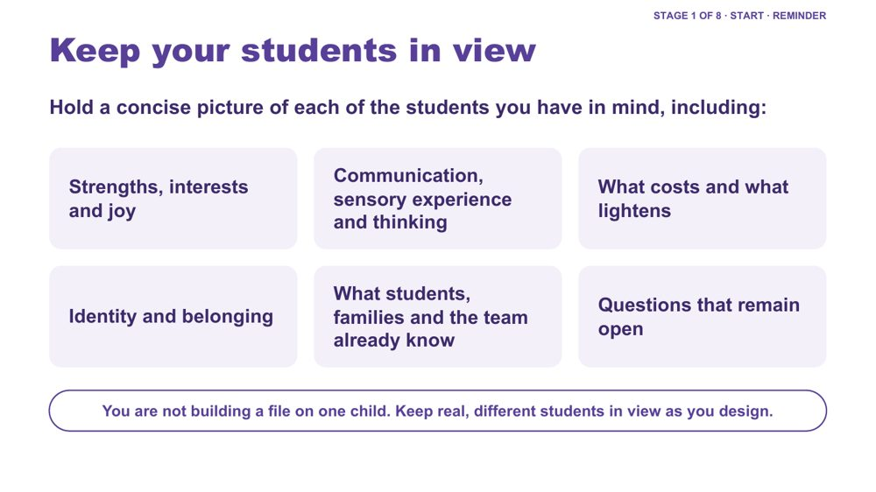 | Keep your students in view  SUGGESTED TIME  1 min  CLOCK  1:17 - 1:18

A quick reminder to hold a concise picture of each student in mind while designing at school level.
WHAT TO DO  - Keep this to about one minute, inside the Start stage.  - Run through the areas on the slide as prompts, not a form to fill in.  - Name that participants will use these students in Stage 6, the private check. | KEY MESSAGES  - You are not building a file on one child. Keep real, different students in view as you design.  - Include strengths, interests and joy, communication, sensory experience, thinking, costs, lighteners, identity and belonging only where these are known or framed as questions.

KEEP IN MIND
- Do not use this to diagnose, rank or reduce students to support needs.

SESSION 4 | Learning Design | SLIDE 9 of 24

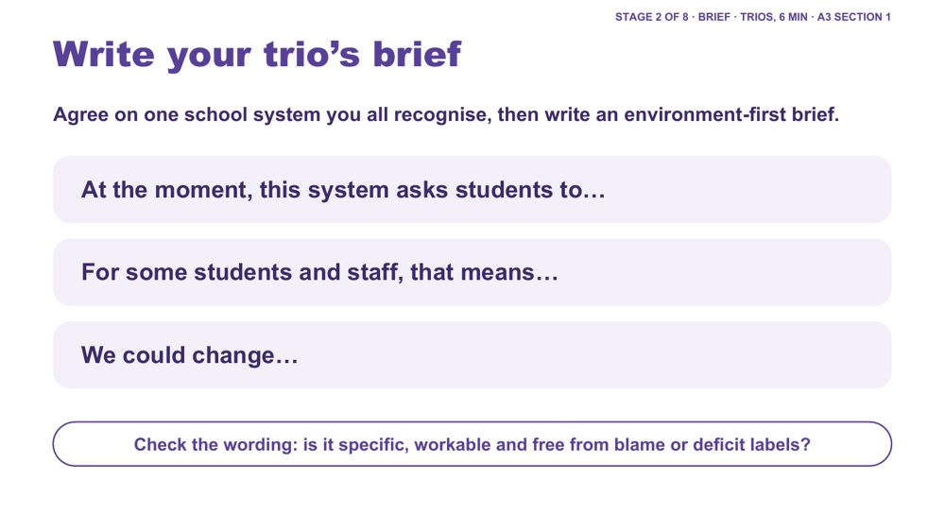 | Write your trio's brief  SUGGESTED TIME  6 min  CLOCK  1:18 - 1:24  GROUPING  Trios  PARTICIPANT GUIDE  Page 18 - Our brief

Agree one school system and write an environment-first design brief for it.
WHAT TO DO  - Ask trios to agree on one school system they all recognise; it may come from one person's Reduce box.  - Give examples if needed: relief-day arrangements, how change is communicated, assemblies, where students can go to regulate, how information about a student reaches every teacher.  - Ask them to complete the three stems together on the A3 sheet, section 1.  - Check that the brief points to something within the school's influence.  - Prompt trios to remove any wording that blames or labels students or staff. | KEY MESSAGES  - A design brief connects what matters for students with what the school can change.  - Unknowns remain questions for consultation.

ACTIVITY | Trio design brief on the A3 sheet, section 1 trios · 6 minutes
Agree on one school system you all recognise, then write an environment-first brief.
- Agree on one school system you all recognise.
- Complete: "At the moment, this system asks students to..."
- Complete: "For some students and staff, that means..."
- Complete: "We could change..."
- Check the wording: is it specific, workable and free from blame or deficit labels?
Close: Keep this one brief active for the rest of the session.

KEEP IN MIND
- Watch for observation drifting into interpretation, or questions presented as conclusions.
- Keep staff out of the brief as individuals: describe the system, not the people in it.

SESSION 4 | Learning Design | SLIDE 10 of 24

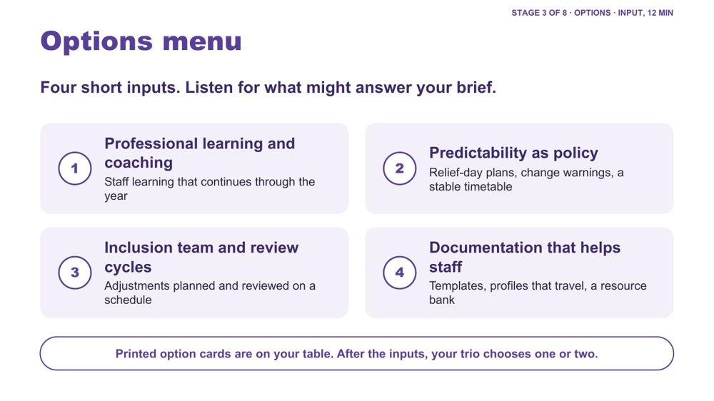 | Options menu  SUGGESTED TIME  1 min  CLOCK  1:24 - 1:25

Frame the four short inputs as a menu that trios listen to with their brief in front of them.
WHAT TO DO  - Ask trios to put their brief in front of them.  - Ask them to listen for which option might answer "At the moment, this system asks students to..."  - Point to the printed option cards on each table: they repeat the four headings so trios can hold and sort them.  - Keep each of the four inputs to about two or three minutes. | KEY MESSAGES  - Listen for what might answer your brief.

SESSION 4 | Learning Design | SLIDE 11 of 24

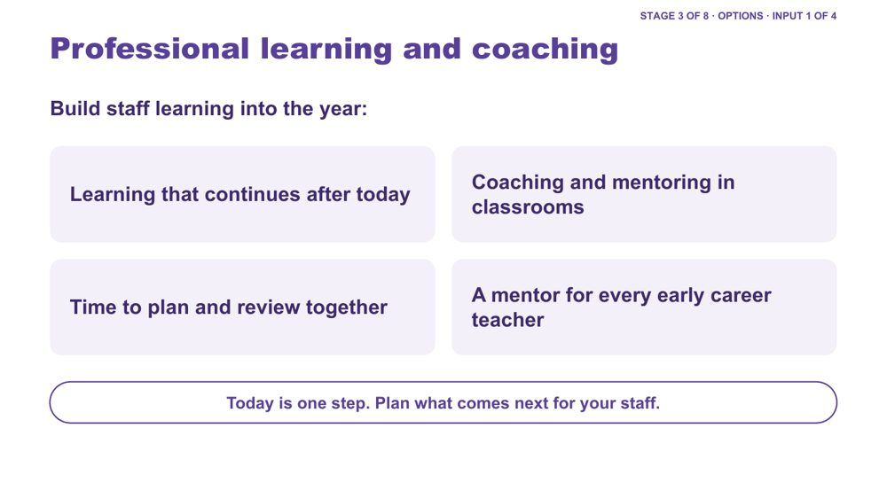 | Professional learning and coaching  SUGGESTED TIME  2 min  CLOCK  1:25 - 1:27

Option 1 of 4: staff learning that continues through the year.
WHAT TO DO  - Keep this input to about two minutes.  - Name that today is one step, and that learning sticks when it continues in classrooms.  - Walk the four points: learning that continues after today, coaching and mentoring in classrooms, time to plan and review together, a mentor for every early career teacher.  - Ask: after a professional learning day in your school, what happens next? Where can staff ask, observe, practise and reflect? | KEY MESSAGES  - Professional learning is more likely to change practice when it continues through coaching, planning and review.  - Coaching can connect staff learning with what students and families say.

KEEP IN MIND
- Do not present one coaching or mentoring model as the right one; structures vary across schools.

Background Examples if needed. Primary: a teacher who has trialled a change warning routine is observed by a colleague, and they review it together at the next team meeting. Secondary: a faculty sets aside part of one meeting each term for staff to share one adjustment they tried and what they noticed.

SESSION 4 | Learning Design | SLIDE 12 of 24

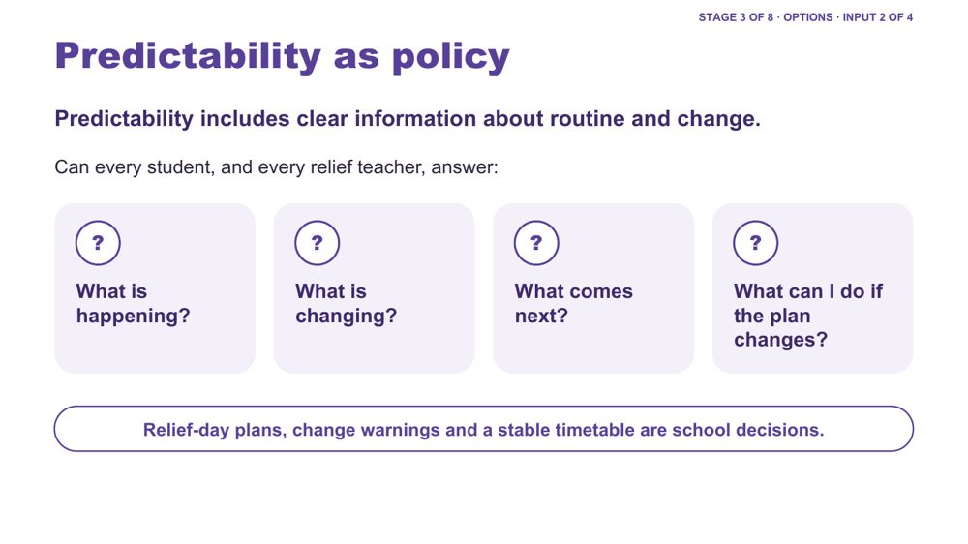 | Predictability as policy  SUGGESTED TIME  3 min  CLOCK  1:27 - 1:30

Option 2 of 4: predictability as information about routine and change, set at school level.
WHAT TO DO  - Keep this input to about two or three minutes.  - Frame predictability as access to information, not making every day the same or removing change.  - Use the four questions on the slide and ask: could every student, and every relief teacher, answer these on a normal day and on a day when something changes?  - Name the school-level decisions: a relief-day plan, how and when changes are warned, and how stable the timetable is.  - Connect back to the Session 3 audit: when something changes at school, how do students find out?  - If needed, use an example below. | KEY MESSAGES  - Predictability is access to information, not a promise that nothing will change.  - Clear information about change can be just as important as information about routine.  - Relief-day plans, change warnings and a stable timetable are school decisions.

YOU MIGHT SAY
Predictability is not the absence of change. It includes having accessible information when change happens.

Background Primary example: assembly is moved earlier than usual. How will students know the plan has changed? Is the change on their schedule? Can they see what happens next? Secondary example: a class has a relief teacher for period 3 and a room change. Is there a school-wide way students are told before they arrive, and does the relief teacher have the information they need?
Thread Links back to the Session 3 school-level audit (relief-day arrangements, how change is communicated).

SESSION 4 | Learning Design | SLIDE 13 of 24

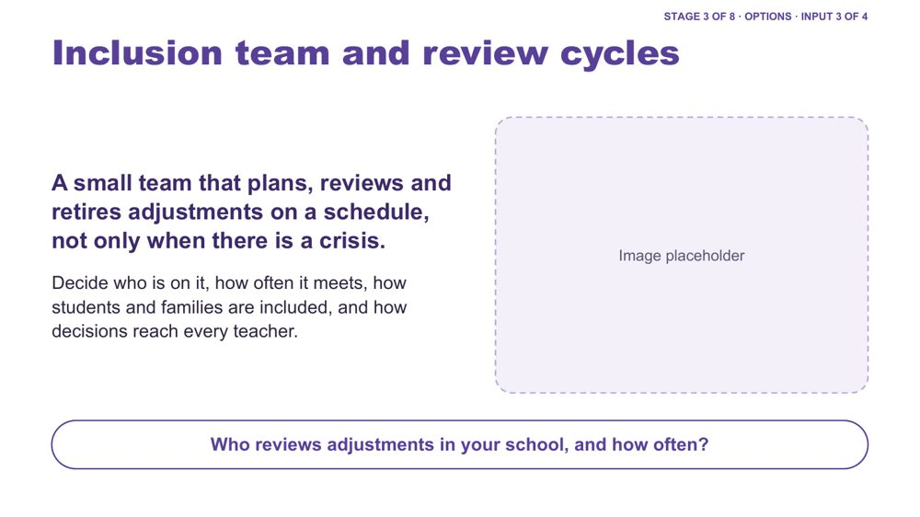 | Inclusion team and review cycles  SUGGESTED TIME  2 min  CLOCK  1:30 - 1:32

Option 3 of 4: a small team that plans and reviews adjustments on a schedule.
WHAT TO DO  - Keep this input to about two minutes.  - Explain the idea: adjustments are planned, reviewed and retired on a schedule, not only when there is a crisis.  - Walk the four decisions on the slide: who is on the team, how often it meets, how students and families are included, and how decisions reach every teacher.  - Ask the question on the slide: who reviews adjustments in your school, and how often? | KEY MESSAGES  - Regular review makes adjustments more dependable than reacting only when something goes wrong.  - Decisions need a clear route to every teacher, including relief staff.  - Students and families contribute to review.

KEEP IN MIND
- Do not prescribe team membership or meeting frequency; these vary by school and system.

SESSION 4 | Learning Design | SLIDE 14 of 24

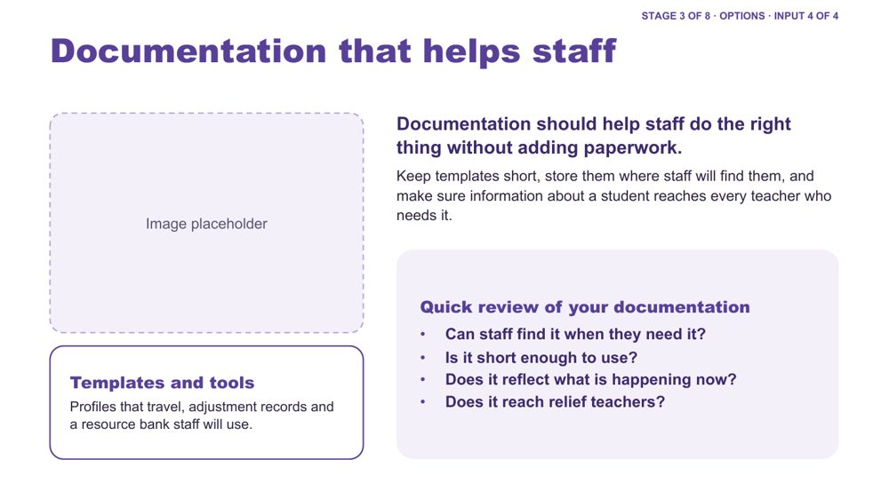 | Documentation that helps staff  SUGGESTED TIME  2 min  CLOCK  1:32 - 1:34  PARTICIPANT GUIDE  Page 19 - Quick review of your documentation

Option 4 of 4: short templates and records that help staff act on what is known.
WHAT TO DO  - Keep this input to about two minutes.  - Name the tools: profiles that travel, adjustment records, templates and a resource bank staff will use.  - Name the aim: documentation should help staff do the right thing without adding paperwork.  - Use the four quick-review questions on the slide: can staff find it, is it short enough, is it current, does it reach relief teachers?  - Point to the Quick review of your documentation box in the Participant Guide for trios whose change involves documentation. | KEY MESSAGES  - Documentation should support continuity and access across people, roles and time.  - Keep templates short and store them where staff will find them.  - Information about a student needs to reach every teacher who needs it.

KEEP IN MIND
- Keep to continuity and access; connect to the school's existing privacy, recordkeeping and NCCD processes rather than giving legal or recordkeeping advice.

SESSION 4 | Learning Design | SLIDE 15 of 24

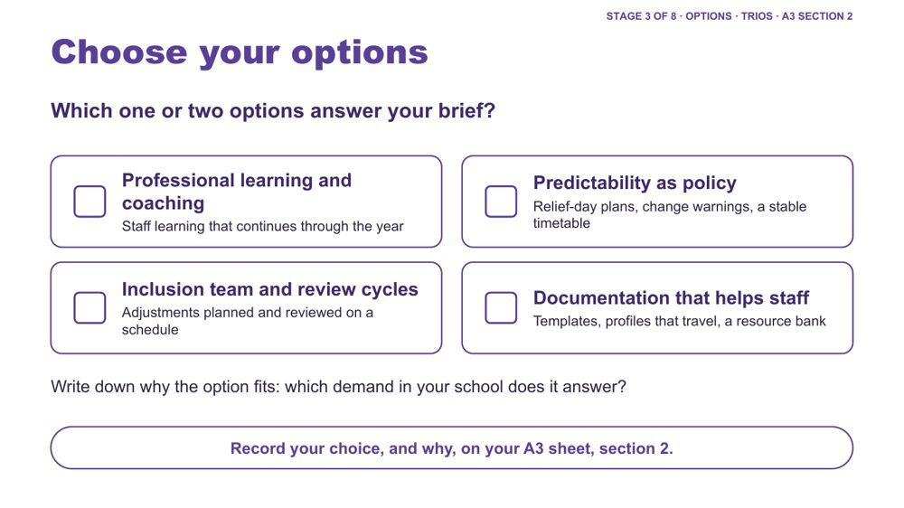 | Choose your options  SUGGESTED TIME  2 min  CLOCK  1:34 - 1:36  GROUPING  Trios  PARTICIPANT GUIDE  Page 18 - Options we chose

Trios choose one or two options that answer a specific demand in their school system.
WHAT TO DO  - Ask trios to pick one or two options, not all four.  - Ask them to note why each option answers a specific demand in their school.  - Name that "Something else" is also on the sheet if their brief needs a different system.  - Ask them to record the choice, and why, on the A3 sheet, section 2. | KEY MESSAGES  - The point is matching support to a known demand, not collecting strategies.

ACTIVITY | Trio decision on the A3 sheet, section 2 trios · about 2 minutes
Which one or two options answer your brief?
- Sort the printed option cards against your brief.
- Choose one or two options.
- Write down which demand in your school each option answers.
- Record your choice, and why, on the A3 sheet, section 2.

KEEP IN MIND
- Discourage choosing all four options.

SESSION 4 | Learning Design | SLIDE 16 of 24

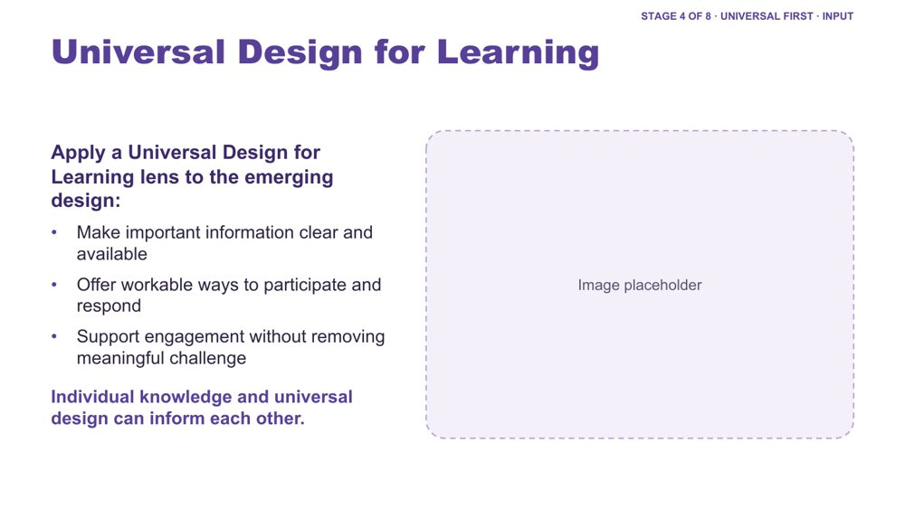 | Universal Design for Learning  SUGGESTED TIME  2 min  CLOCK  1:36 - 1:38

Frame a Universal Design for Learning lens before the trios' accessibility check.
WHAT TO DO  - Keep this input to about two minutes.  - Introduce Universal Design for Learning using the three points on the slide.  - Name that at school level, universal design can shape policies, templates, timetables and shared spaces as well as lessons.  - Name that individual knowledge and universal design can inform each other. | KEY MESSAGES  - Universal design and individual knowledge can inform each other.  - The presence of a resource does not guarantee access.

SESSION 4 | Learning Design | SLIDE 17 of 24

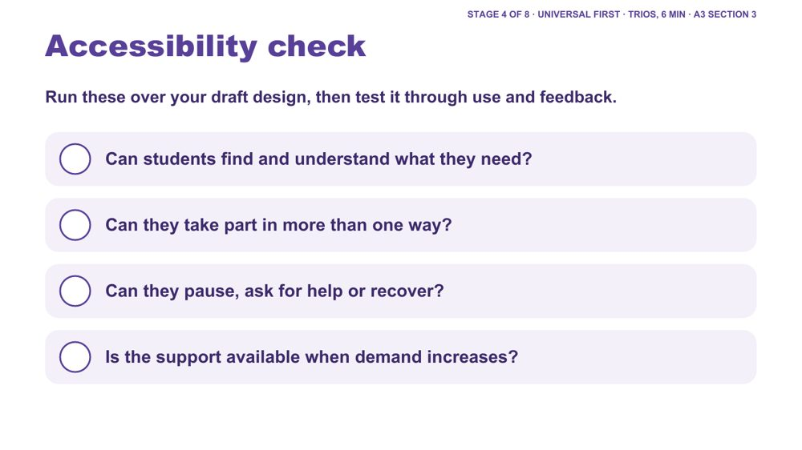 | Accessibility check  SUGGESTED TIME  4 min  CLOCK  1:38 - 1:42  GROUPING  Trios  PARTICIPANT GUIDE  Page 19 - Universal first

Trios test their draft design against four accessibility questions.
WHAT TO DO  - Ask trios to run the four questions over their draft design.  - Ask them to tick each on the A3 sheet, section 3, and note what they adjusted.  - Where the answer is "not yet", ask them to adjust the design before moving on.  - Ask whether the design works for students across the school, including on a day when something changes. | KEY MESSAGES  - Accessibility is tested through use and feedback, not assumed from the presence of a resource.

ACTIVITY | Trio check on the A3 sheet, section 3 trios · about 4 minutes (6 minutes with the UDL input)
Run these over your draft design, then test it through use and feedback.
- Can students find and understand what they need?
- Can they take part in more than one way?
- Can they pause, ask for help or recover?
- Is the support available when demand increases?
- Where the answer is "not yet", adjust the design.

SESSION 4 | Learning Design | SLIDE 18 of 24

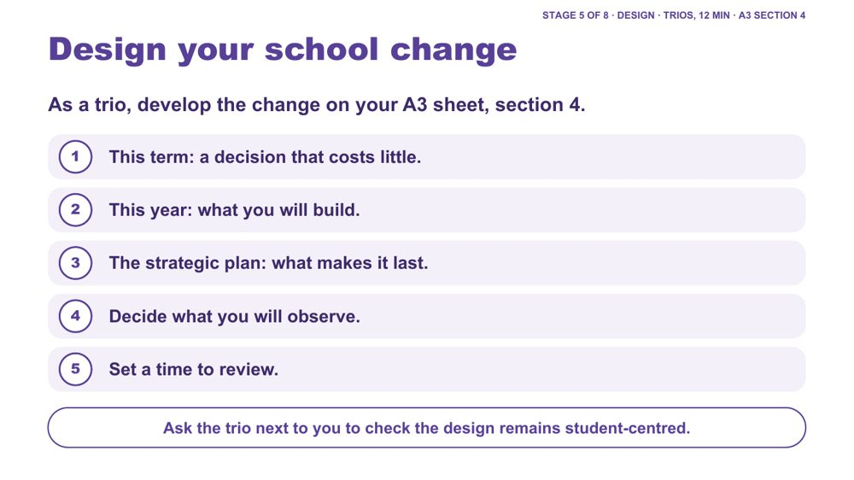 | Design your school change  SUGGESTED TIME  12 min  CLOCK  1:42 - 1:54  GROUPING  Trios  PARTICIPANT GUIDE  Page 20 - Our school change

Trios develop one school change, planned for this term, this year and the strategic plan.
WHAT TO DO  - Ask trios to work through the five steps on the A3 sheet, section 4.  - This term: a decision that costs little and can start soon.  - This year: what the school will build, such as a template, a review cycle or a coaching arrangement.  - The strategic plan: what makes the change last, so it becomes part of how the school works and does not depend on particular staff.  - Ask trios to decide what they will observe and when they will review it.  - Near the end, ask each trio to have the trio next to them check the design remains student-centred and environment-first. | KEY MESSAGES  - The measure of success should be access, not compliance.  - Planning across this term, this year and the strategic plan links a quick start to lasting change.

ACTIVITY | Trio design on the A3 sheet, section 4, with a neighbouring-trio check trios · 12 minutes
As a trio, develop the change on your A3 sheet, section 4.
- This term: a decision that costs little.
- This year: what you will build.
- The strategic plan: what makes it last.
- Decide what you will observe.
- Set a time to review.
- Ask the trio next to you to check the design remains student-centred.
Close: Each person takes the design back to their own school; trio members from different schools may adapt it.

KEEP IN MIND
- Avoid making students' compliance the success measure.
- Keep the design at the level of systems and norms, not individual staff.

Background This-term examples if needed: an agreed relief-day plan; a norm that changes are warned before students arrive; leaders modelling a kind interruption of deficit language at the next staff meeting. This-year examples: a one-page profile template that travels; an inclusion team with a set review cycle. Strategic plan examples: an inclusion goal and review point written into the school plan; induction for new and relief staff that includes the school's approach.
Thread Section 4 of the A3 sheet is what participants take back to their executive team.

SESSION 4 | Learning Design | SLIDE 19 of 24

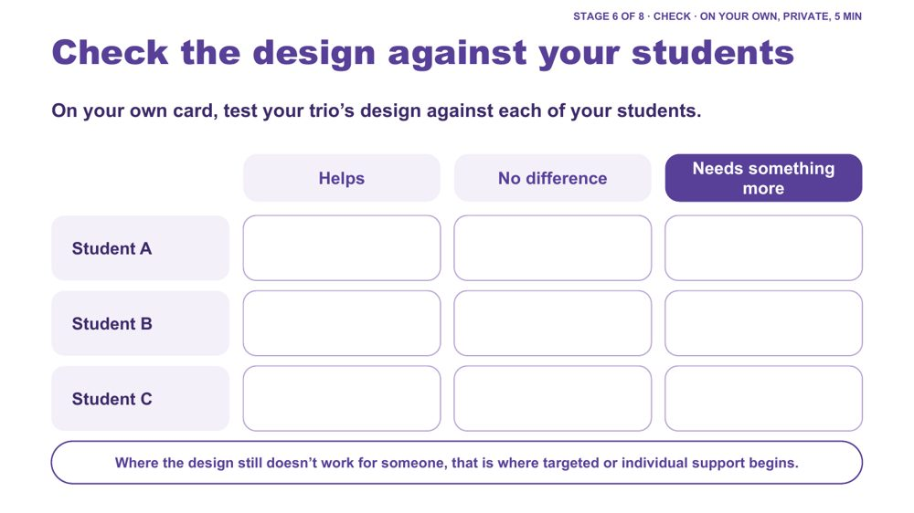 | Check the design against your students  SUGGESTED TIME  5 min  CLOCK  1:54 - 1:59  GROUPING  On your own  PARTICIPANT GUIDE  Page 21 - My students check

Each person privately tests the trio's design against each of the students they have in mind.
WHAT TO DO  - Ask each person to use their own "My students" card, privately.  - Ask them to mark each student (Student A, B, C) as Helps, No difference or Needs something more.  - Name that a trio brings six to nine real students to one design: this is where the broad, mixed picture of autism shows up.  - Invite trios to share only what they choose, for example how many "needs something more" marks the design collected, without describing students.  - Invite one or two examples of "needs something more" to open the continuum discussion. | KEY MESSAGES  - Where the design still doesn't work for someone, that is where targeted or individual support begins.  - One school design will work differently for different Autistic students.

ACTIVITY | Private check on the "My students" card on your own · 5 minutes
On your own card, test your trio's design against each of your students.
- List your students as Student A, B and C.
- Mark each: Helps, No difference or Needs something more.
- Share with your trio only what you choose.
Bring the room back
- How many "needs something more" marks did your design collect?
Close: Where it helps, the universal design is doing its job. Where it makes no difference or a student needs something more, that leads into the continuum of support.

KEEP IN MIND
- Keep it private: no names or identifying details, initials or letters only.

Background This keeps individual students in view without building a profile of one child.
Thread Leads straight into the continuum of support (Stage 7).

SESSION 4 | Learning Design | SLIDE 20 of 24

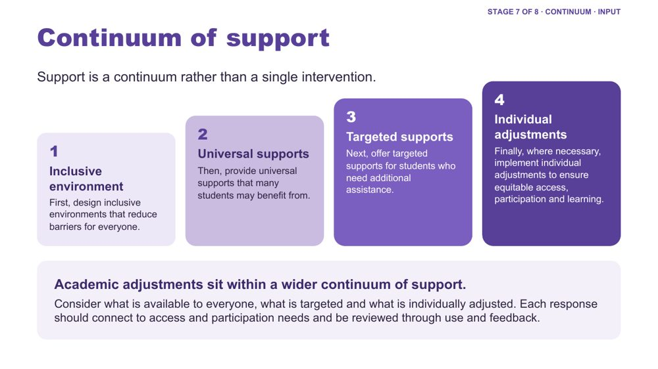 | Continuum of support  SUGGESTED TIME  3 min  CLOCK  1:59 - 2:02

Show what happens when the check shows "needs something more": a continuum from inclusive environment to individual adjustments.
WHAT TO DO  - Open from the "needs something more" examples just shared.  - Walk the four layers: inclusive environment, universal supports, targeted supports, individual adjustments.  - Use one example per layer from the background below.  - Ask where each layer sits in their school: who decides, who delivers and who reviews.  - Connect adjustments to evidence from the school-day map, consultation and the design process. | KEY MESSAGES  - Support is a continuum rather than a single intervention.  - Design the inclusive environment first, then add support deliberately where it is needed.  - Each response should connect to access and participation needs and be reviewed through use and feedback.

KEEP IN MIND
- Do not imply that diagnosis alone determines an adjustment.

Background Inclusive environment: predictable routines, visual schedules, clear expectations, and a classroom culture where different ways of participating are accepted and valued. Universal supports: instructions in verbal, written and visual forms, flexible ways to demonstrate learning, movement breaks, sensory tools available to any student. Targeted supports: a small group receives pre-teaching of key vocabulary, a structured organisation checklist or additional executive functioning supports during independent work. Individual adjustments: a personalised adjustment plan, for example a quieter workspace during assessments, additional processing time, a visual task breakdown and alternative ways to demonstrate learning.

SESSION 4 | Learning Design | SLIDE 21 of 24

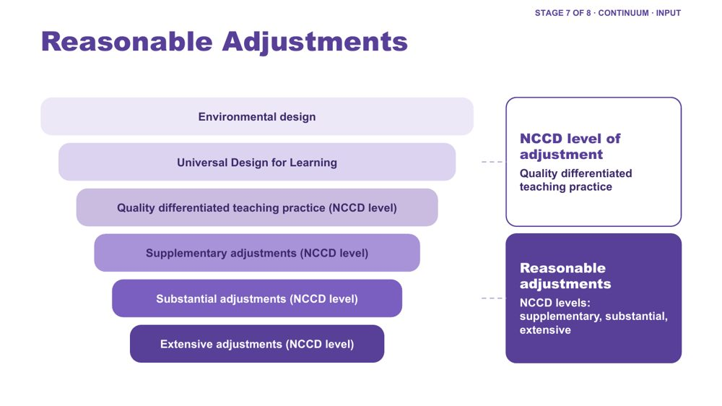 | Reasonable Adjustments  SUGGESTED TIME  2 min  CLOCK  2:02 - 2:04

Place reasonable adjustments and NCCD levels of adjustment within the layers of inclusive design.
WHAT TO DO  - Walk the funnel from environmental design and UDL through quality differentiated teaching practice (an NCCD level of adjustment) to supplementary, substantial and extensive adjustments (the other three NCCD levels of adjustment).  - Give the definition of reasonable adjustments from the background below.  - Distinguish reasonable adjustments (the support actions) from the NCCD (the process for collecting information about them). | KEY MESSAGES  - Adjustments are individualised, strengths based, remove barriers, practical and effective, based on informed decision making, and empowering and enabling.  - Supports and adjustments build student capability, confidence, self-advocacy and independence, not dependence on adults.

YOU MIGHT SAY
Reasonable adjustments are changes or supports that help students access and participate in education in a way that works for them.

KEEP IN MIND
- Do not give legal advice or present the workshop as a substitute for school or system processes.

Background Adjustments align to the curriculum. Schools consider the needs of the student as well as the impact on staff, other students and available resources. A student is included in the NCCD when they have a disability as defined under the Disability Discrimination Act (DDA), the school has provided reasonable adjustments to address their educational needs, and evidence exists that the adjustments have been provided and monitored. The NCCD helps schools demonstrate compliance with the DSE, monitor the effectiveness of adjustments, ensure students receive appropriate support, and inform planning and resource allocation.

SESSION 4 | Learning Design | SLIDE 22 of 24

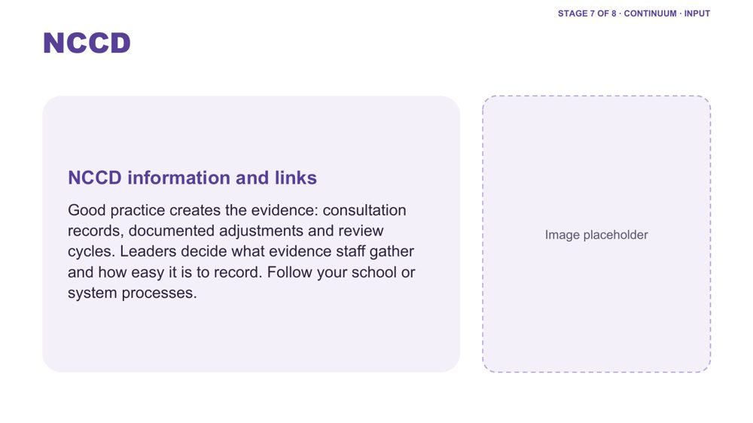 | NCCD  SUGGESTED TIME  2 min  CLOCK  2:04 - 2:06

Connect NCCD to everyday practice: good practice creates the evidence, and leaders set how easy it is to record.
WHAT TO DO  - Direct participants to current official NCCD information.  - Name that consultation records, documented adjustments and review cycles are the evidence; good practice creates it.  - Ask the leadership question: what evidence do you ask staff to gather, and how easy have you made it to record?  - Link to the documentation option: short templates make recording part of the work.  - Invite participants to follow the consultation, documentation and review processes used in their school or system. | KEY MESSAGES  - Good practice creates the evidence.  - Leaders decide what evidence staff gather and how easy it is to record.  - Use current official NCCD information and follow school and system requirements.

KEEP IN MIND
- Do not give legal advice or present the workshop as a substitute for school or system processes.
- Do not imply that diagnosis alone determines an adjustment.

Thread Consultation and the NCCD meeting tool kit are developed further in Session 5.

SESSION 4 | Learning Design | SLIDE 23 of 24

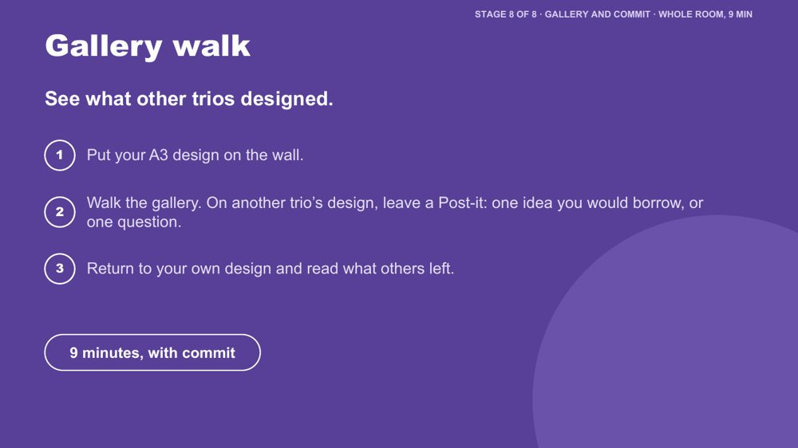 | Gallery walk  SUGGESTED TIME  5 min  CLOCK  2:06 - 2:11  GROUPING  Whole room

Every trio sees the other designs and can borrow ideas from them.
WHAT TO DO  - Ask each trio to put their A3 design on the wall.  - Ask people to walk the gallery and leave a Post-it on another trio's design: one idea they would borrow, or one question.  - Allow about 4 minutes for the walk.  - Ask trios to return to their own design and read what others left.  - Move to the commit slide. | KEY MESSAGES  - Leaders can borrow ideas from other schools' designs.

ACTIVITY | Gallery walk with Post-its whole room · about 5 minutes
See what other trios designed.
- Put your A3 design on the wall.
- Walk the gallery. On another trio's design, leave a Post-it: one idea you would borrow, or one question.
- Return to your own design and read what others left.

KEEP IN MIND
- Keep designs anonymised: no student or staff names or identifying details on the wall.

Thread Echoes the Session 3 Post-it wall ("What should travel between people and places?").

SESSION 4 | Learning Design | SLIDE 24 of 24

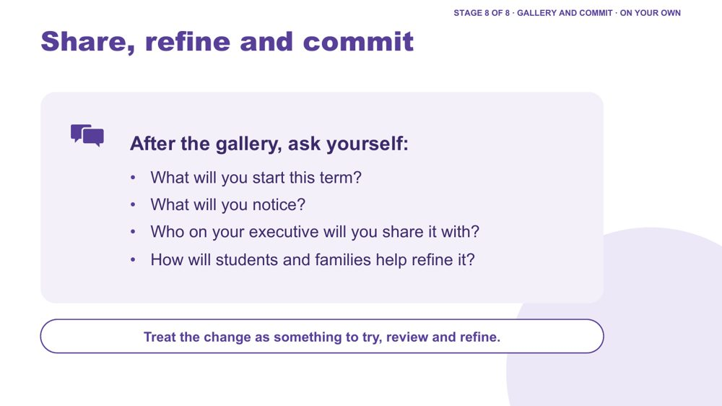 | Share, refine and commit  SUGGESTED TIME  4 min  CLOCK  2:11 - 2:15  GROUPING  On your own  PARTICIPANT GUIDE  Page 21 - Commit

Refine the design and commit to a realistic first step back at school.
WHAT TO DO  - Ask participants to write their answers in the Commit box: what I will start this term, what I will notice, and who on my executive I will share it with.  - They can also use the "My students" card on page 2 of the A3 sheet: This term, I will start / I will share it with.  - Ask how students and families will help refine the change.  - Invite optional sharing in pairs or with the whole group.  - Encourage consultation with students, families and staff before the change is presented as finished.  - Transition to Session 5, Working in Partnership. | KEY MESSAGES  - A school change is something to try, review and refine.  - Student, family and staff knowledge can refine what leaders notice and try.

ACTIVITY | Personal commitment in the Participant Guide on your own · about 4 minutes
What will you start this term? What will you notice? Who on your executive will you share it with? How will students and families help refine it?
- Write what you will start this term.
- Write what you will notice.
- Write who on your executive you will share it with.
Close: Treat the change as something to try, review and refine.

KEEP IN MIND
- Keep any public example anonymised.
- Do not ask participants to announce a decision before consulting the people affected.

Thread Leads into Session 5, where partnership with students, families and staff is treated as part of leadership strategy. The "this term" step can become the Start on the Session 6 card.

Session 4 · Hidden slides
These slides stay in the deck but are hidden, so they do not show when presenting. Unhide one in PowerPoint (right-click the slide, then Unhide Slide) if you want it back.
Slide | Title | Why it is hidden
25 | Design one change | Folded into Regroup and the brief: trios now choose one school system to redesign.
26 | Identifying and reducing barriers in practice | Folded into the options menu to keep inputs short; its questions also suit the accessibility check.
27 | Inclusive Design | The fuller Reasonable Adjustments funnel in Stage 7 covers the same layers.
28 | Differentiation | Cut for time in the workshop version; UDL carries this idea.
29 | Designing inclusive learning environments | Cut for time in the workshop version.
30 | A continuum of support example | Condensed: its examples are in the Continuum of support notes (slide 20).
31 | What are reasonable adjustments? | Condensed: its definition and notes are on the Reasonable Adjustments slide (slide 21).
32 | Environmental / Audits | Overlaps the school-level audit, which now sits at the end of Session 3.
33 | Let's discuss - Inclusive Checklist for Supporting Autistic Students | A second activity competing with the main design task; the printed checklist could still be offered as a resource.
34 | Supporting Frameworks/Guidance | Cut for time; these resources are listed in the Participant Guide (p. 30), and consultation is covered in Session 5.
35 | Disability Standards for Education (DSE) 2005 | Cut for time; these resources are listed in the Participant Guide (p. 30), and consultation is covered in Session 5.
36 | Activity: Determining supports and adjustments | Cut for time; these resources are listed in the Participant Guide (p. 30), and consultation is covered in Session 5.
37 | Record - Monitor - Review | Appendix reference on reviewing adjustments; not in the workshop flow.
38 | Student Consultation | Appendix reference on consulting students; not in the workshop flow (fits Session 5).
39 | Parent/Carer Consultation | Appendix reference on consulting families; not in the workshop flow (fits Session 5).

SESSION  5 | 2:15 - 3:15 · 60 MINUTES · 19 SLIDES  Working in Partnership  Partnership as strategy

SESSION INTENT
Help school leaders treat partnership as part of how the school is designed: keep the student at the centre, build family engagement into school routines, help repair trust where it has broken down, and examine how power shapes consultation with families, students and staff. Participants leave with practical consultation moves and a question ready for their Session 6 conversation plan.
PARTICIPANTS LEAVE WITH
- explain why the student sits at the centre of every partnership, and name the collaboration principles all partners share
- describe the basics of family engagement by design and the leader's part in repairing trust
- identify where power sits in home-school meetings and one process change the school could make
- use practical ways to consult students, families and staff, including discussing capacity without blame
- prepare the opening question and shared purpose for one purposeful family conversation

RUN SHEET
Clock | Segment | Slides | Minutes
2:15 - 2:21 | Opening: the student at the centre | 1-3 | 6
2:21 - 2:31 | Collaboration, engagement by design and repairing trust | 4-6 | 10
2:31 - 2:40 | Power dynamics | 7-8 | 9
2:40 - 2:45 | Student voice video | 9 | 5
2:45 - 2:59 | Partnership activity and what works | 10-11 | 14
2:59 - 3:08 | Consulting well | 12-15 | 9
3:08 - 3:11 | Tools and supports | 16-18 | 3
3:11 - 3:15 | Bridge to Session 6 | 19 | 4

PREPARE
☐ Post-it notes and pens for every participant (slide 8).
☐ Butcher's paper on the wall headed Home, School and Solutions, if using the wall option (slide 8).
☐ Participant Guide p. 24 (Partnership activity grid) ready for each table (slide 10).
☐ Student voice video (Adon) cued and sound checked (slide 9).
☐ Phone numbers and services on slide 18 checked as current.
☐ Participant Guide pp. 22 - 25 ready to point to.

SESSION 5 | Working in Partnership | SLIDE 1 of 19

 | Working in Partnership  SUGGESTED TIME  1 min  CLOCK  2:15 - 2:16

Open the partnership session and connect it to the school-level design work.
WHAT TO DO  - Name the shift from what the school can redesign to how home and school can understand and act together.  - Explain that leaders shape the routines in which contact, meetings, decisions and follow-up happen.  - Pick up the "I will share it with" line participants wrote on their Session 4 'My students' card, and the executive colleague they named on their Commit.  - Keep the student at the centre of the conversation.  - Acknowledge that participants may bring both productive and difficult partnership experiences, with families and within their own teams.  - Remind the room that sharing is voluntary and examples stay anonymised (initials or roles only). | KEY MESSAGES  - Partnership is part of understanding and support, not an additional task after decisions are made.  - The student, family and school may each hold different parts of the picture.  - Leaders set up the conditions in which partnership conversations happen.

Thread Picks up the Session 4 'My students' card ("I will share it with") and the Commit table ("Who on my executive I will share it with"), Participant Guide p. 21.

SESSION 5 | Working in Partnership | SLIDE 2 of 19

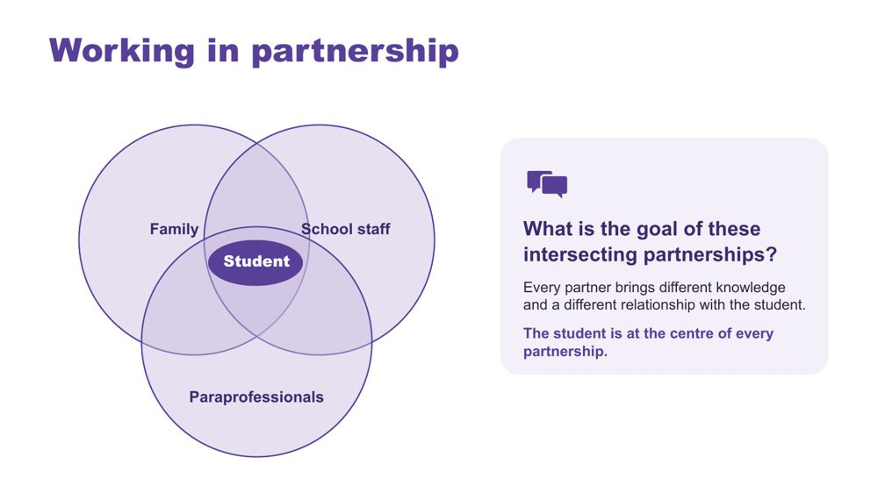 | Working in partnership  SUGGESTED TIME  3 min  CLOCK  2:16 - 2:19  PARTICIPANT GUIDE  Page 22 - Session 5 summary

Show where the partnerships around a student intersect, with the student at the centre of every one.
WHAT TO DO  - Introduce the Venn: family, school staff and paraprofessionals, with the student at the centre.  - Explain that every partner brings unique knowledge, expertise and perspectives, and a different relationship with the student and with each other.  - Ask the group: What is the goal of these intersecting partnerships?  - Steer the discussion so the point is made that the student is at the centre of all partnerships.  - Link back where relevant: Autistic flourishing (Session 2), Autistic experience at school (Session 3), learning design and the continuum of support (Session 4).  - Ask who is missing from the picture and how the student's communication can be included.  - Ask leaders where their school's processes bring these partners together, and where their knowledge stays separate.  - Point participants to Where partnerships converge in the Participant Guide (p. 22). | KEY MESSAGES  - Positive partnership keeps the student at the centre.  - No single person holds the complete picture.  - Every partner brings different knowledge and a different relationship with the student.

YOU MIGHT SAY
What is the goal of these intersecting partnerships?

KEEP IN MIND
- Use the elements as discussion prompts rather than a complete definition.

Background With session time limited, this slide is a chance to see where all the partnerships converge and what is needed for success across all of them.
Thread Draws on Autistic flourishing (Session 2), Autistic experience at school (Session 3) and the Session 4 school change and continuum of support.

SESSION 5 | Working in Partnership | SLIDE 3 of 19

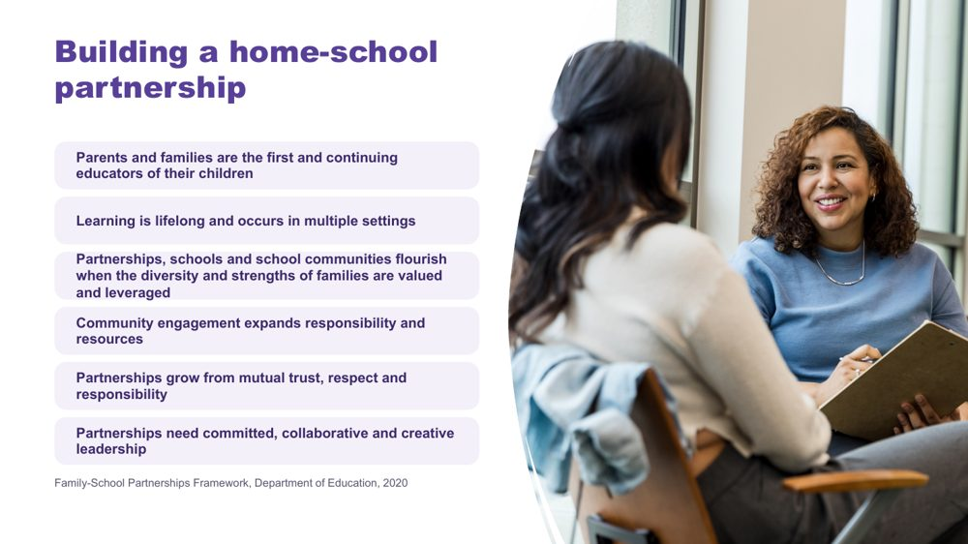 | Building a home-school partnership  SUGGESTED TIME  2 min  CLOCK  2:19 - 2:21

Make positive partnership concrete in school practice using the Family-School Partnerships Framework principles.
WHAT TO DO  - Walk through the six Framework principles briefly.  - Draw attention to the last principle: partnerships need committed, collaborative and creative leadership.  - Position family knowledge and school knowledge as different, useful perspectives.  - Name what makes partnership visible in practice: a shared purpose, respectful listening, student voice and communication, clear accessible information, and agreed next steps, responsibilities and follow-up. | KEY MESSAGES  - The student, family and school may each see different parts of experience. Partnership helps these perspectives inform understanding, design, action and review from the beginning.  - Listening, clarity and shared next steps can be observed in practice.

KEEP IN MIND
- Avoid implying that agreement is required before listening or respect are possible.

RESOURCES
- Family-School Partnerships Framework - Department of Education, Australian Government - https://www.education.gov.au/supporting-family-school-community-partnerships-learning/family-school-partnerships/family-school-partnerships-framework

SESSION 5 | Working in Partnership | SLIDE 4 of 19

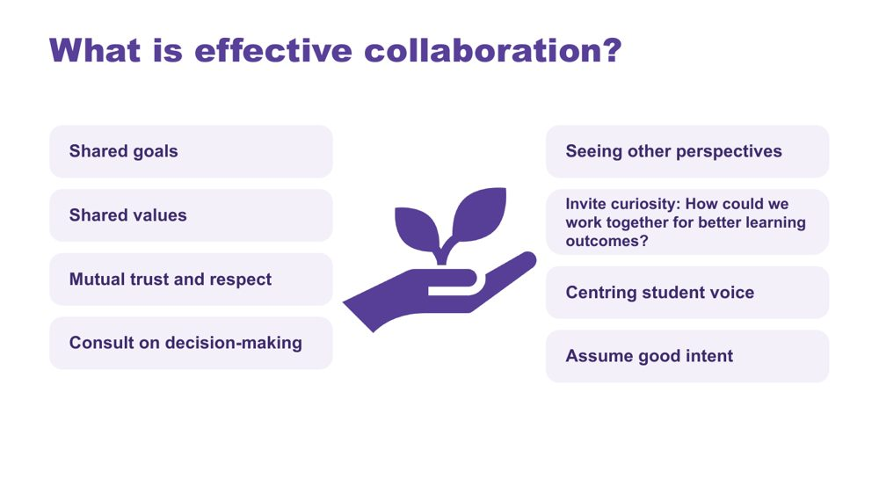 | What is effective collaboration?  SUGGESTED TIME  3 min  CLOCK  2:21 - 2:24

Name the collaboration principles that strong partnerships share, whoever is at the table.
WHAT TO DO  - Introduce the importance of collaboration: for Autistic students there are multiple collaboration points across multiple partnerships.  - Explain that the key collaboration skills are the same across all groups, and are vital for strong partnerships. They apply to leaders working with staff as well as with families.  - Ask the group: What are some of the key principles for effective collaboration to occur?  - Build the discussion to cover: shared goals, shared values, mutual trust and respect, consulting on decision-making, seeing other perspectives, inviting curiosity, centring student voice, assuming good intent.  - If the cards are set to appear on click, reveal them once the room has contributed. | KEY MESSAGES  - The collaboration skills needed are the same across every partnership around the student.

YOU MIGHT SAY
What are some of the key principles for effective collaboration to occur?
How could we work together for better learning outcomes?

Background This slide was added by the team because it works well with all parties and helps shift perspectives.

SESSION 5 | Working in Partnership | SLIDE 5 of 19

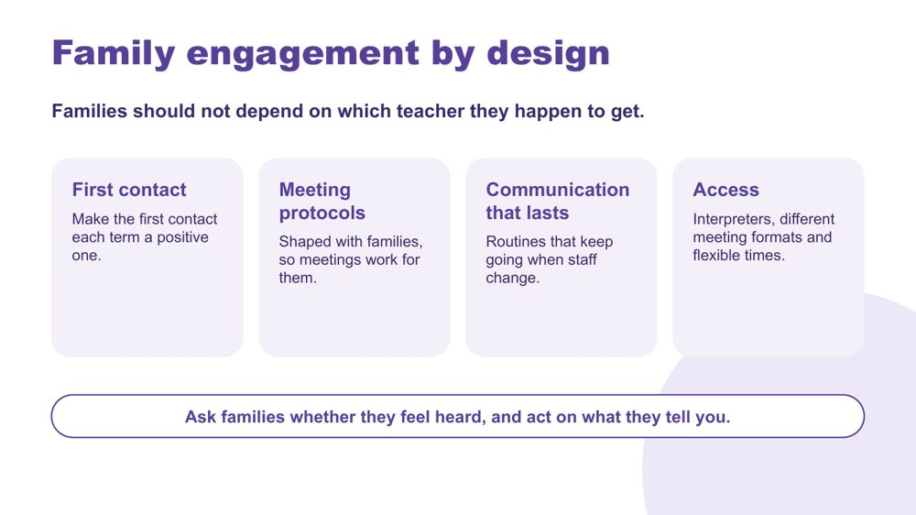 | Family engagement by design  SUGGESTED TIME  4 min  CLOCK  2:24 - 2:28  PARTICIPANT GUIDE  Page 22 - Session 5 summary (Family engagement by design)

Show how a school can build the basics of family engagement into its routines, so the quality of partnership does not depend on which teacher a family has.
WHAT TO DO  - Read the opening line: families should not depend on which teacher they happen to get.  - Explain that in many schools, how well a family is included depends on individual staff. Leaders can set some basics that every family can expect.  - Walk through the four cards.  - First contact: make the first contact each term a positive one, so the first call or message home about a student is not about a problem.  - Meeting protocols: shape them with families. For example, the agenda is sent ahead, a support person is welcome, there is time for questions, and a short written summary follows.  - Communication that lasts: routines that keep going when staff change, such as agreed contact channels, a record of each family's communication preferences, and a handover when a teacher or case manager changes.  - Access: interpreters, different meeting formats (in person, phone or online) and flexible times.  - Ask: Which of these does your school already do reliably? Which ones depend on particular staff?  - Point to the last line: ask families whether they feel heard, and act on what they tell you. This could be one question at the end of a meeting, a follow-up call, or an item in a family survey. Tell families what changed as a result. | KEY MESSAGES  - Family engagement can be part of a school's systems, as well as its individual relationships.  - First contact, meeting design, communication and follow-up are leadership concerns.  - Access (interpreters, formats and timing) is part of making partnership fair for every family.  - Asking families whether they feel heard is a practical way to check the system is working.

YOU MIGHT SAY
Which of these does your school already do reliably? Which ones depend on particular staff?

KEEP IN MIND
- Keep examples structural (norms, protocols, routines), rather than stories of one staff member doing it well or badly.
- Do not name or blame staff. Where something depends on one person, treat that as a gap in the process.

Background Family engagement can be designed at school level: first-contact norms, meeting protocols that families help shape, and communication routines that continue when staff change. Interpreter access, meeting formats and flexible timing affect which families can take part. Schools can also check how it is working by asking families whether they feel heard.
Thread A family-engagement routine can sit in the Session 4 School change sheet, under "This year: what we will build" or "The strategic plan: what makes it last".

SESSION 5 | Working in Partnership | SLIDE 6 of 19

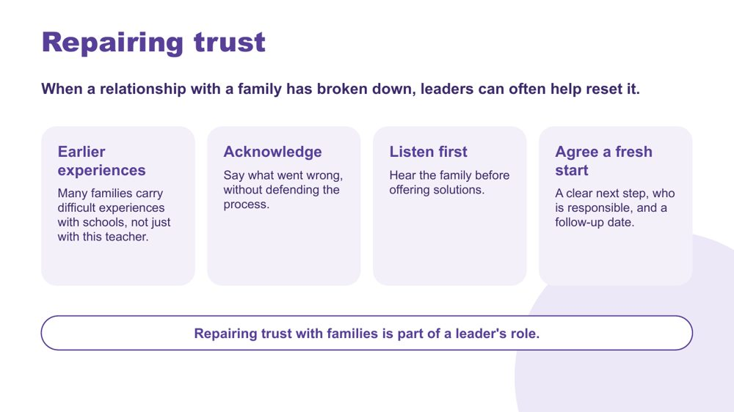 | Repairing trust  SUGGESTED TIME  3 min  CLOCK  2:28 - 2:31  PARTICIPANT GUIDE  Page 22 - Session 5 summary (Repairing trust)

Explore how leaders can help reset a relationship with a family when trust has broken down.
WHAT TO DO  - Read the opening line: when a relationship with a family has broken down, leaders can often help reset it. A teacher cannot always do this alone.  - Earlier experiences: explain that many families carry difficult experiences with schools over several years, not just with this teacher. Some arrive at a meeting expecting a difficult conversation before anything is said.  - Acknowledge: say plainly what went wrong, without defending the process.  - Listen first: hear the family's account before offering solutions.  - Agree a fresh start: a clear next step, who is responsible, and a follow-up date. Then follow through.  - Ask the group to think privately: What can a school acknowledge? What can it clarify? What can it change within its authority? What follow-through is possible?  - Point to the last line: repairing trust with families is part of a leader's role. | KEY MESSAGES  - Trust repair depends on listening, acknowledgement and reliable follow-through.  - Trust is mostly built in routine communication, so the basics on the previous slide help prevent breakdowns.  - Trust repair cannot promise a particular outcome. It can promise a clear next step and a follow-up.

YOU MIGHT SAY
What can a school acknowledge, clarify, change and follow through?

KEEP IN MIND
- Do not ask participants to describe a current dispute or invite the group to solve an identifiable case.
- Some participants will have had hard encounters with families. Acknowledge that partnership works both ways, while keeping the focus on what the school can change.
- Follow local complaints and escalation processes; this slide does not replace them.

Thread Builds on Family engagement by design (slide 5) and leads into power dynamics (slides 7 - 8).

SESSION 5 | Working in Partnership | SLIDE 7 of 19

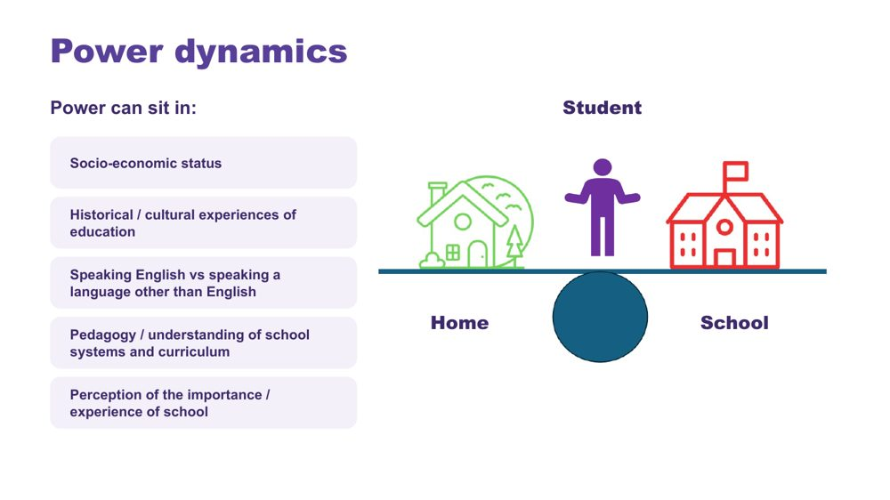 | Power dynamics  SUGGESTED TIME  3 min  CLOCK  2:31 - 2:34

Help participants notice how agendas, language, authority and decision-making shape consultation.
WHAT TO DO  - Introduce the seesaw: school, home and the student.  - Name where power can sit: socio-economic status, historical and cultural experiences of education, speaking English or another language, understanding of school systems and curriculum, and perceptions of the importance of school.  - Ask the power questions below to examine practice, not to blame individual participants.  - Invite leaders to identify where school language, timing or process may create a barrier, and where the same barrier keeps coming up across families. | KEY MESSAGES  - Power is present in meeting structures, language and decision pathways.  - Leaders can change a process when it repeatedly creates a barrier.

YOU MIGHT SAY
Who sets the agenda?
Whose knowledge is heard?
Who can make decisions?
Is the student included in a way that works for them?
What could the school change about the process?
Where could leadership change a barrier that keeps coming up?

KEEP IN MIND
- Avoid describing a family as difficult, disengaged or unrealistic without examining the context and process.

Thread Follows Repairing trust (slide 6): families who arrive expecting a difficult meeting are often responding to how power has worked in earlier meetings.

SESSION 5 | Working in Partnership | SLIDE 8 of 19

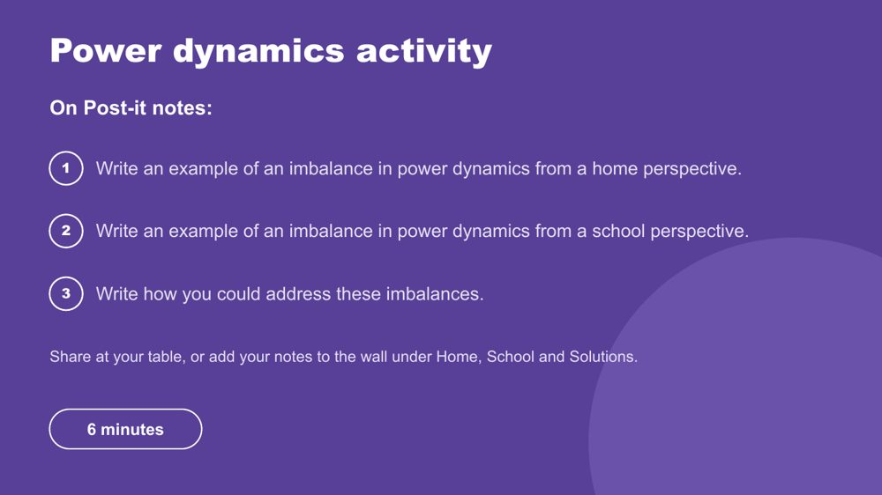 | Power dynamics activity  SUGGESTED TIME  6 min  CLOCK  2:34 - 2:40  GROUPING  Table groups  PARTICIPANT GUIDE  Page 23 - Power dynamics

Prompt educators to reflect on perceived and real power imbalances in the home-school relationship.
WHAT TO DO  - Make sure every participant has Post-it notes and a pen.  - Direct participants to the three instructions on the slide.  - Choose a sharing option that suits the room (see steps).  - Support tables to look for solutions rather than place blame, and to think about school processes as well as individual meetings.  - Take feedback from a few participants at the end. | KEY MESSAGES  - Power can be structural, historical, cultural, conscious and unconscious.  - Status can be perceived as an imbalanced power dynamic, regardless of intent.

ACTIVITY | Post-it note reflection table groups · 6 minutes
Where do power imbalances sit in the home-school relationship, and how could you address them?
- On one Post-it, write an example of an imbalance in power dynamics from a home perspective.
- On a second, write an example from a school perspective.
- On a third, write how you could address these imbalances.
- Option 1: share Post-it notes with your table.
- Option 2 (movement break): take your Post-it notes to another person in the room to share.
- Option 3: place Post-it notes on butcher's paper on the wall under Home, School and Solutions.
Bring the room back
- Who sets the agenda?
- Whose knowledge is heard?
- Who can make decisions?
- What could the school change about the process?
- Which of these solutions would need a leadership decision?
Close: Ask participants to keep one process change for their conversation plan.

KEEP IN MIND
- This may be challenging for some participants, who may have found themselves in positions of power or lack of power at different times in their career. Guide individuals to seek solutions and not place blame.

Background Educators are immersed in the culture of education, including a shared understanding of acronyms (e.g. NAPLAN, NCCD, IEP) which families may not be able to access as easily. Some people will purposely and naturally endow teachers with higher status, which can be a cultural or personal attitude. External providers and professionals can also affect the power dynamic between those working with and supporting Autistic students.
Thread The process change chosen here carries into the bridge reflection (slide 19) and the Session 6 conversation plan.

SESSION 5 | Working in Partnership | SLIDE 9 of 19

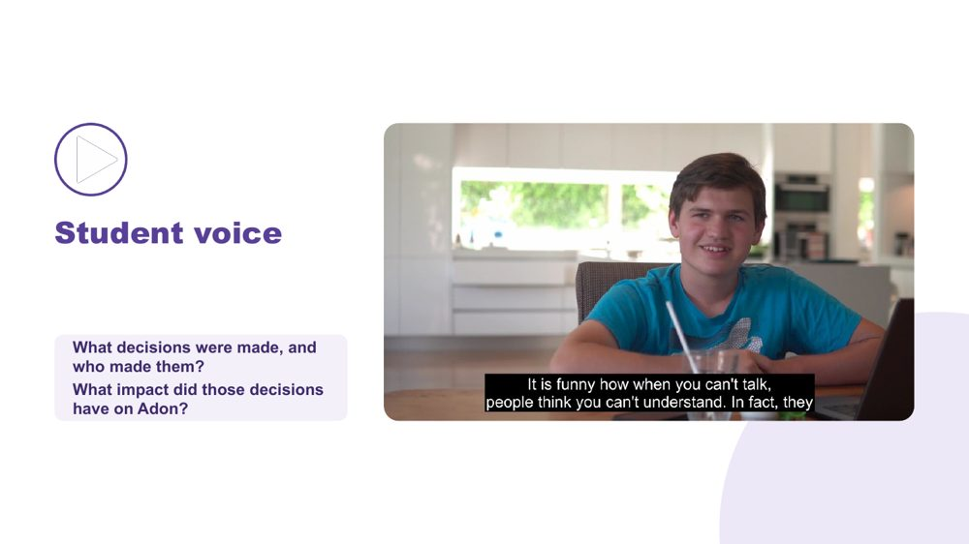 | Student voice  SUGGESTED TIME  5 min  CLOCK  2:40 - 2:45  PARTICIPANT GUIDE  Page 23 - Student voice

Show what happens when a student is not listened to or consulted.
WHAT TO DO  - Introduce the video as an example of a student who is not listened to or consulted.  - Ask participants, while watching, to pay attention to what decisions were made and who made them.  - Play the video.  - Ask the group: What impact did those decisions have on Adon?  - Connect to the students participants have in mind: how are their preferences asked and heard, and where does the school record them? | KEY MESSAGES  - Students should have a say in decisions about them, at their level and in the way they communicate.  - Even young children can show preferences: choices offered visually, reactions observed and honoured.  - Ask students in a way that works for them: what helps? what's hard? what should teachers know?  - Record their answers in their own words, so the student's view is part of the record.  - This is an early step in building self-advocacy.

YOU MIGHT SAY
While watching, pay attention to what decisions were made and who made them.
What impact did those decisions have on Adon?

SESSION 5 | Working in Partnership | SLIDE 10 of 19

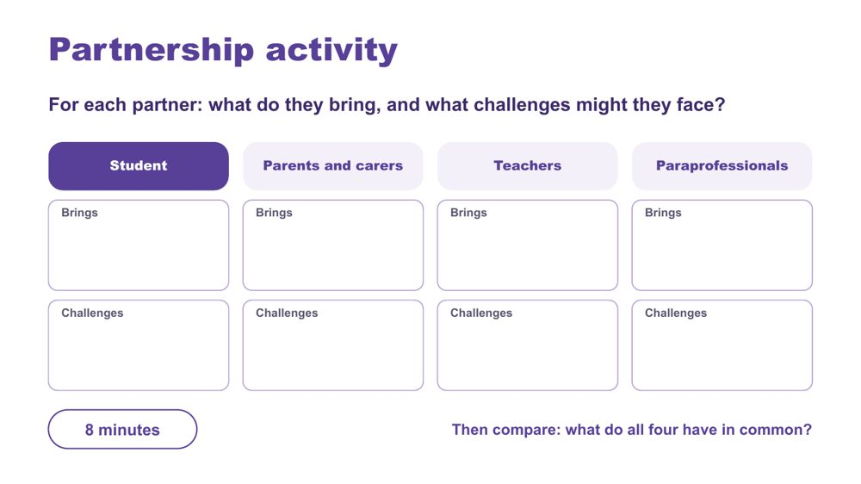 | Partnership activity  SUGGESTED TIME  8 min  CLOCK  2:45 - 2:53  GROUPING  Table groups  PARTICIPANT GUIDE  Page 24 - Partnership activity

Compare what each partner brings and the challenges they may face, and find what they share.
WHAT TO DO  - Make sure each table has the Partnership activity grid in the Participant Guide (p. 24).  - Ask table groups to record what each partner brings and what challenges they might face: student, parents and carers, teachers, paraprofessionals.  - Ask tables to compare: what do all four have in common?  - Take thoughts on similarities and differences, list the commonalities, and ask what would make the partnership more successful. | KEY MESSAGES  - Understanding the challenges and strengths of each partner can help build trust and confidence in the relationship.  - There are similarities and differences between what each partner brings to the partnership.  - Everyone has the student at the centre and student voice is included.  - At the heart of all interactions there should be an assumption of good intent regarding the outcomes for the student.

ACTIVITY | Table group partnership grid table groups · 8 minutes
For each partner: what do they bring, and what challenges might they face?
- Work through the four partners: student, parents and carers, teachers, paraprofessionals.
- For each, note what they bring and what challenges they might face.
- Compare: what do all four have in common?
Bring the room back
- What are the similarities and differences across the four partners?
- What would make the partnership more successful?
Close: List the commonalities the room names and link them to the collaboration principles on slide 4.

SESSION 5 | Working in Partnership | SLIDE 11 of 19

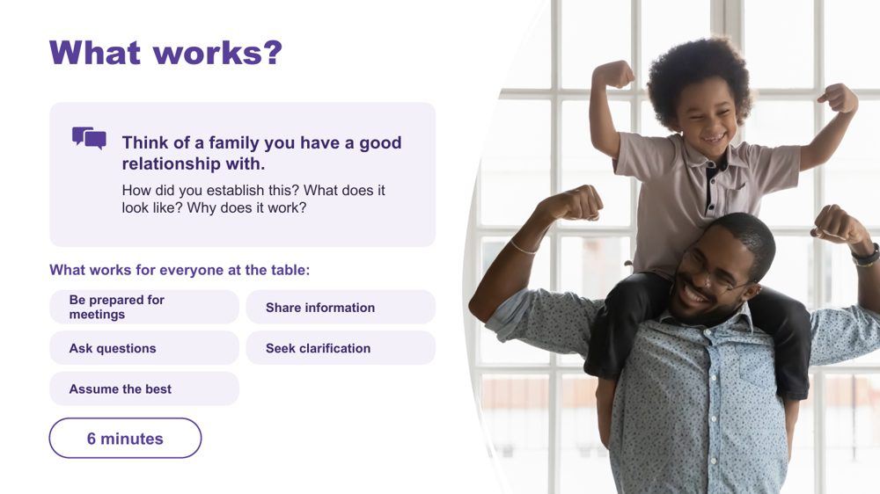 | What works?  SUGGESTED TIME  6 min  CLOCK  2:53 - 2:59  GROUPING  Small groups  PARTICIPANT GUIDE  Page 24 - What works?

Draw on relationships with families that already work, and name the moves that work for everyone at the table.
WHAT TO DO  - Ask participants, in their school groups, to think of a family they have or have had a good relationship with.  - Discuss the prompts on the slide.  - Ask groups to feed back some of the key ideas to the whole room.  - Point to the list of what works for everyone at the table, and add the educator side of each move. | KEY MESSAGES  - Send the agenda before the meeting, so families know what to expect.  - Welcome a support person. This is normal and allowed, and it can change the dynamic of the meeting.  - Open with a strength; share notes or minutes.  - Follow up in writing ('as we agreed...'), so everyone is clear on what was agreed.  - If it went wrong: acknowledge it, offer a reset, and make the next meeting fairer.

YOU MIGHT SAY
How did you establish this? What does it look like? Why does it work?

ACTIVITY | School group reflection small groups · 6 minutes
Think of a family you have a good relationship with. How did you establish this? What does it look like? Why does it work?
- Think of a family you have or have had a good relationship with.
- Discuss the three prompts in your school group.
- Keep examples anonymised.
Bring the room back
- What key ideas came up in your group?
Close: Connect the ideas shared to the list of what works for everyone at the table.

Background Parent and family engagement in learning happens when schools and educators support families, understanding and leveraging how they interact with their child's learning, and supporting them to do that in equal partnership with the school. Parents and families need to know how important their continued support for learning is, and that as the experts in their child they are an extremely valuable resource. Educators have a vital role to play here (Barker & Harris, 2020).
RESOURCES
- Barker, B., & Harris, D. (2020). Parent and Family Engagement: An Implementation Guide for School Communities. Canberra: ARACY
- Tett, L. & Macleod, G. (2020) Enacting home-school partnerships: the roles of headteachers, family-learning practitioners and parents, Cambridge Journal of Education, 50:4, 451-468 https://doi.org/10.1080/0305764X.2020.1722062

SESSION 5 | Working in Partnership | SLIDE 12 of 19

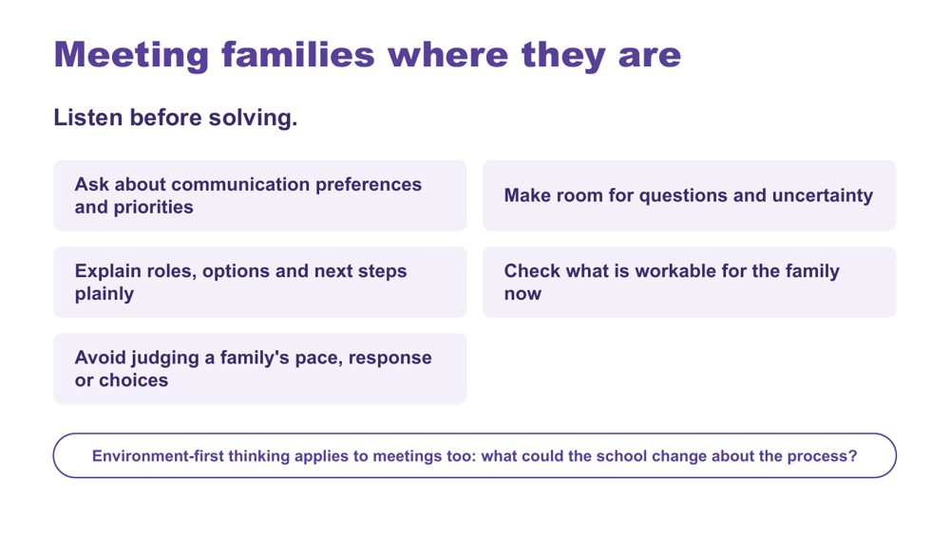 | Meeting families where they are  SUGGESTED TIME  2 min  CLOCK  2:59 - 3:01

Emphasise listening before solving, and making room for questions, uncertainty and different priorities.
WHAT TO DO  - Read the six practices briefly.  - Emphasise listening before solving and making room for questions, uncertainty and different priorities.  - Invite leaders to identify where school language, timing or process may create a barrier.  - Make the key point: environment-first thinking applies to meetings too. Where the same barrier comes up for many families, it is a process the school can change. | KEY MESSAGES  - Power is present in meeting structures, language and decision pathways.  - Meeting families where they are begins with listening and clarity.  - Environment-first thinking also applies to consultation processes.

YOU MIGHT SAY
What could the school change about the process?

KEEP IN MIND
- Avoid judging a family's pace, response or choices.
- Avoid describing a family as difficult, disengaged or unrealistic without examining the context and process.

SESSION 5 | Working in Partnership | SLIDE 13 of 19

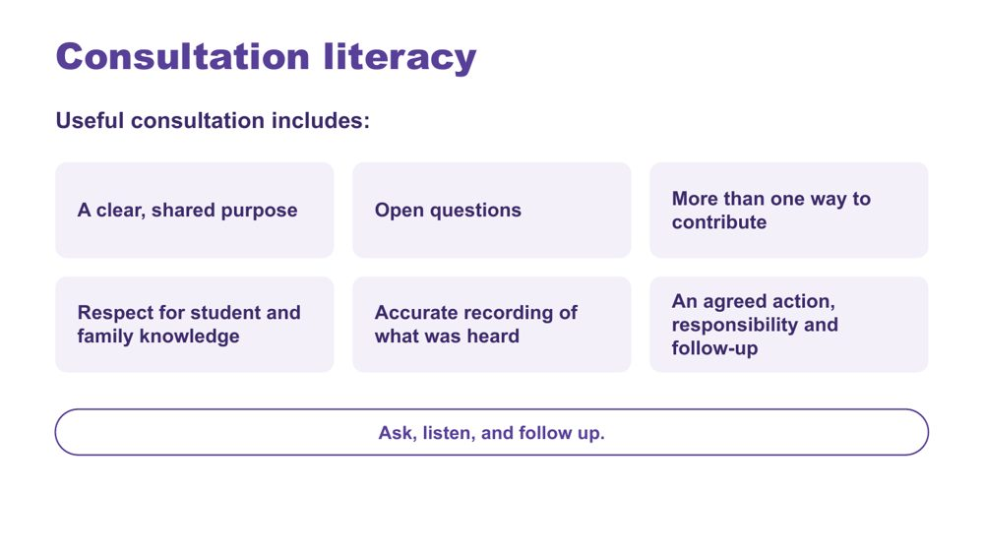 | Consultation literacy  SUGGESTED TIME  3 min  CLOCK  3:01 - 3:04  PARTICIPANT GUIDE  Page 25 - Consultation checklist

Introduce consultation literacy: asking, listening and following up, with families and students and with the school's own staff.
WHAT TO DO  - Walk through what useful consultation includes.  - Frame the list as a check participants can use before and after a meeting.  - Make the point: ask, listen, and follow up.  - Turn the list towards the school's own staff: leaders can consult their staff in the same way they ask staff to consult families.  - Explain that support staff often have the closest hour-by-hour picture of a student's day. Ask: How does what they notice reach decisions in your school?  - Ask: Have teachers been asked where the timetable and routines are hardest for students?  - Offer three questions from the team's leadership materials that a leadership team can put to staff: What evidence do we expect? What enables consistent adjustments? What is our unique responsibility?  - Follow up with staff as you would with families: tell them what was heard and what changed. | KEY MESSAGES  - Ask, listen, and follow up.  - Tools should support consultation rather than replace listening and student voice.  - Leaders can consult staff the same way they ask staff to consult families.  - Staff who are consulted well are better placed to consult families and students well.

YOU MIGHT SAY
How does what support staff notice reach decisions in your school?

KEEP IN MIND
- Keep the staff discussion about processes and roles. Do not name or blame staff.

Background Support staff often hold the closest hour-by-hour picture of a student's day in the school, and teachers know where the timetable and routines are hardest. Consulting them uses the same checklist as consulting families: a clear purpose, open questions, more than one way to contribute, accurate recording and an agreed action with follow-up. How leaders consult staff shapes how staff consult families and students.

SESSION 5 | Working in Partnership | SLIDE 14 of 19

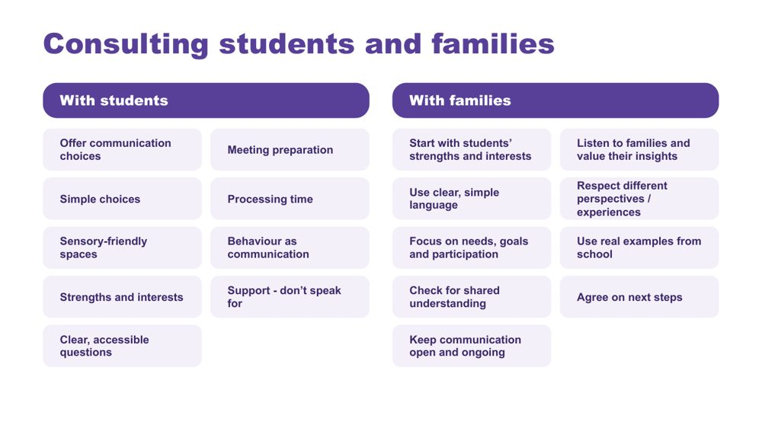 | Consulting students and families  SUGGESTED TIME  2 min  CLOCK  3:04 - 3:06

Give practical ways to consult students and families so every voice can be heard.
WHAT TO DO  - Take the two columns in turn: with students, then with families.  - With students: presume competence, provide communication supports, offer choices, allow time, and act on what students tell us.  - With families: start with the student's strengths, interests and what works well, and listen to families' knowledge of their child without making assumptions.  - Ask participants to pick one practice from each column that the school could build into its usual meeting processes. | KEY MESSAGES  - Listen, adapt, give choices, and make it easy for every student to have a voice.  - Ensure trusted supporters assist communication without replacing the student's voice.  - Use plain language and explain educational terms clearly.  - Focus on the student's needs and goals, not just their diagnosis.  - Recognise that some parents will be neurodivergent themselves.

Background Student consultation: provide multiple communication options (AAC, visuals, writing, drawing, video, symbols); prepare students in advance with questions, agendas and meeting information; use supported decision-making with simple choices and extra processing time; create sensory-friendly environments; recognise that behaviour is communication and can indicate preferences; build on strengths, interests and preferences; use accessible, strengths-based questions. Family consultation: be respectful of different cultures, experiences and family perspectives; use real examples from school to discuss supports and adjustments; check everyone has the same understanding; agree clear next steps and how progress will be reviewed; keep communication open and ongoing.
Thread Picks up the continuum of support and NCCD from Session 4.

SESSION 5 | Working in Partnership | SLIDE 15 of 19

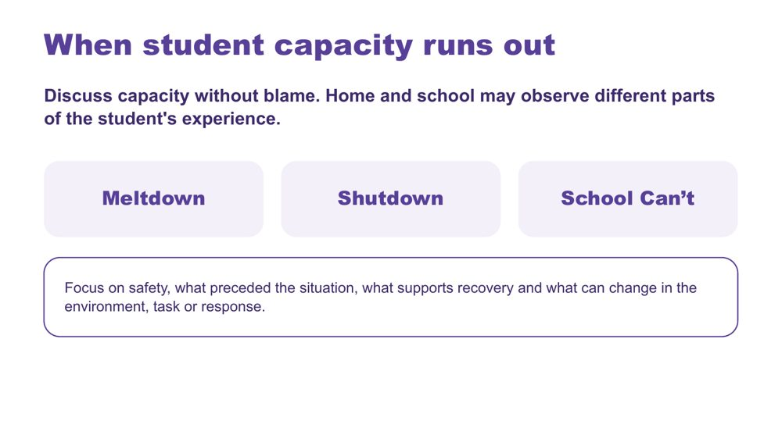 | When student capacity runs out  SUGGESTED TIME  2 min  CLOCK  3:06 - 3:08

Introduce meltdown, shutdown and School Can't within partnership discussion, without blame.
WHAT TO DO  - Introduce the three terms without presenting them as wilful behaviour.  - Connect discussion to accumulated demands, what may not be visible, and what home and school can learn from each other.  - Ask what information, listening and environmental change would help the team respond more safely and usefully.  - Ask leaders whether relevant staff know the school's local wellbeing, safety and support pathways.  - Point to the focus line: safety, what preceded the situation, what supports recovery and what can change in the environment, task or response. | KEY MESSAGES  - Capacity should be discussed without blame.  - Home and school may observe different parts of the student's experience.  - Use non-blaming language and the workshop safety guidance.  - Leaders are responsible for making local response pathways clear to staff.

KEEP IN MIND
- Do not frame meltdown, shutdown or School Can't as wilful misbehaviour or a failure of parenting.
- Do not offer clinical, diagnostic, legal or crisis guidance beyond the material.

Thread Builds on capacity and accumulated demands from Sessions 2 and 3.

SESSION 5 | Working in Partnership | SLIDE 16 of 19

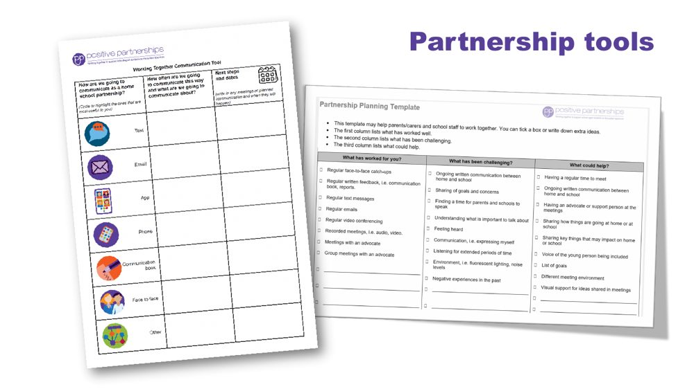 | Partnership tools  SUGGESTED TIME  1 min  CLOCK  3:08 - 3:09

Demonstrate the Partnership tools and explain how they are used.
WHAT TO DO  - Show the Partnership tools and explain how each is used.  - Frame the tools as supports for consultation, not replacements for listening.  - Ask how each tool would fit the school's existing meeting, decision and review processes. | KEY MESSAGES  - Tools should support consultation rather than replace listening and student voice.

SESSION 5 | Working in Partnership | SLIDE 17 of 19

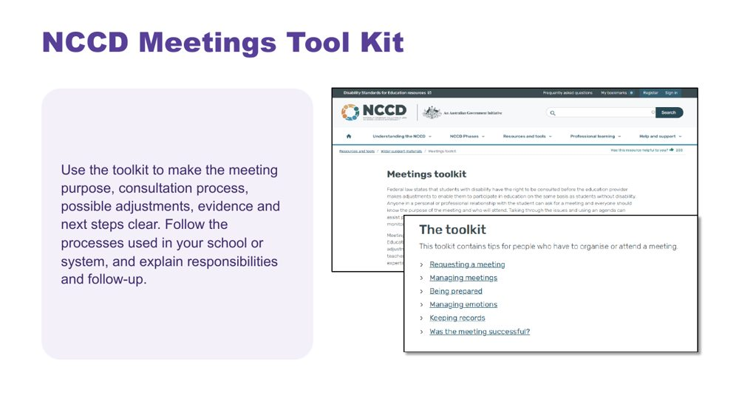 | NCCD Meetings Tool Kit  SUGGESTED TIME  1 min  CLOCK  3:09 - 3:10

Introduce the NCCD Meetings Tool Kit and direct participants to official NCCD information.
WHAT TO DO  - Explain how the Tool Kit makes the meeting purpose, consultation process, possible adjustments, evidence and next steps clear.  - Remind participants to follow the processes used in their school or system.  - Ask leaders to check who in their school uses the Tool Kit, who makes decisions, how student and family knowledge is included, and what is recorded.  - Emphasise explaining responsibilities and follow-up to families.  - Direct participants to official NCCD information. | KEY MESSAGES  - NCCD information must be current and official.

SESSION 5 | Working in Partnership | SLIDE 18 of 19

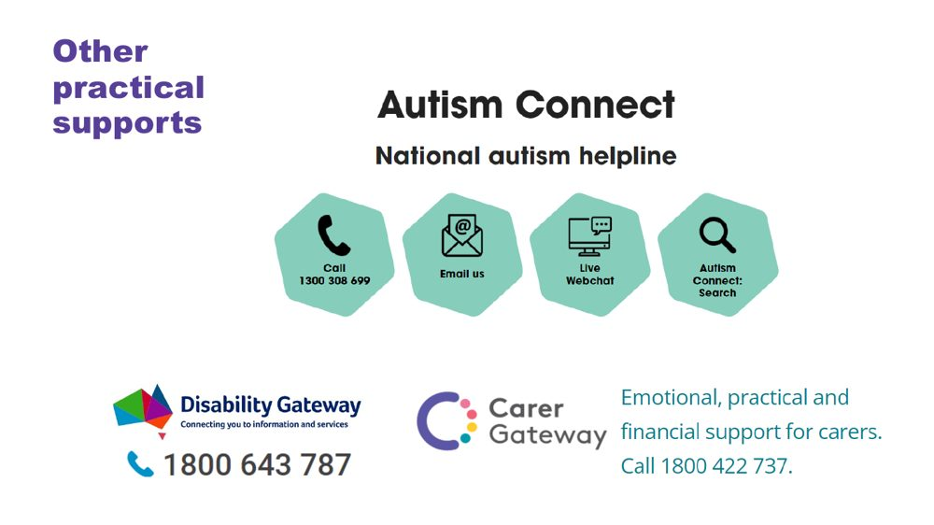 | Other practical supports  SUGGESTED TIME  1 min  CLOCK  3:10 - 3:11

Introduce the support pathways included in the workshop.
WHAT TO DO  - Briefly introduce the Positive Partnerships support options and other supports on the slide.  - Point participants to Participant Guide p. 30 for resources. | KEY MESSAGES  - Introduce the Positive Partnerships support options included with the workshop.

KEEP IN MIND
- Check phone numbers and services are current before delivery.

SESSION 5 | Working in Partnership | SLIDE 19 of 19

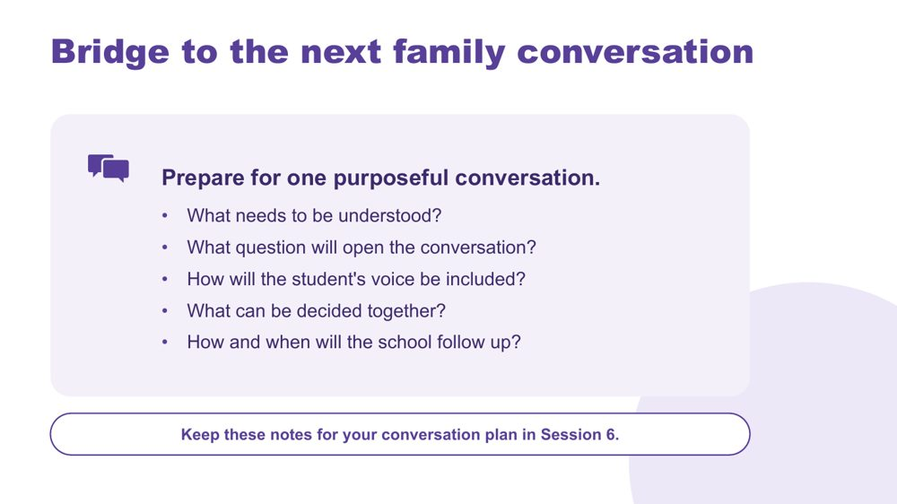 | Bridge to the next family conversation  SUGGESTED TIME  4 min  CLOCK  3:11 - 3:15  GROUPING  On your own  PARTICIPANT GUIDE  Page 25 - Bridge to the next family conversation

Identify the question and shared purpose participants will take into the Session 6 conversation plan.
WHAT TO DO  - Ask participants to return to the students they have in mind and their Session 4 school change.  - Invite them to work through the prompts on the slide privately.  - Keep the focus on preparation rather than scripting what the family should say.  - Ask participants to carry one process change from the power reflection into the plan.  - Preview the closing session on belonging, capacity, joy and practical next steps. | KEY MESSAGES  - Prepare for one purposeful conversation.

YOU MIGHT SAY
Keep these notes for your conversation plan in Session 6.

ACTIVITY | Private bridge reflection on your own · 4 minutes
Prepare for one purposeful conversation.
- What needs to be understood?
- What question will open the conversation?
- How will the student's voice be included?
- What can be decided together?
- How and when will the school follow up?
Close: Keep these notes available for the family-conversation plan in Session 6.

Thread Connects to the Session 4 'My students' card ("I will share it with") and the conversation plan in Session 6 (Participant Guide p. 28).

SESSION  6 | 3:15 - 4:00 · 45 MINUTES · 11 SLIDES  Flourishing & Full Circle  One change, one purposeful conversation

SESSION INTENT
Bring the day full circle through belonging, capacity and joy, then leave each participant with one school change and one purposeful conversation with a family or student. Keep the close grounded: no new content, protected time for planning, resources and feedback.
PARTICIPANTS LEAVE WITH
- connect the day's lens, school design and partnership through belonging, capacity and joy
- name one strategy to start, one to continue and one to reconsider, thinking school-wide, each with a way to know it worked
- plan a real conversation with a student's family or a student, to happen within two weeks
- know where continuing learning and community sit beyond the day

RUN SHEET
Clock | Segment | Slides | Minutes
3:15 - 3:19 | Opening and flourishing frame | 1-2 | 4
3:19 - 3:27 | Bringing it all together | 3 | 8
3:27 - 3:43 | Action card and conversation plan | 4-5 | 16
3:43 - 3:51 | Student voice and final reflection | 6-7 | 8
3:51 - 3:55 | Connections and resources | 8-9 | 4
3:55 - 4:00 | Feedback and farewell | 10-11 | 5

PREPARE
☐ Participant Guide p. 27 (Start · Continue · Reconsider action card) and p. 28 (Plan the next conversation)
☐ Participant Guides open to pp. 26 - 30; participants' Session 4 Commit table and Participant Guide p. 20 (Our school change), and their Session 5 bridge notes
☐ Session 4 gallery wall still up, if possible
☐ Video queued and tested (Caitlin, or the fallback clip)
☐ Feedback link and QR code confirmed; accessible alternative ready

SESSION 6 | Flourishing & Full Circle | SLIDE 1 of 11

 | Flourishing & Full Circle  SUGGESTED TIME  1 min  CLOCK  3:15 - 3:16

Bring the day together and prepare for practical action.
WHAT TO DO  - Name the final session as a return to the students and questions participants began with this morning.  - Explain that participants will consolidate one school change and one conversation with a family or student.  - Protect enough time for individual planning, resources and feedback.  - Keep the closing grounded rather than adding new content. | KEY MESSAGES  - The day closes by connecting understanding with action.  - One thoughtful next step is more useful than an unmanageable list.

SESSION 6 | Flourishing & Full Circle | SLIDE 2 of 11

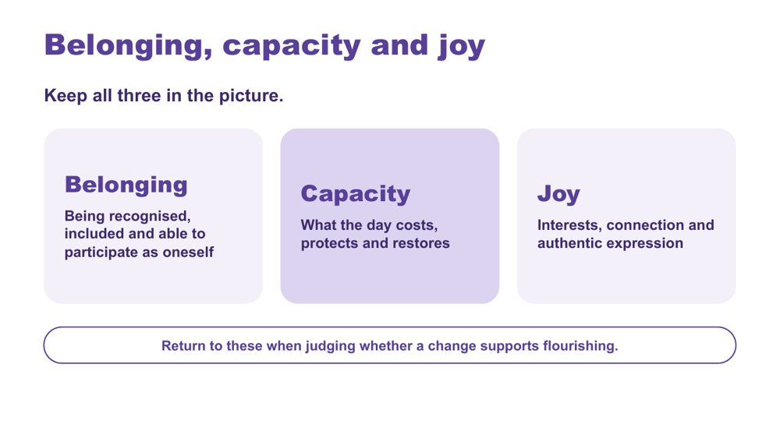 | Belonging, capacity and joy  SUGGESTED TIME  3 min  CLOCK  3:16 - 3:19

Bring together the workshop lens, school design and partnership through belonging, capacity and joy.
WHAT TO DO  - Present belonging, capacity and joy together, as connected ideas.  - Optionally link the day's three practical strands: a neurodiversity-affirming lens that begins with the person; a more accessible school shaped by student experience; positive partnership that brings student, family and school knowledge together.  - Connect the lens, the accessible classroom and positive partnership without repeating the full day.  - Invite participants to notice whether their Session 4 school change supports belonging or joy as well as reducing a barrier.  - Point to the last line on the slide: return to these three when judging whether a change supports flourishing. | KEY MESSAGES  - Belonging, capacity and joy belong alongside access and participation.  - School design and partnership should stay connected to each student's whole experience.

YOU MIGHT SAY
Belonging, capacity and joy run through all three.

KEEP IN MIND
- Avoid presenting academic performance, quiet compliance or conventional independence as the only evidence of flourishing.

Thread Capacity picks up Session 3's 'What costs? What lightens?' thinking; the whole frame is the test for the Session 4 design change and the Session 5 partnership planning.

SESSION 6 | Flourishing & Full Circle | SLIDE 3 of 11

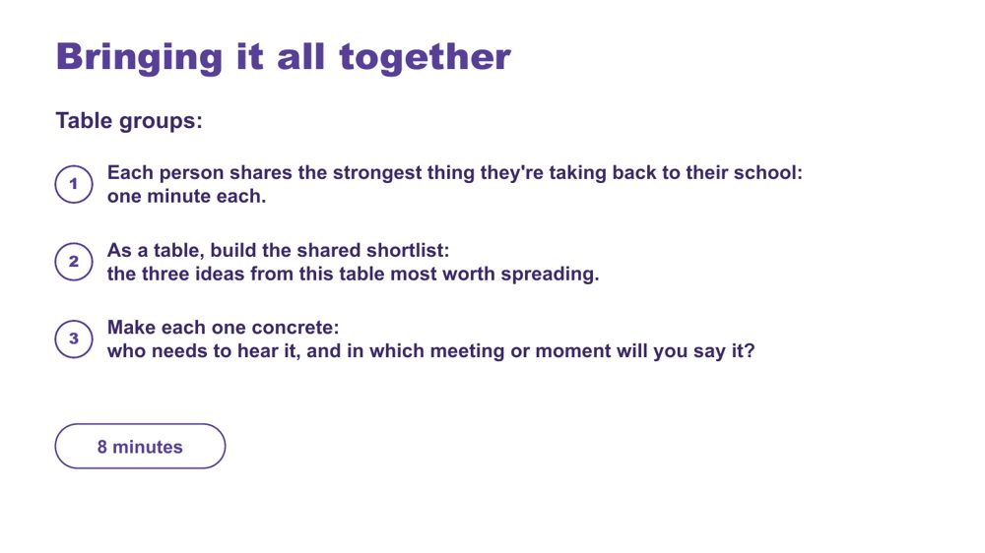 | Bringing it all together  SUGGESTED TIME  8 min  CLOCK  3:19 - 3:27  GROUPING  Table groups  PARTICIPANT GUIDE  Page 26 - Bringing it all together

Surface the strongest ideas at each table and make the most useful ones concrete enough to spread back at school.
WHAT TO DO
- Move participants into table groups.
- Keep time: one minute per person, then the shortlist.
- Remind tables they can draw on what they saw on the gallery wall in Session 4.
- Push each table to name a real person and a real meeting or moment for each shortlisted idea.

ACTIVITY | Table sharing and shortlist table groups · 8 minutes
What is the strongest thing you're taking back to your school?
- Each person shares the strongest thing they're taking back to their school: one minute each.
- As a table, build the shared shortlist: the three ideas from this table most worth spreading.
- Make each one concrete: who needs to hear it, and in which meeting or moment will you say it?

Thread The shortlist builds on the Session 4 gallery walk.

SESSION 6 | Flourishing & Full Circle | SLIDE 4 of 11

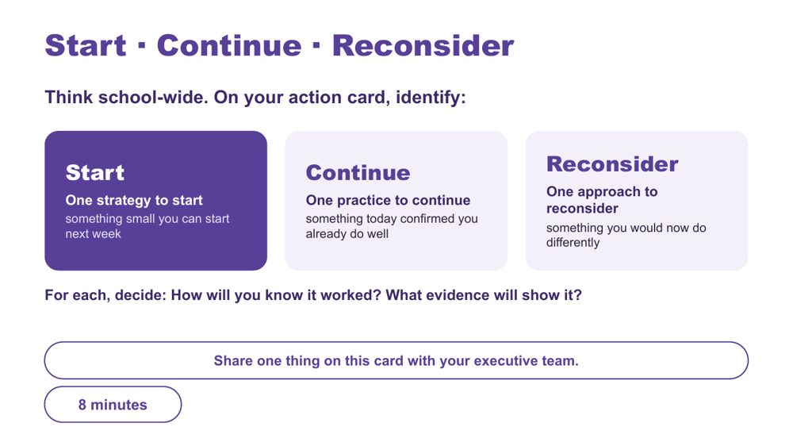 | Start · Continue · Reconsider  SUGGESTED TIME  8 min  CLOCK  3:27 - 3:35  GROUPING  On your own  PARTICIPANT GUIDE  Page 27 - Start · Continue · Reconsider

Turn the day into one specific, environment-first school action, alongside a practice to keep and one to rethink.
WHAT TO DO  - Ask participants to have their Session 4 Commit table and Participant Guide p. 20 in front of them.  - Read the opening line: think school-wide.  - Ask what matters most now, rather than for a summary of every topic.  - Suggest their Start can be their Session 4 "this term" step, now with how they will know it worked.  - Offer the stems for an environment-first Start: I will... / The barrier or demand I am addressing is... / I will notice... / I need to consult... / I will review this on...  - Check that each Start sits within the participant's influence and does not require a student to appear less Autistic.  - Encourage participants to include when they will consult students, families or staff.  - Point to the last line: share one thing on this card with your executive team. | KEY MESSAGES  - Use access, participation or experience as the measure, not outward compliance.  - Choose one insight, question or design opportunity that is specific and small enough to start.

ACTIVITY | Individual action planning on your own · 8 minutes
Think school-wide. What matters most now, and what is one change you will take forward?
- On the action card, identify one strategy to start: something small you can start next week.
- Identify one practice to continue: something today confirmed you already do well.
- Identify one approach to reconsider: something you would now do differently.
- For each, decide: How will you know it worked? What evidence will show it?
- If time allows, note beside your Start the barrier or demand it addresses, who to consult and when to review it.
- This card is yours. Share one thing on it with your executive team.
Close: Ask participants to keep the action small, testable and open to revision.

KEEP IN MIND
- Do not let 'what they will notice' become outward compliance.
- The card is theirs: participants choose what to share with their executive team.

Thread Picks up the Session 4 Commit table and the School change sheet "This term" step (p. 20); Participant Guide p. 27 notes the "this term" step can be the Start.

SESSION 6 | Flourishing & Full Circle | SLIDE 5 of 11

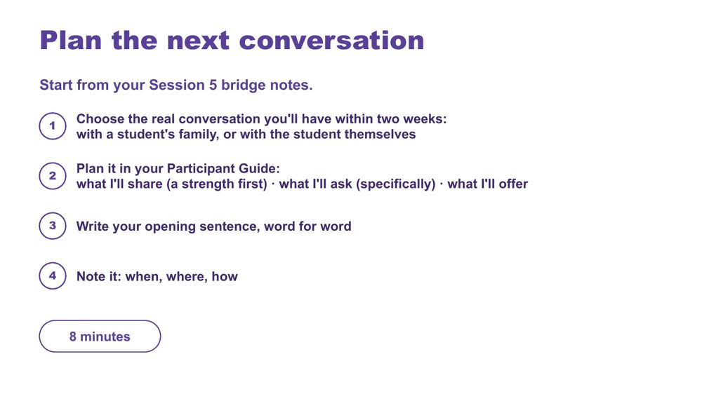 | Plan the next conversation  SUGGESTED TIME  8 min  CLOCK  3:35 - 3:43  GROUPING  On your own  PARTICIPANT GUIDE  Page 28 - Plan the next conversation

Prepare one purposeful, power-aware conversation with a student's family or the student themselves, within two weeks.
WHAT TO DO
- Ask participants to open their Session 5 bridge notes.
- Ask them to define the purpose before writing questions or next steps.
- Point back to the bridge prompts on p. 25: what needs to be understood, how student voice will be included, what can be decided together and how the school will follow up.
- Ask participants to apply the process change they identified during the power-dynamics reflection.
- Keep all notes anonymised (initials or roles only) and sharing voluntary.

ACTIVITY | Individual conversation planning on your own · 8 minutes
Plan one real conversation you will have within two weeks.
- Choose the real conversation you'll have within two weeks: with a student's family, or with the student themselves.
- Write the purpose in one sentence: what you need to understand, rather than what you need the family to accept.
- Plan it in your Participant Guide: what I'll share (a strength first), what I'll ask (specifically), what I'll offer.
- Plan how the student's communication and preferences will be included.
- Write two open questions and what you will listen for.
- Write your opening sentence, word for word.
- Name one possible shared next step, leaving room for the conversation to change it, and how you will follow up.
- Note it: when, where, how.
Close: Invite participants to check that the plan is clear, respectful and genuinely open to family and student knowledge.

KEEP IN MIND
- Avoid scripting the family's response.
- Avoid treating the meeting as a way to secure agreement with a finished school plan.

Thread Starts from the Session 5 bridge notes (p. 25 - Bridge to the next family conversation) and the power-dynamics reflection (p. 23).

SESSION 6 | Flourishing & Full Circle | SLIDE 6 of 11

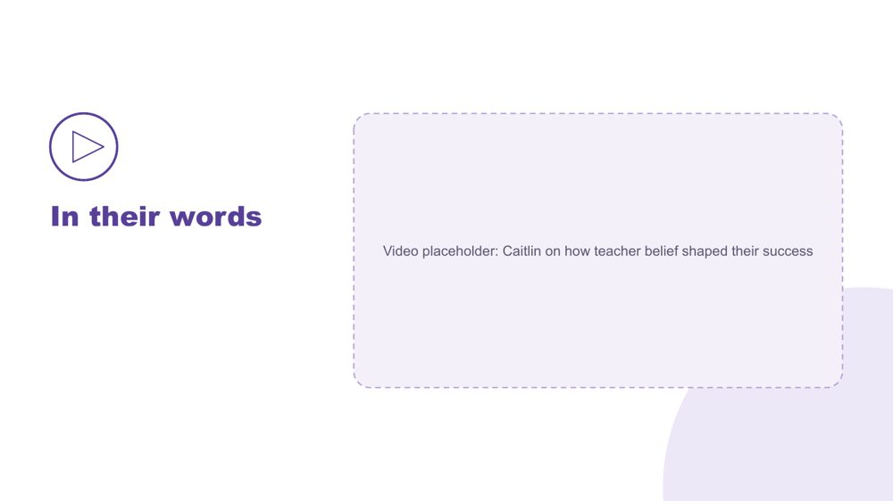 | In their words  SUGGESTED TIME  4 min  CLOCK  3:43 - 3:47

Hear, in a student's own words, how teacher belief shaped their success.
WHAT TO DO
- Play the video.
- Move to the final reflection after the video, without discussion.

SESSION 6 | Flourishing & Full Circle | SLIDE 7 of 11

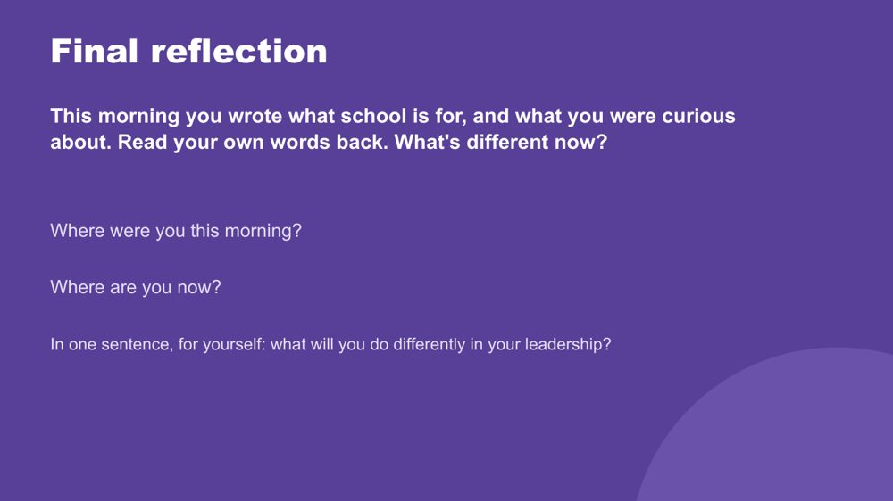 | Final reflection  SUGGESTED TIME  4 min  CLOCK  3:47 - 3:51  PARTICIPANT GUIDE  Page 29 - Final reflection

Return participants to where they started this morning and name, privately, what has shifted.
WHAT TO DO
- Ask participants to find what they wrote this morning (p. 5 - My starting point) and read their own words back.
- Ask: What's different now?
- Give quiet time for the two prompts: Where were you this morning? Where are you now?
- Ask each person to answer the last question in one sentence, to themselves.
- Keep it private; no sharing is needed.

YOU MIGHT SAY
In one sentence, for yourself: what will you do differently in your leadership?

Thread Returns to Session 1 (p. 5 - My starting point).

SESSION 6 | Flourishing & Full Circle | SLIDE 8 of 11

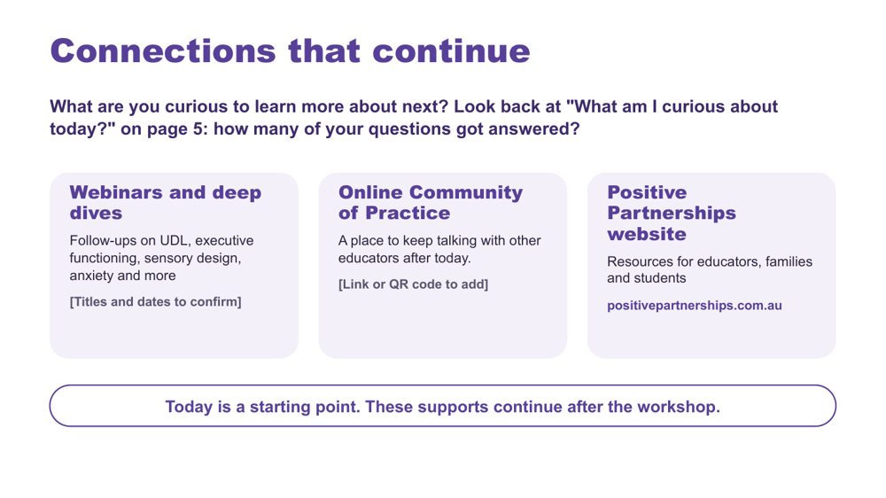 | Connections that continue  SUGGESTED TIME  3 min  CLOCK  3:51 - 3:54  PARTICIPANT GUIDE  Page 30 - Connections that continue

Introduce continuing professional learning and community pathways.
WHAT TO DO  - Ask: What are you curious to learn more about next?  - Point participants back to "What am I curious about today?" (Participant Guide p. 5, My starting point): how many of their morning questions got answered?  - Explain how to access each pathway: webinars and deep dives, the Online Community of Practice and the Positive Partnerships website.  - Mention that photos of today's wall work will be shared in the Community of Practice this week.  - Keep this brief and practical. | KEY MESSAGES  - The workshop is one point in continuing professional learning, reflection and partnership.  - Choose the pathway that fits your next question.

YOU MIGHT SAY
Today is a starting point. These supports continue after the workshop.

RESOURCES
- Positive Partnerships website - positivepartnerships.com.au

SESSION 6 | Flourishing & Full Circle | SLIDE 9 of 11

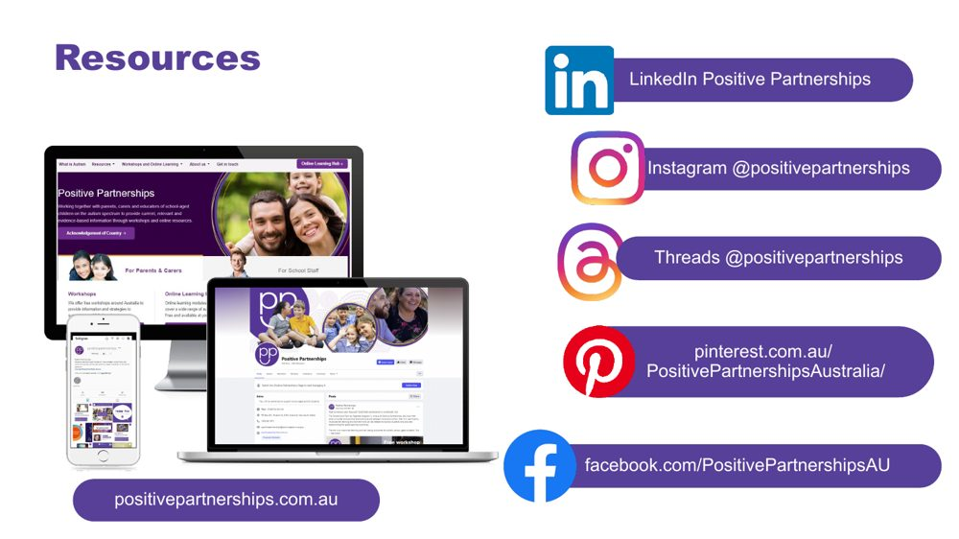 | Resources  SUGGESTED TIME  1 min  CLOCK  3:54 - 3:55

Show where to follow Positive Partnerships online.
WHAT TO DO
- Leave the slide up briefly so participants can note or photograph the handles.

RESOURCES
- Positive Partnerships website - positivepartnerships.com.au
- Facebook - facebook.com/PositivePartnershipsAU
- Instagram - @positivepartnerships
- Threads - @positivepartnerships
- LinkedIn - Positive Partnerships
- Pinterest - pinterest.com.au/PositivePartnershipsAustralia/

SESSION 6 | Flourishing & Full Circle | SLIDE 10 of 11

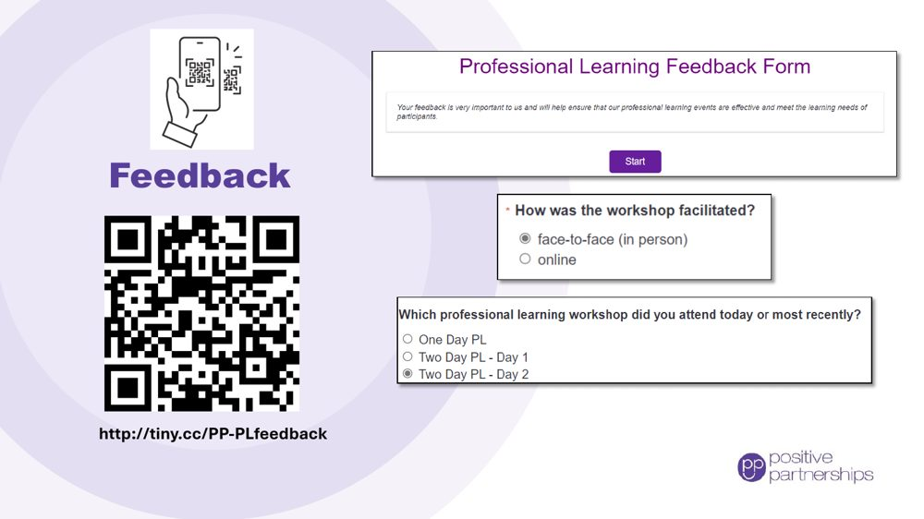 | Feedback  SUGGESTED TIME  4 min  CLOCK  3:55 - 3:59

Collect participant feedback.
WHAT TO DO
- Explain why feedback is being collected and how it is used.
- Show how to access the form (link and QR code).
- Allow protected time for completion in the room.
- Provide an accessible alternative if the process includes one.

RESOURCES
- Feedback form - http://tiny.cc/PP-PLfeedback

SESSION 6 | Flourishing & Full Circle | SLIDE 11 of 11

 | Good luck on your journey  SUGGESTED TIME  1 min  CLOCK  3:59 - 4:00

Close warmly and return participants to student-centred curiosity.
WHAT TO DO  - Thank participants for their attention, questions and professional reflection.  - Invite them to stay curious and keep students at the centre.  - Remind participants to take their action card and conversation plan, and to share one thing with their executive team.  - State the relevant follow-up and contact arrangements. | KEY MESSAGES  - Stay curious.  - Keep students at the centre.  - Small, informed changes can be reviewed and refined in partnership.

